PROFORMA FOR ANNUAL REPORT- 2024 (January-December 2024)

1. GENERAL INFORMATION ABOUT THE KVK

1.1. Name and address of KVK with phone, fax and e-mail

Address | Telephone |  | E mail
 | Office | FAX
Krishi Vigyan Kendra  At/Po- Badmal  Jharsuguda, Pin-768202 | Office | FAX | kvkjharsuguda.ouat@gmail.com  kvk.jharsuguda@ouat.ac.in

1.2 .Name and address of host organization with phone, fax and e-mail

Address | Telephone |  | E mail
Address | Office | FAX
Odisha University of Agriculture & Technology, Bhubaneswar, Odisha. | 0674-2397818/919  0674-2397424 | 0674-2397818/919 | registrarouat@gmail.com

1.3. Name of Senior Scientist and Head with phone & mobile No.

Name | Telephone / Contact
 | Residence | Mobile | Email
Dr. Samir Ranjan Dash | KVK, Jharsuguda | 9438531167 | samirdash639@gmail.com

1.4. Year of sanction of KVK: 2006

1.5. Staff Position (as on 1stJanuary, 2024)

Sl.  No. | Sanctioned post | Name of the incumbent | Designation | Discipline | Pay  Scale with present basic | Date of joining | Permanent/Temporary | Category (SC/ST/  OBC/  Others)
1 | Senior Scientist& Head | Dr. Samir Ranjan Dash | Sr. Scientist & Head | Extension Education | 95300 | 01.08.2022 | Temporary | Other
2 | Subject Matter  Specialist | Dr. Anuj Kumar Rai | Scientist | Plant Science | 22200 with AGP 5400 | 07.06.2021 | Temporary | Other
3 | Subject Matter  Specialist | Ms. Susmita Panda | Subject Matter Specialist | Agronomy | 65000 | 01.08.2022 | Temporary | Other
4 | Subject Matter  Specialist | Dr. Tarak Chandra Panda | Scientist | Agriculture Engineering | 19050 with AGP 5400 | 01.02.2024 | Temporary | Other
5 | Subject Matter  Specialist | DrJyotiprabha Mishra | Subject Matter Specialist | Animal Science | 19810 with AGP 5400 | 03.02.2025 | Temporary | Other
6 | Subject Matter  Specialist | Vacant | - | - | - | - | - | -
7 | Subject Matter  Specialist | Vacant | - | - | - | - | - | -
8 | Programme Assistant | Vacant | - | - | - | - | - | -
9 | Computer  Programmer | Sri Bishnu Ranjan Padhi | Computer Programmer | B.E (Computer Sc.) | 66000 | 11.08.2014 | Temporary | Other
10 | Farm Manager | Vacant | - | - | - | - | - | -
11 | Accountant / Superintendent | Vacant | - | - | - | - | - | -
12 | Stenographer | Vacant | - | - | - | - | - | -
13. | Driver | Sri SamantaMallick | Driver | - | 27600 | 28.07.2015 | Temporary | SC
14. | Driver | Manoj Kumar Sahoo | Driver | - | 30200 | 20.09.2017 | Temporary | Others
15. | Supporting staff | Kamala Nag | Peon -cum -Watchman | - | 25000 | 29.07.2008 | Temporary | SC
16. | Supporting staff | Vacant | - | - | - | - | - | -

1.6. Total land with KVK (in ha)
S. No. | Item | Area (ha)
1 | Under Buildings | 0.3
2. | Under Demonstration Units | 0.4
3. | Under Crops | 1.34
4. | Orchard/Agro-forestry | 2.0
5. | Others with details ( Lawn Area , Road | 0.7
6. | Land under encroachment | 1.0
 | Total | 5.74
:
Total area should be matched with breakup

1.7. Infrastructure Development:

A) Buildings and others
S. No. | Name of infrastructure | Not yet started | Completed up to plinth level | Completed up to lintel level | Completed up to roof level | Totally completed | Plinth area (sq.m) | Under use or not* | Source of funding
1. | Administrative  Building | - | - | - | - | Completed | 1500 | Under Use | ICAR
2. | Farmers Hostel | - | - | - | - | Completed | 1500 | Under use | ICAR
3. | Staff Quarters (6) | - | - | - | - | Completed | 1400 | Under use | ICAR
4. | Piggery unit | - | - | - | -
5 | Fencing | - | - | - | - | Completed | -- | Under Use | ICAR & RKVY
6 | Rain Water harvesting structure | - | - | - | - | Completed | 1800 | Under Use | ICAR & RKVY
7 | Threshing floor | - | - | - | - | Completed | 600 | Under Use | ICAR
8 | Farm godown | - | - | - | -
9. | Dairy unit | - | - | - | -
10. | Poultry unit | - | - | - | - | Completed | 20 | Under Use | RKVY
11. | Goatary unit | - | - | - | - | - | - | - | -
12. | Mushroom Lab | - | - | - | - | Completed | 15 | Under Use | RKVY
13. | Mushroom production unit | - | - | - | - | Completed | 20 | Under use | ICAR
14. | Shade house | - | - | - | - | Completed | 50 | Under use | ICAR
15. | Soil test Lab | - | - | - | - | Completed | 20 | Under use | ICAR
16 | Duckery unit | - | - | - | - | Completed | 20 | Under Use | ICAR
17 | Vermicompost Unit | - | - | - | - | Completed | 15 | Under Use | RKVY
18 | Poly House | - | - | - | - | Completed | 80 | Under Use | RKVY
19 | Azolla Unit | - | - | - | - | Completed | 20 | Under Use | ICAR
20 | Overhead Tank with irrigation system |  |  |  |  | Completed | 2000 Ltr, | Under Use | ICAR

* If not in use then since when and reason for non-use

B) Vehicles
Type of vehicle | Year of purchase | Cost (Rs.) | Total km. Run | Present status
Bolero | 2017 | 8,00,000 | 84494 | Good
Motor Cycle | 2012 | 50000 | 34640 | Good
Tractor | 2023 | 750000 | 27 hrs | Good

C) Equipment & AV aids

Name of equipment | Year of purchase | Cost (Rs.) | Present status | Source of fund
a. Lab equipment
Soil Testing Lab. Equipment | 2017 | 1700000 | Good | ICAR
Mushroom Spawn production equipment | 2011 | 250000 | Good | RKVY
b. Farm machinery
Tractor | 2023 | 750000 | Good | ICAR
Solar Nano Pump (0.1hp) | 2024 | 17920 | good | ICAR
Mini Tractor | 2024 | 478276 | Good | OMBADC
Power Tiller | 2024 | 220500 | Good | OMBADC
Power Sprayer | 2024 | 27070 | Good | OMBADC
Brush Cutter | 2024 | 34500 | Good | OMBADC
Ragi thresher cum pearler | 2024 | 117312 | Good | OMBADC
Foot sprayer | 2024 | 9550 | Good | OMBADC
Chain Saw | 2024 | 14000 | Good | OMBADC
Power operated Ridger | 2024 | 60000 | Good | OMBADC
Hand Sprayer | 2024 | 800 | Good | OMBADC
Dryland Power weeder | 2024 | 72000 | Good | OMBADC
Paddy Reaper | 2024 | 145000 | Good | OMBADC
c.AV Aids
LCD | 2012 | 50000 | Good | ICAR
Television | 2013 | 40000 | Not working | ICAR
Sound System | 2011 | 50000 | Good | ICAR
Conference table Audio System | 2017 | 64000 | Good | ICAR
Smart Television | 2021 | 34000 | Good | ICAR
All-in-One | 2020 | 40000 | Good | ICAR
Dell Laptop | 2021 | 40000 | Good | ICAR
Printer | 2022 | 20000 | Good | ICAR

D) Farm implements

Name of equipment | Year of purchase | Cost (Rs.) | Present status | Source of fund
Cultivator | 2006 | 30000 | Not Good | ICAR
Brush Cutter | 2017 | 42000 | Good | ICAR
Manual Rice Thresher | 2012 | 4500 | Good | ICAR
Manual Rice Winnower | 2012 | 5000 | Good | ICAR
Ridger | 2021 | 20000 | Good | ICAR
Mini Tractor Cultivator | 2024 | 30000 | Good | OMBADC
Rotavator | 2024 | 138000 | Good | OMBADC
Seed cum fertilizer drill | 2024 | 138000 | Good | OMBADC
Multi-crop Thresher | 2024 | 281000 | Good | OMBADC
Hydraulic Trolley | 2024 | 212000 | Good | OMBADC

1.8. Details of SAC meeting* conducted in the year

Sl.No. | Date | Number of Participants | Salient Recommendations | Action taken | If not conducted, state reason
1. | 05.11.2024 | 30 | 1. Promotion of Climate resilient technology | - Demonstration on drought tolerant rice var. Swarna Shreya under SCSP program (10.0 ha in 6 villages involving 25 farmers) Yield-32.4q/ha, FP-28.1q/ha, Dry spell at pre flowering stage  - Demonstration on INM in finger millet var. Arjun (2.0 ha area with 10 farmers in 4 villages), Yield 13.3q/ha, FP- 9.5q/ha,B:C-2.0  - Demonstration on (application of 75 % N+75% P + full dose of K)+ Foliar spray of 2% Urea Phosphate(N:P:K:: 17:44:0) at 20 & 35 DAS in green gram  - (2.0 ha area with 10 farmers in 3 villages),yield-6.9q/ha,FP-5.7q/ha,20% increase  - Demonstration on drought tolerant groundnut var. Kadiri Lepakshi under Irrigated cond., FP-K6, (5.0 ha area in 5 villages involving 15 farmers), Yield-20.8 q/ha,FP-17.5q/ha, 13% increase in yield  - Assessment of different water conservation practices in tomato (2.0 ha, 10 farmers)  - Poly mulching with furrow irrigation and Poly-mulching with Drip irrigation
 |  |  | 2. Promotion of organic input production and its use | - Demonstration of vermicompost production using poly vermi bed (20 Nos.) Conducted in village Dalki, Kureibaga, Mauliberna and Siriapalli  - Demonstration of rhizobium seed inoculation in Groundnut (2.0 ha) Conducted in villages Bhaunra,Rautbahal,Tareikela,Yield- 20.8q/ha, FP-17.1q/ha  - Demonstration on management of Brinjal fruit and shoot borer using Tricho card from OUAT (1.0 ha) Conducted in villages Talmal, Gudigaon and Tharkaspur, 5 times starting 21 DAT in weekly interval ,Result- Fruit infestation- 12.9%, Yield- 258 q/ha, FP-204q/ha  - Demonstration of Arka vegetable special in hybrid Tomato (2.0 ha ) Conducted in 4 villages , Yield-424.8q/ha, FP- 390q/ha  - Demonstration of bio-fertilizer and micronutrients in Toria. (3.0 ha), Yield-8.4 q/ha, FP- 6.9q/ha  - Three nos. of skill training on vermicompost production (5 days duration -60 participants)  - One no. of skill training on organic farming (20 participants) conducted under CBSAE development project  - Publication of booklet on Vermicompost production (500 copies), distributed to 465 farmers
 |  |  | 3.Intervention on weed management practices in rice, maize and oilseed crops | - Herbicidal weed management in groundnut by pre-emergence application of Oxyfluorfen (@0.04kg a.i/ha) , variety Kadiri Lepakshi in 2.0 ha area in Rabi 2023-24, WCE (%) at 20 DAS – 89, B:C ratio-2.4, Cost saving- Rs.8000/ha  - Assessment of herbicides for weed management in transplanted rice (2.0 ha in 3 villages)  TO₁-Application of Cyhalofop butyl + Penoxulam @ 135g/ha at 20DAT  TO₂-Pre-emergence application of Pretilachlor @500 g/ha fb post emergence application of Chlorimuron ethyl + Metsulfuron methyl @ 4 g/ha at 20DAT, Dry matter of weed (g/m²)- FP-8.4, TO₂-3.2  - Demonstration on weed management in maize (2.0 ha in 4 villages), Pre-mergence application of Atrazine 1000g/ha followed by Post emergence application of Tembotrione 34.4 SC@290ml/ha at 20-25 DAS, Weed biomass (g/m2)- FP- 20.3 , Demo.- 11.5, B:C -2.06, Cost Saving-Rs.12000/ha
 |  |  | 4. Site and resource specific IFS models development through convergence mode | - Four no. of IFS models are developed in villages- Chandinimal, Pudapalli, Saletikra ,Gudigaon  1. Farmer- Sri Rohit Pradhan  Village Chandinimal ( Poultry + Duckery+ Goatery+ Fish+ Vegetables) ,Area- 1.0 ha , Gross income –Rs.3.2 Lakhs  2. Farmer- Sri Mitrabhanu Patel  Village Gudigaon ( Dairy + Goatery + Fish+ Vegetables + Fruit) ,Area- 1.0 ha , Gross income –Rs.2.8 Lakhs  3. Farm Woman – Smt. Sarojini Bhainsa  Village Saletikra (Vegetables + Mango+ Vegetables + Poultry + Fish),Area -0.8 ha , Gross income –Rs.2.6 Lakhs  4. Farmer- Sri LambodarBarik  Village Pudapalli - (Paddy+Vegetables+ Mushroom+ Sugarcane ),  Gross income –Rs.2.4 Lakhs
 |  |  | 5. Inter cropping of turmeric, zinger, pineapple etc in mango orchard of KVK | - Intercropping of turmeric variety Roma in mango orchard of KVK farm (0.3 ha)  - Intercropping of pineapple variety Queen in KVK farm
 |  |  | 6. Large scale promotion on Honey bee keeping in convergence with Hort. Dept. | - Skill development training programme on Scientific Bee Keeping under NBB (4 nos. with 100 participants) and (2 nos. with 40 participants) under CBSAE dev. Project, Entrepreneur developed- 4 Nos.  - 4 nos. of demonstration on Honeybee keeping under SCSP programme (2 villages)  - Promotion of FPO “Honeyfed” in Laikera block on Honey production
 |  |  | 7. Oyster mushroom production with crumpled straw | - Demonstration on Oyster mushroom production using crumpled straw (No. of beds -500 , No. of Demonstration – 10 Nos.) , Yield -1.6 kg/bed with return Rs.1500 /10 bed  - Two nos. of skill training Oyster mushroom production (5 days duration involving 40 participants) conducted under CBSAE development project  - Publication of booklet on “Oyster Mushroom Cultivation ”in Odia (500 copies) and distributed to 275 farmers
 |  |  | 8. Intervention on rhizome rot management in ginger | - Conducted training programmes on Rhizome treatment and post harvest management of Ginger in Lakhanpur block. (2 Nos., 60 Participants) Area affected -568 ha, There was 25 % less incidence of rhizome rot.
 |  |  | 9. Intervention on Nursery development for quality planting materials | - Skill Training on Nursery raising (2 Nos. with 40 participants) conducted under CBSAE development project  - Production and distribution of 1.02 lakh seedlings and saplings of HYV vegetables  - Papaya – 2200 Nos. (Red Lady, Ranchi Dwarf), Drumstick- 3600 Nos. (ODC 3), Tomato-16000 Nos. (Arka Samrat), Marigold- 7000 Nos. (BM-2) supplied to OLM and Farmers  - Seedlings and Saplings were distributed to the farmers during various flagship programmes like Vanomahostav, Poshan Abhijan (220 Farmers)  - 07 nos. of entrepreneurs have been developed on nursery raising
 |  |  | 10. Popularisation of bio pesticides and bio inputs | - OFT on Management of Brinjal fruit and shoot borer using Pheromone trap and Tricho card (1.0 ha), Fruit infestation (%) FP- 46.8, TO₂ -12.9, Yield -258q/ha.  - Demonstration of seed inoculation with bio fertilizer (Rhizobium, Azotobacter and PSB) conducted in Toria and Groundnut (4 .0 ha) , Toria Yield- 8.4q/ha, Groundnut -20.8q/ha  - Publication of leaflets ( 500 Nos.) on Azolla production
 |  |  | 11. Demonstration on backyard poultry farming | - FLD on poultry breed Kaveri and Vezaguda in villages Chandinimal, Keldamal, Banjari and Malidihi under SCSP programme(4 villages and 20 units)  - Result-Body wt./Bird/year – Kaveri -2.5 kg, Vezaguda – 2.2 kg , FP- 1.4 kg  - Demonstration on stress tolerant poultry breed Kadaknath under SCSP programme (3 villages and 20 units) Body. wt./bird/6month in kg- 1.4
 |  |  | 12.Promotion of floriculture | - Demonstration of Marigold variety –Bidhan Marigold 2 (1.5 ha with 10 farmers, Net income of 2.3 lakhs/ha ,B:C ratio 3.8 Two nos. of training conducted on Improved cultivation practices of marigold involving 60 participants
 |  |  | 13.Convergence mode of activities in agri and allied sectors | - Joint diagnostic field visit with Dept. of Agriculture for BPH and stem borer management, G.P -Bhikampali, H. Katapalli, Rampella, Kolabira, Kumarbandha, Siriaplai of Jharsuguda district  - Technical support to Odisha Millet mission. Participated in district level millet recipe competition , Seminar for promotion of millet  - Conducted capacity building programme for para-extension workers (120 participants)  - Joint celebration of World soil day, farm mechanisation mela and exhibition with Dept. of Agriculture, Jharsuguda  - Convergence activities like verification of planting materials ,Installation of Sabji Cooler and training conducted for Udyan Sathi with of Dept. of Horticulture, Jharsuguda  - Skill training for income generation to WSHGs members in collaboration with OLM, Jharsuguda under CBSAE development project. ( 8 nos. of Training with 160 participants)  - Training for FPOs members with SEWA NGO Kolabira ( 50 Participants)  - Participation of KVK in District level “Matsya O Prani Sampad Mela” with ARD, Jharsuguda  - Participation in awareness programme , drone demonstration and use of nano-fertlizer in 78 GP of Jharsuguda under VBSY programme with CDO, DRDA, Jharsuguda ( 29.11.23 to 19.12.23)  - Participation in World Fishery day 2023 , Dept. of Fishery, Jharsuguda  - Farmers Training on High value vegetable cultivation and Fodder farming in collaboration with ATMA (2 nos. of Training with 50 participants).  - District level Project Launching Workshop on CoE for FPOs (One Program with 100 participants)  - Webcasting of PM Kisan program in collaboration with line departments.  - Training to extension functionaries under CDP program during kharif 24
 |  |  | 14. Training on Bio-floc fish farming and backyard poultry farming and other live stock in convergence mode | - Skill development training on Bio-floc fish farming in convergence with Fishery Dept. (One training involving 20 participants under CBSAE-OMBADC)  - Skill development training on Poultry farming in convergence with ARD, Jharsuguda (2 trainings involving 40 participants under CBSAE-OMBADC)
 |  |  | 15. Training on value addition of vegetables and millets | - Participation of KVK in International convention on Millets (09.11.2023)  - Conducted 02 nos. of training programme on package and practices of finger millet with post harvest management (Participant -60)  - Participation in District level Millet recipes cooking competition  - Training on value addition of millets (one training involving 60 participants)
* Salient recommendation of SAC in bullet form
Attach a copy of SAC proceedings along with list of participants

Members present in20thScientific Advisory Committee Meeting held on dt. 05.11.2024
1 | Dr. Amaresh Khuntia, JDE, OUAT, Bhubaneswar | Chairman
2 | Dr. Abhijit Haldar, Principal Scientist, ICAR-ATARI, Kolkata | Member
3 | Sri J. B.B Roy, CDAO, Jharsuguda | Member
4 | Sri Manoranjan Nanda, ADH, Jharsuguda | Member
5 | Dr. Sudhanshu Sekhar Dash, ADVO, Jharsuguda | Member
6 | Sri Vivek Soren, DFO (Fishery), Jharsuguda | Member
7 | Sri Prasanna Kumar Dash, P.D Watershed, Jharsuguda | Member
8 | Sri Sanjay Kumar Pradhan, Scientist (Hort.), KVK, Sundargarh-II | --
9 | Dr. Jayanta Ku. Pati, SS&H, KVK, Sundargarh-II | --
10 | Dr. Sanjeeb Biswasi, Sr. Scientist, RRTTS, Kirei, Sundargarh | --
11 | Sri Rashmi Ranjan Mohanty, ASCO, Sundargarh | Member
12 | Sri Sushil Kumar Dash, Secretary SEWA, Kolabira | Member
13 | Sri. Gautam Behera, Secretary AJKA, Lakhanpur, Jarsuguda | --
14 | Sri. Ashis Kumar Mohanty, Scientist (Hort.), KVK, Sundargarh-I | --
15 | Sri Jay Kumar Minz, Asst. Manager, DIC, Jharsuguda | --
16 | Punyabati Hellen Xess, DSWO, Jharsuguda | --
17 | Sri Kaibartta Sahu, Akashvani, Sambalpur | --
18 | Sri. Manish Bhattacharya, DD&AIR, Sambalpur | --
19 | Sri Saroj Sahu, Progressive Farmer, Tharkashpur, Jharsuguda | Member
20 | Sri Lambodar Barik, Progressive Farmer, Pudapali, Jharsuguda | Member
21 | Sri Pradeep Ku. Swain, Jr. Engineer, DMOAIC, Jharsuguda | --
22 | Smt. Kamalini Singh, Progressive Farm woman, Jharsuguda | Member
23 | Sri Jakshya Sahu, Progressive Farmer, Jamera, Jharsuguda | Member
24 | Sri Mukesh Patel, CEO, SPCL, Lakhanpur, Jharsuguda | --
25 | Sri Jagmohan Sahu, Progressive Farmer, Jharsuguda | --
26 | Ms. Susmita Panda, Scientist (Agronomy), KVK, Jharsuguda | --
27 | Dr. Anuj Kumar Rai, Scientist, KVK, Jharsuguda | --
28 | Dr. Tarak Chandra Panda, Scientist (Ag. Engg), KVK, Jharsuguda | -
29 | Sri. Bishnu Ranjan Padhi, PA (Comp.), KVK, Jharsuguda | -
30 | Dr. Samir Ranjan Dash, Sr. Scientist & Head, KVK, Jharsuguda | Member -Secretary

2.a. District level data on agriculture, livestock and farming situation (2024)
Sl. no. | Item | Information
1 | Major Farming system/enterprise | Rainfed
2 | Agro-climatic Zone | Western Central Table Land Zone and North Western Plateau Zone
3 | Agro ecological situation | Undulating sub mountainous tract rainfed,Plateau Rainfed  Lateritic low rainfall.
4 | Soil type | The soil is mostly lateritic. Red and Yellow soils are found in small patches of Kolabira block only. Soil reaction is generally acidic in Jharsuguda, Lakhanpur and Kirimira and almost neutral in Laikera and Kolabira block.
5 | Productivity of major 2-3 crops under cereals, pulses, oilseeds, vegetables, fruits and others | Rice-2255kg/ha,Maize-2670kg/ha, Greengram- 442 kg/ha, Blackgram-417 kg/ha, Kulthi-455kg/ha, Groundnut-1291kg/ha, Sesamum-402 kg/ha,Mustard-405kg/ha, Potato-13600kg/ha, Onion- 10000kg/ha, Chilli-976 kg/ha, Turmeric-6200 kg/ha, Ginger-5250kg/ha.
6 | Mean yearly temperature, rainfall, humidity of the district | 42˚ C & 12˚ C, 1362.8mm, 55%
7 | Production of major livestock products like milk, egg, meat etc. | Milk- 14.41 000’MT, Meat- 1256.55MT, Egg- 9.76 Million, 5421 MT

2.b. Details of operational area / villages (2024)

Sl.  No. | Name of District | Name of the block | Name of the villages | Major crops  & enterprises | Major problems identified (crop-wise) | Identified Thrust Areas
1 | Jharsuguda | Jharsuguda | Jamera, Tharkaspur, Durlaga, Tihadipali  Bhoimunda | Rice, Greengram, Brinjal, Tomato, Mustard, Mushroom | Rice-Local variety, Stem borer, BPH, Blast, BLB, BPH and Weed problem  Greengram-Local variety, YMV incidence,  Brinjal- Local variety, disease and pest incidence  Tomato- Local variety, disease and pest incidence  Mustard- Local variety, disease and pest incidence  Mushroom- Low yield | - Varietal replacement  - Disease and pest management  - Weed management  - Integrated nutrient management.  - Improved Production practices
2 | Jharsuguda | Kolabira | Gudigaon ,Siriapalli, Ghantamal,  Tareikela | Rice, Sesamum, Mustard, Greengram, Potato, Onion, Cauliflower, Cabbage, Tomato,  Marigold | Rice Rice-Local variety, Stem borer, BPH, Blast, BLB and Weed problem  Sesamum-Local variety, disease and pest incidence.  Tomato- Local variety, disease and pest incidence  Potato- Blight problem and local variety.  Onion- Low yield due to local variety.  Cauliflower- Local variety, disease and pest  Mustard- Local variety, disease and pest incidence  Marigold- Local variety, disease and pest incidence | - Varietal replacement  - Disease and pest management  - Weed management  - Integrated nutrient management.
3 | Jharsuguda | Kirmira | Bhaunra, Sulehi, Sialrama | Rice, Green gram, Brinjal, Tomato, Potato, Chilli, Groundnut | Rice-Local variety, Stem borer, BPH, Blast, BLB and Weed problem  Green gram- Local variety, YMV incidence, Improper nutrient management  Brinjal- Local variety, disease and pest incidence  Tomato- Local variety, disease and pest incidence  Potato- Blight problem and local variety.  Chilli- Local variety, disease and pest incidence  Groundnut- Low yield, disease and pest incidence, Improper nutrient management | - Varietal replacement  - Disease and pest management  - Weed management  - Integrated nutrient management  - .Integrated Crop Management
4 | Jharsuguda | Laikera | Rengalbeda, Routbahal  Odiapali | Rice, Green gram, Mustard, Sesame,  Brinjal, Tomato, Cabbage, Cauliflower, Chilli, maize and Sweet corn | Rice-Local variety, Stem borer, BPH, Blast, BLB and Weed problem  Sesame-Local variety, disease and pest incidence.  Tomato- Local variety, wilting, blossom end rot  Brinjal- Local variety, wilting , Fruit and shoot borer  Cauliflower- Local variety, disease and pest incidence.  Cabbage- Local variety, disease and pest incidence.  Chilli- Local variety, leaf curl and thrips , wilting  Maize- Local variety, disease and pest incidence.  Sweet Corn- Low yield, disease and pest incidence. | - Varietal replacement  - Disease and pest management  - Weed management  - Integrated nutrient management.
5. | Jharsuguda | Lakhanapur | Mauliberna  Kureimal, Baddhara, Atabira ,Bhikampalli | Rice, Green gram, Groundnut, Potato, Tomato, Ginger, Pointed gourd, Mustard, Maize | Rice-Local variety, Stem borer, BPH, Blast, BLB and Weed problem  Green gram- Local variety, YMV incidence Brinjal- Local variety, wilting , Fruit and shoot borer  Tomato- Local variety, wilting, blossom end rot  Groundnut- Local variety, Tikka disease  Potato- Blight problem and local variety.  Ginger- Rhizome rot, local variety  Pointed Gourd- Root rot, local variety  Mustard- Local variety, disease and pest incidence  Maize- Local variety, disease and pest incidence. | - Varietal replacement  - Disease and pest management  - Weed management  - Integrated nutrient management.

2. c. Details of village adoption programme:

Name of the villages adopted by PC and SMS (2024) for its development and action plan
Name of village | Block | Action taken for development
Siriapali | Kolabira | Execution of action plan 2022
Mauliberna | Lakhanapur | Execution of action plan 2023
Odiapli | Laikera | Execution of action plan 2023
Tharkaspur | Jharsuguda | Execution of action plan 2022
Jamera | Jharsuguda | Execution of action plan 2022

2.1 Priority thrust areas
S. No | Thrust area
1. | Crop diversification and varietal replacement
2. | Integrated Nutrient Management
3. | Production of quality planting materials
4. | IPM, IDM & IWM in rice
5. | Women empowerment through Income Generating Activities
6. | Promotion of Nutritional garden
7. | Breed up-gradation of livestock and poultry
8. | Livestock disease management
9. | Production of organic inputs and promotion of organic farming
10. | Nursery raising of vegetable seedlings and its management
11. | Cultivation of High value & commercial horticultural crops
12. | Post-harvest technology and value addition of fruits and vegetables
13. | Market led production strategies
14. | Promotion of Integrated farming system
15. | Formation and strengthening of FPOs
3. TECHNICAL ACHIEVEMENTS

3.A.Details of target and achievement of mandatory activities by KVK during the year

OFT |  |  |  |  |  |  |  |  |  |  |  | FLD
No. of technologies tested: |  |  |  |  |  |  |  |  |  |  |  | No. of technologies demonstrated:
Number of OFTs |  | Number of farmers |  |  |  |  |  |  |  |  |  | Number of FLDs |  | Number of farmers
Target | Achievement | Target | Achievement |  |  |  |  |  |  |  |  | Target | Achievement | Target | Achievement
 |  |  | SC |  | ST |  | Others |  | Total |  |  |  |  |  | SC |  | ST |  | Others |  | Total
 |  |  | M | F | M | F | M | F | M | F | T |  |  |  | M | F | M | F | M | F | M | F | T
8 | 8 | 68 | 9 | 5 | 12 | 6 | 24 | 12 | 45 | 23 | 68 | 22 | 22 | 255 | 28 | 28 | 34 | 27 | 101 | 41 | 163 | 96 | 259

Training |  |  |  |  |  |  |  |  |  |  |  | Extension activities
Number of Courses |  | Number of Participants |  |  |  |  |  |  |  |  |  | Number of activities |  | Number of participants
Target | Achievement | Target | Achievement |  |  |  |  |  |  |  |  | Target | Achievement | Target | Achievement
 |  |  | SC |  | ST |  | Others |  | Total |  |  |  |  |  | SC |  | ST |  | Others |  | Total
 |  |  | M | F | M | F | M | F | M | F | T |  |  |  | M | F | M | F | M | F | M | F | T
61 | 61 | 1730 | 73 | 277 | 136 | 335 | 292 | 619 | 494 | 1236 | 1730 | 250 | 274 | 7500 | 1029 | 956 | 1165 | 808 | 2088 | 2173 | 4282 | 3937 | 8221

Impact of capacity building |  |  |  |  |  |  |  |  |  |  | Impact of Extension activities
Number of Participants trained |  | Number of Trainees got employment (self/ wage/ entrepreneur/ engaged as skilled manpower) |  |  |  |  |  |  |  |  |  | Number of Participants attended |  | Number of participants got employment (self/ wage/ entrepreneur/ engaged as skilled manpower)
Target | Achievement | SC |  | ST |  | Others |  | Total |  |  |  | Target | Achievement | SC |  | ST |  | Others |  | Total
 |  | M | F | M | F | M | F | M | F | T |  |  |  | M | F | M | F | M | F | M | F | T

Seed production (q) |  | Planting material (in Lakh)
Target | Achievement | Target | Achievement
1.4 | 1.2 | 0.5 | 0.3316

Livestock strains and fish fingerlings produced (in lakh)* |  | Soil, water, plant, manures samples tested (in lakh)
Target | Achievement | Target | Achievement
 |  | 100 | 114
- * Give no. only in case of fish fingerlings

Publication by KVKs
Item | Number | No. circulated | No. of Research papers in NAAS rated Journals | Highest NAAS rating of any publication | Average NAAS rating of the publications | Details of awarded publication, if any | Details of Award given to the publication
Research paper | 4 |  | 4 |  | 5.05
Seminar/conference/ symposia papers
Books
Bulletins
News letter
Popular Articles | 1
Book Chapter
Extension Pamphlets/ literature
Technical reports
Electronic Publication (CD/DVD etc)
TOTAL | 5

3.1 Achievements on technologies assessed and refined

OFT-1

1. | Title of Onfarm Trial | Assessment of Rice varieties for rain fed medium land
2. | Problem diagnosed | Less yield due to cultivation of low yielding varieties of rice
3. | Details of technologies selected for assessment/refinement  (Mention either Assessed or Refined) | Farmers Practice- MTU-1010 ( 125 days duration Medium slender grain. Res to leaf blast, mod. tores brown spot, sheat heath rot, SB and leaf folder, 3.5-4 t/ha)  TO₁- Kalinga dhan-1203, 132days duration, Good cooking quality, medium slender grain, Yield- 52q/ha. moderately resistant to sheath-rot, BPH, stem-borer and leaf folder.  TO₂- Kalinga dhan-1205, 135 days duration, Good cooking quality, medium slender grain, Yield- 51q/ha. resistant to leaf blast, sheath-rot, brown spot, tolerant to leaf folder, gundhi bug and stem borer.
4. | Source of Technology (ICAR/ AICRP/SAU/other, please specify) | TO₁ -OUAT, 2021  TO₂-OUAT, 2021
5. | Production system and thematic area | Rice based and Varietal Evaluation
6. | Performance of the Technology with performance indicators | FP- Yield 35.7q/ha with B:C of 1.62  TO₁ -Yield 44.8 q/ha with B:C of 2.00  TO₂-Yield 42.5 q/ha with B:C of 1.90
7. | Final recommendation for micro level situation | Kalinga dhan-1203 performed better as compared to Kalinga Dhan-1205
8. | Constraints identified and feedback for research
9. | Process of farmers participation and their reaction | Accepted by the farmers
Thematic area:
Problem definition:
Technology assessed:
Table:
Technology option | No. of trials | Yield component |  |  | Disease/ insect pest incidence (%) | Yield  (q/ha) | Cost of cultivation  (Rs./ha) | Gross return (Rs/ha) | Net return  (Rs./ha) | BC ratio
Technology option | No. of trials | No. of effective tillers/hill | No. of spikelet per panicle | Test wt. (100 grain wt.)
FP | 7 | 9.2 | 134 | 21.9 |  | 35.7 | 50700 | 82110 | 31410 | 1.62
TO1 | 7 | 13.5 | 162 | 23.7 |  | 44.8 | 51500 | 103040 | 50540 | 2.00
TO2 | 7 | 11.3 | 149 | 22.5 |  | 42.5 | 51500 | 97750 | 45250 | 1.90

Results:

Good quality photographs of different treatments:

OFT-2

1. | Title of Onfarm Trial | Assessment of herbicides for weed management in transplanted rice
2. | Problem diagnosed | Low yield due to heavy weed infestation in transplanted rice
3. | Details of technologies selected for assessment/refinement  (Mention either Assessed or Refined) | Farmers Practice- Manual weeding and application of Pretilachlor 50% E.C @500ml per acre  TO₁-Application of Cyhalofop butyl + Penoxulam @ 135g/ha at 20DAT  TO₂-Pre-emergence application of Pretilachlor @500 g/ha fb post emergence application of Chlorimuron ethyl + Metsulfuronmethyl @ 4 g/ha at 20DAT
4. | Source of Technology (ICAR/ AICRP/SAU/other, please specify) | TO₁ -OUAT, Annual report, 2020  TO₂-OUAT, Annual report, 2015
5. | Production system and thematic area | Rice based and Weed management
6. | Performance of the Technology with performance indicators | FP- Yield 34.7q/ha with B:C of 1.60  TO₁ -Yield 40.9q/ha with B:C of 1.85  TO₂-Yield 42.5q/ha with B:C of 1.91
7. | Final recommendation for micro level situation | TO₂- Pre-emergence application of Pretilachlor @500 g/ha fb post emergence application of Chlorimuron ethyl + Metsulfuronmethyl @ 4 g/ha at 20DAT
8. | Constraints identified and feedback for research
9. | Process of farmers participation and their reaction | Accepted by the farmers
Thematic area:
Problem definition:
Technology assessed:
Table:
Technology option | No. of trials | Weed infestation |  | WCE (%) | Yield  (q/ha) | Gross return (Rs/ha) | Net return  (Rs./ha) | BC ratio
Technology option | No. of trials | Weed count (No/m²) | Dry matter of weed (g/m²)
FP | 7 | 64 | 7.8 | 62 | 34.7 | 79810 | 30010 | 1.60
TO1 | 7 | 41 | 4.4 | 76 | 40.9 | 94070 | 43170 | 1.85
TO2 | 7 | 29 | 2.9 | 89 | 42.5 | 97750 | 46450 | 1.91

OFT-3
1. | Title of On farm Trial | Assessment of BPH management in transplanted ric
2. | Problem diagnosed | Low yield due to BPH incidence (Area-6000 ha)
3. | Details of technologies selected for assessment/refinement  (Mention either Assessed or Refined) | Farmers Practice- Spraying of Imidacloprid(17.8 SL) @ 100 ml per acre twice  TO₁-Skip row planting, draining the rice field for 3-4 days during the early stage of infestation, spraying of Pymetrozine 50 WG @ 300 g/ha at 60DAT  TO₂-Skip row planting, draining the rice field for 3-4 days during the early stage of infestation, spraying of Triflumezopyrim 10 SC @ 240 ml/ha (single spray at 65-70 DAT) is helpful
4. | Source of Technology (ICAR/ AICRP/SAU/other, please specify) | TO₁ -NRRI,Cuttack 2021.  TO₂-RRTTS, Chiplima 2022
5. | Production system and thematic area | Rice based and Plant protection
6. | Performance of the Technology with performance indicators | FP- Yield 37.8q/ha with B:C of 1.85  TO₁ -Yield 40.0q/ha with B:C of 2.10  TO₂-Yield 42.1q/ha with B:C of 2.05
7. | Final recommendation for micro level situation
8. | Constraints identified and feedback for research
9. | Process of farmers participation and their reaction | Accepted by the farmers
Thematic area:
Problem definition:
Technology assessed:
Table:
Technology option | No. of trials | Yield component |  |  | No. of hoppers/hill | Yield  (q/ha) | Gross return (Rs/ha) | Net return  (Rs./ha) | BC ratio
Technology option | No. of trials | Plant Ht. (cm) | No. of tillers/hill
FP | 7 | 102.6 | 11.3 |  | 13.4 | 37.8 | 102060 | 46760 | 1.85
TO1 | 7 | 105.2 | 12.1 |  | 7.6 | 40.0 | 124195 | 65095 | 2.10
TO2 | 7 | 105.7 | 11.6 |  | 5.2 | 42.1 | 118000 | 60500 | 2.05

OFT-4

1. | Title of On farm Trial | Assessment of wet land power weeder in paddy
2. | Problem diagnosed | Labour intensive, Drudgery prone and time consuming operation in manual weeding
3. | Details of technologies selected for assessment/refinement  (Mention either Assessed or Refined) | FP :Manual Weeding  TO₁ :MandwaWeeder: Field Capacity – 180sq.m/h, weeding by means of push-pull action. . The float of the weeder controls working depth and does not allow rotor assembly to sink in the soil. It is used for weeding in between rows of line transplanted Paddy field. (Source: AICRP on ESA, CAET, OUAT, 2011)  TO₂ :Suitable for weeding in line transplanted paddy crops, 1st weeding: after 12-15 days of transplanting, 2nd: 25-30 days, 3rd: 45-50 days. Weeding capacity: 0.075 ha/h
4. | Source of Technology (ICAR/ AICRP/SAU/other, please specify) | AICRP on FIM, CAET, OUAT , 2013
5. | Production system and thematic area
6. | Performance of the Technology with performance indicators
7. | Final recommendation for micro level situation
8. | Constraints identified and feedback for research
9. | Process of farmers participation and their reaction
Thematic area: Farm mechanisation
Problem definition: Labour intensive, Drudgery prone and time consuming operation in manual weeding
Technology assessed: Assessment of wet land power weeder in paddy

Table:
Technology option | No. of trials | Machine data |  |  | Yield  (q/ha) | % change in yield | Cost of cultivation (Rs./ha) | Gross return (Rs/ha) | Net return  (Rs./ha) | BC ratio
Technology option | No. of trials | Field capacity (ha/h) | Weeding efficiency (%) | Cost of operation (Rs./ha)
FP | 7 | 0.006 | 89 | 6520.00 | 44.8 | - | 43500 | 68030 | 24530 | 1.56
TO1 | 7 | 0.013 | 86 | 5454.00 | 45.0 | 0.45 | 42320 | 68324 | 26004 | 1.61
TO2 | 7 | 0.076 | 92 | 1952.00 | 46.1 | 3.0 | 39150 | 70900 | 31750 | 1.80

Results: there is requirement of 2md/ha for weeding by power weeder instead of 20md/ha for conventional method to reduce weeding cost i.eRs. 4568.00, time consuming and drudgery.

Good quality photographs of different treatments:

OFT-5
1. | Title of On farm Trial | Assessment of different water conservation practices in tomato
2. | Problem diagnosed | Low irrigation efficiency and yield due to flood irrigation and severe weed and pest infestation
3. | Details of technologies selected for assessment/refinement  (Mention either Assessed or Refined) | F.P.: Furrow irrigation  TO1: Poly mulching with furrow irrigation  TO2: Poly-mulching Drip irrigation  Use of 50micron mulch film with inline drip irrigation (emitter discharge 4lph) operating for 1-2 h daily and water use efficiency will be increased by 30-40% and yield enhancement 15-20%
4. | Source of Technology (ICAR/ AICRP/SAU/other, please specify) | IIWM, BBSR, 2017-18
5. | Production system and thematic area
6. | Performance of the Technology with performance indicators
7. | Final recommendation for micro level situation
8. | Constraints identified and feedback for research
9. | Process of farmers participation and their reaction
Thematic area: Resource conservation
Problem definition: Low irrigation efficiency and yield due to flood irrigation and severe weed and pest infestation
Technology assessed: Assessment of different water conservation practices in tomato

Table:
Technology option | No. of trials | Yield  (q/ha) | % change in yield | Cost of cultivation  (Rs./ha) | Gross return (Rs/ha) | Net return  (Rs./ha) | BC ratio
FP | 7 | 192.2 |  | 88250 | 269080 | 180830 | 3.0
TO1 | 7 | 201.8 | 5.00 | 92460 | 282520 | 190060 | 3.1
TO2 | 7 | 221.6 | 15.3 | 98250 | 310240 | 234150 | 3.2

OFT-6

1. | Title of On farm Trial | Assessment of effectiveness of different extension methods to access information on rice crop production code 230EE02(Y)
2. | Problem diagnosed | Poor accessibility to accurate and timely information on technical knowledge/advisory in rice production
3. | Details of technologies selected for assessment/refinement  (Mention either Assessed or Refined) | FP-Farmers getting information from peer group, input dealers, extension functionaries, mass media and, KMA  TO1- FP + Short Video Lecture+ Focus Group discussion  TO2-FP + Using of ”riceXpert” App.
4. | Source of Technology (ICAR/ AICRP/SAU/other, please specify)
5. | Production system and thematic area | Rice based production system
6. | Performance of the Technology with performance indicators | FP- Yield 34.8q/ha with B:C of 1.78  TO₁ -Yield 41.0q/ha with B:C of 1.93  TO₂-Yield 42.5q/ha with B:C of 2.03
7. | Final recommendation for micro level situation | FP + Short Video Lecture+ Focus Group discussion is very effective as perceived by the farmers
8. | Constraints identified and feedback for research
9. | Process of farmers participation and their reaction | Accepted by the farmers
Table:
Technology option | No. of trials | Timely Availability / delivery of technology |  | suitability of technology |  | Ease in handling the extension method |  |  | retention and retrieval of information |  | Yield  (q/ha) | Gross return (Rs/ha) | Net return  (Rs./ha) | BC ratio
Technology option | No. of trials | Mean score | Gap  ( %) | Mean score | Gap  (%) |  | Mean score | Gap (%) | Mean score | Gap  ( %)
FP | 30 | 1.11 | 48.2 | 1.62 | 49.4 |  | 1.8 | 45.8 | 1.74 | 62.4 | 34.8 | 81000 | 35800 | 1.78
TO1 | 30 | 1.32 | 44.44 | 1.28 | 36.1 |  | 1.49 | 25.55 | 1.09 | 45.55 | 41.0 | 90500 | 42000 | 1.93
TO2 | 30 | 1.25 | 49.2 | 1.56 | 44.5 |  | 1.4 | 42.6 | 1.65 | 58.4 | 42.5 | 94087 | 45000 | 2.03

,

OFT-7

1. | Title of On farm Trial |  |  |  |  | Assessment of effectiveness of various sources of information for pest management in rice  [24OEE05(K)]
2. | Problem diagnosed |  |  |  |  | Yield loss due to poor accessibility to accurate and timely information on technical knowledge for pest management in rice
3. | Details of technologies selected for assessment/refinement  (Mention either Assessed or Refined) |  |  |  |  | FP: Information from fellow farmers  TO₁: Information from input dealers (Information to be collected through identified dealers)  TO₂ : Technological backstopping from first line extension workers Extension functionaries (Information through AAOs/KS/VAWs)  TO₃: Technological backstopping from Front line extension workers(KVK/RRTTS/SAU/ICAR)
4. | Source of Technology (ICAR/ AICRP/SAU/other, please specify)
5. | Production system and thematic area |  |  |  |  | Rice based production system
6. | Performance of the Technology with performance indicators |  |  |  |  | FP- Yield 32.5q/ha with B:C of 1.1.65  TO₁ -Yield 41.8q/ha with B:C of 1.85  TO₂-Yield 43.2q/ha with B:C of 2.02  TO₃₋
7. | Final recommendation for micro level situation
8. | Constraints identified and feedback for research
9. | Process of farmers participation and their reaction |  |  |  |  | Accepted by the farmers
Technology option |  | No. of trials | Accuracy | Timeliness | Usability |  | Accessibility | Change in knowledge skill and attitude | Yield  (q/ha) | Gross return (Rs/ha) | Net return  (Rs./ha) | BC ratio
 |  | No. of trials | % | % | % |  | % | %
FP |  | 30 | 34 | 41 | 32 |  | 32 | 32 | 32.5 | 8000 | 35800 | 1.65
TO₁ |  | 30 | 48 | 58 | 45 |  | 58 | 41 | 41.8 | 90500 | 42000 | 1.85
TO₂ |  | 30 | 52 | 45 | 51 |  | 48 | 48 | 43.2 | 92000 | 4000 | 2.02
TO₃ |  | 30 | 54 | 46 | 57 |  | 42 | 56 | 43.2 | 93000 | 45000 | 2.02

OFT-8

1. | Title of Onfarm Trial | Assessment of Brinjal shoot and fruit borer management
2. | Problem diagnosed | Low production due to shoot and fruit borer incidence (Area-1800 ha)
3. | Details of technologies selected for assessment/refinement  (Mention either Assessed or Refined) | Farmers Practice- Brinjal var. Blue star and non judicious use of Pesticides (Chloropyriphos, Triazophos@2ml/ltr.)  TO₁-Erection of pheromone trap @ 1 for 400 m2 (Lure should be changed once in 21 days), release of T. chilonis @ 50,000/ha five times from 21 DAT in weekly interval, spraying of Bt at peak flowering @1ml/L two times in 10 days interval. Need based spraying of Emamectin benzoate 5% SG @ 200 g/ha at ETL > 5%  TO₂-Clipping and disposal of infested shoots, removal of fruits with bore holes, installation of pheromone traps @ 25 nos./ha, spraying of Azadiractin 1500 ppm @ 5 ml/L at 15-20 DAT, spraying of Bt @ 1 ml/L twice at 25−30 DAT and 45 DAT, spraying of Chlorantraniliprole 18.5% SC @ 0.25 ml/L at above ETL of pest.
4. | Source of Technology (ICAR/ AICRP/SAU/other, please specify) | TO-I -Annual Report ,OUAT-2019  TO-II- Annual Report ,OUAT-2018
5. | Production system and thematic area | Pest Management
6. | Performance of the Technology with performance indicators | FP- Yield 204.6q/ha with B:C of 2.0  TO₁ -Yield 246.2q/ha with B:C of 2.6  TO₂-Yield 258.0q/ha with B:C of 2.7
7. | Final recommendation for micro level situation | TO2 performed better as compared to others
8. | Constraints identified and feedback for research
9. | Process of farmers participation and their reaction | Accepted by the farmers
Thematic area:
Problem definition:
Technology assessed:
Table:
Technology option | No. of trials | Disease/ insect pest incidence (%) |  | Yield  (q/ha) | Cost of cultivation  (Rs./ha) | Gross return (Rs/ha) | Net return  (Rs./ha) | BC ratio
Technology option | No. of trials | Shoot infestation (%) | Fruit  infestation (%)
FP | 7 | 32.5 | 46.8 | 204.6 | 92000 | 184140 | 92140 | 2.0
TO1 | 7 | 10.2 | 15.4 | 246.2 | 94000 | 246200 | 152200 | 2.6
TO2 | 7 | 8.6 | 12.9 | 258.0 | 95000 | 258000 | 163000 | 2.7

3.2 Achievements of Frontline Demonstrations

A. Details of FLDs conducted during the year

Cereals
Sl.  No. | Crop | Thematic area | Technology Demonstrated with detailed treatments | Area (ha) |  | No. of farmers/  demonstration |  |  |  |  |  |  |  |  |  |  |  |  |  | Reasons for shortfall in achievement
 |  |  |  | Proposed | Actual | SC |  |  | ST |  |  | Others |  |  | Total
 |  |  |  |  |  | M |  | F | M |  | F | M |  | F | M |  | F | T
1. | Maize | Weed management | Demonstration on Weed Management in maize  Pre-mergence application of Atrazine 1000g/ha followed by Post emergence application of Tembotrione 34.4 SC@290ml/ha at 20-25 DAS | 2ha | 2ha | 0 | 0 |  | 1 | 0 |  | 7 | 2 |  | 8 | 2 |  |  | 10
2. | Finger millet | INM | Demonstration on integrated crop management in finger millet  Finger millet var. Arjuna (OEB526), line Sowing of finger millet at 22.5cm x10cm), 100 %STBF+ Seed treatment with biofertilizers (Azospirillum& PSB @ 25g/kg of seeds each, B application@1kg/ha | 2 ha | 2 ha | 0 | 0 |  | 0 | 3 |  | 1 | 6 |  | 1 | 9 |  |  | 10
3. | Maize | Varietal replacement | Maize var. Kalingraj | 2.5 | 2.5 | 3 | 4 |  | 1 | 0 |  | 5 | 0 |  | 9 | 4 |  |  | 13
4 | Sweet corn | Varietal replacement | Sweet corn var. Misthi | 2.0 | 1.0 | 0 | 0 |  | 1 | 1 |  | 5 | 3 |  | 6 | 4 |  |  | 10
5 | Maize | IPM | Demonstration on Integrated Management of Fall Army Worm (FAW) in Maize  First Window (seedling to early whorl stage): spray 5% NSKE or Azadirachtin 1500 ppm @ 5 ml/l of water  Second window (mid whorl to late whorl stage): To manage 2nd and 3rd instar larvae at 10-20% damage spray Spinetoram 11.7% SC @ 0.5 ml/l of water  Poison baiting: Poison baiting is recommended for late instar larvae of second window. Keep the mixture of 10 kg rice bran + 2 kg jaggery with 2-3 litres of water for 24 hours to ferment. Add 100g Thiodicarb just half an hour before application in the field. The bait should be applied into the leaf whorl of the plants.  Third Window (8 weeks after emergence to tasselling and post tasselling): Hand picking of the larvae is advisable. | 2.0 | 2.0 | 1 | 3 |  | 1 | 0 |  | 4 | 1 |  | 6 | 4 |  |  | 10

Details of farming situation

Crop | Season | Farming situation (RF/Irrigated) | Soil type | Status of soil  (Kg/ha) |  |  | Previous crop | Sowing date | Harvest date | Seasonal rainfall (mm) | No. of rainy days
 |  |  |  | N | P₂O₅ | K₂O

In both the Tables, information of same crop should be provided. For example, if in Table 3.2A crops are mentioned as a,b,c,d etc., in the table for Details of farming situation, the same crop should be mentioned in the identical sequence.

Performance of FLD

Oilseeds:

Frontline demonstrations on oilseed crops

Crop | Thematic Area | Name of the technology demonstrated | No. of Farmers | Area  (ha) | Yield (q/ha) |  | % Increase | *Economics of demonstration (Rs./ha) |  |  |  | *Economics of check  (Rs./ha)
 |  |  |  |  | Demo | Check | % Increase | Gross  Cost | Gross  Return | Net Return | **  BCR | Gross  Cost | Gross  Return | Net Return | **  BCR
Groundnut | Varietal Replacement | Very high yielding, profuse bearing Spanish variety with high oil and high protein. Multiple resistant for drought , pest and diseases. Stable yields ( 15-20q/ha) even under severe drought. | 15 | 5.0 | 19.8 | 17.5 | 13 | 42530 | 115830 | 73300 | 2.7 | 41000 | 102375 | 61375 | 2.5
Toria | Integrated Nutrient Management | Demonstration of integrated nutrient management in toria  Seed inoculation with Azotobactor& PSB along with 50-25-25 kg N-P₂O₅-K₂O kg/ha, Application of 25 kg ZnSO₄ and 1 kg B per hectare | 10 | 2.0 | 8.4 | 6.9 | 22 | 24200 | 45780 | 21580 | 1.89 | 22600 | 37605 | 15005 | 1.66
Groundnut | Crop management | Demonstration on integrated crop management in rabi groundnut  Seed treatment with Rhizobium, Line sowing, 20-40-40 Kg NPK/ha along with 40 kg S/ha, Foliar spray of @0.03 % B twice at 10days interval starting from 30 days after sowing ,Pre-emergence Application of oxyfluorfen @ 0.04kg/ha | 10 | 2.0 | 20.8 | 17.1 | 21 | 46300 | 114400 | 68100 | 2.4 | 43600 | 94050 | 50450 | 2.1
Total

* Economics to be worked out based on total cost of production per unit area and not on critical inputs alone.
** BCR= GROSS RETURN/GROSS COST

Pulses
Frontline demonstration on pulse crops
Crop | Thematic Area | Name of the technology demonstrated | No. of Farmers | Area  (ha) | Yield (q/ha) |  | % Increase | *Economics of demonstration (Rs./ha) |  |  |  | *Economics of check  (Rs./ha)
 |  |  |  |  | Demo | Check | % Increase | Gross  Cost | Gross  Return | Net Return | **  BCR | Gross  Cost | Gross  Return | Net Return | **  BCR
Greengram | Nutrient Management | Demonstration of foliar spray of urea phosphate in green gram  Application of 75 % N+75% P + full dose of K+ Foliar spray of 2% Urea Phosphate(N:P:K:: 17:44:0) at 20 & 35 DAS in greengram | 10 | 2.0 | 6.9 | 5.7 | 20 | 30500 | 59050 | 28550 | 1.94 | 28400 | 48781 | 20381 | 1.72
 | Total

* Economics to be worked out based on total cost of production per unit area and not on critical inputs alone.
** BCR= GROSS RETURN/GROSS COST

Other crops
Crop | Thematic area | Name of the technology demonstrated | No. of Farmer | Area  (ha) | Yield (q/ha) |  | % change in yield | Cob lt.(cm) |  | *Economics of demonstration (Rs./ha) |  |  |  | *Economics of check  (Rs./ha)
 |  |  |  |  | Demons  ration | Check | % change in yield | Demo | Check | Gross  Cost | Gross  Return | Net Return | **  BCR | Gross  Cost | Gross  Return | Net Return | **  BCR
Maize | Varietal Replacement | Maize var. Kalingaraj,. | 13 | 2.5 | 128.7 | 120.4 | 12.7 | 23.1 | 22.4 | 60172 | 141570 | 81398 | 2.4 | 65511 | 120400 | 54889 | 1.8
Maize | IPM | Demonstration on Integrated Management of Fall Army Worm (FAW) in Maize | 10 | 0.5 | 122.3 | 108.0 | 11.6 | pest infestation-16% | pest infestation-38% | 72000 | 134530 | 62530 | 1.9 | 68000 | 108000 | 40000 | 1.6
Marigold | Varietal Replacement | Dem. of Bidhan Marigold 2 | 10 | 0.4 | 102.4 | 77.1 | 24 | Nos of flowers/plant-85 | Nos of flowers/plant-78 | 85000 | 307200 | 222200 | 3.61 | 60000 | 154200 | 94200 | 2.57
Tomato | Varietal Replacement | Demonstration of triple resistant Tomato variety- Arka Samrat  . | 10 | 0.5 | 436.5 | 362.2 | 17 | Wilting %- 8 | Wilting %- 21 | 90000 | 218250 | 128250 | 2.4 | 92000 | 181100 | 89100 | 2.0
Tomato | INM | Demonstration on use of Arka vegetable Special in hybrid Tomato  Application of Arka vegetable special @5 grams per litre at 25-30DAT and subsequent spray after 20-25 days interval. It contains micronutrients such as Zn, Fe, B, Cu, Mn, used as foliar spray in tomato crop. | 10 | 2.0 | 424.8 | 390 | 8.9 | Avg. Fruit wt.-92.7g | Avg. Fruit wt.- 87.3g | 93500 | 212400 | 118900 | 2.3 | 92000 | 195000 | 103000 | 2.1
Sweet Corn | Varietal Replacement | Demonstration of hybrid sweet corn var. Misthi  Cultivation of Sweet corn var. Misthi Potential yield 9-12 t/ha, maturity duration of 85-95 days, creamy yellow cylindrical cob with average brix value of 13% |  |  | 118.7 | 86.5 | 37 | Avg. cob wt.- 215.3g | Avg. cob wt.- 205.3.6g | 98000 | 237355 | 139355 | 2.4 | 96000 | 173031 | 77031 | 1.8
 | Total

Livestock
Category | Thematic  area | Name of the technology demonstrated | No. of Farmer | No.of units | Major parameters |  | % change in major parameter | Other parameter |  | *Economics of demonstration (Rs.) |  |  |  | *Economics of check  (Rs.)
 |  |  |  |  | Demons  ration | Check | % change in major parameter | Demons  ration | Check | Gross  Cost | Gross  Return | Net Return | **  BCR | Gross  Cost | Gross  Return | Net Return | **  BCR
Dairy
Cow
Buffalo
Poultry |  | Demonstration of stress tolerant poultry breed Kadaknath | 10 | 10 | (Body. wt./bird/6month in kg)  1.4 | (Body. wt./bird/6month in kg)  1.2 | 16 |  |  | 1600 | 7000 | 5400 | 4.3 | 1300 | 4200 | 2900 | 3.2
Rabbitry
Pigerry
Sheep and goat
Duckery
Others (pl.specify)
Total
* Economics to be worked out based on total cost of production per unit area and not on critical inputs alone.
** BCR= GROSS RETURN/GROSS COST

Fisheries
Category | Thematic area |  | Name of the technology demonstrated | No. of Farmer | No.of units | Major parameters |  | % change in major parameter | Other parameter |  | *Economics of demonstration (Rs.) |  |  |  | *Economics of check  (Rs.)
 |  |  |  |  |  | Demons  ration | Check | % change in major parameter | Demons  ration | Check | Gross  Cost | Gross  Return | Net Return | **  BCR | Gross  Cost | Gross  Return | Net Return | **  BCR
Common carps
Mussels
Ornamental fishes
Others (pl.specify)
 |  | Total
* Economics to be worked out based on total cost of production per unit area and not on critical inputs alone.
** BCR= GROSS RETURN/GROSS COST

Other enterprises
Category | Name of the technology demonstrated | No. of Farmer | No.of units | Major parameters |  | % change in major parameter | Other parameter |  | *Economics of demonstration (Rs.) or Rs./unit |  |  |  | *Economics of check  (Rs.) or Rs./unit
 |  |  |  | Demons  ration | Check | % change in major parameter | Demons  ration | Check | Gross  Cost | Gross  Return | Net Return | **  BCR | Gross  Cost | Gross  Return | Net Return | **  BCR
Paddy straw mushroom | Cultivation of Paddy straw mushroom in scientific method sp. V. Volvacea | 10 | 10 | Yield (Kg/bed)-1.2 | Yield (Kg/bed)-0.8 | 44 | - | - | 800/ 10 bed | 3000/ 10 bed | 2200/ 10 bed | 3.75 | 700/ 10 bed | 2000/ 10 bed | 1300/ 10 bed | 2.85
Button mushroom
Vermicompost
Sericulture
Apiculture | Enterprise development | 4 | 4 | Honey yield- 6kg/ yr | _ | - | - | - | 6500 | 4500 | -2000 for 1st yr | - | - | - | - | -
Oyster mushroom(ICT) | Demonstration of the effectiveness of short technologies videos on technology production | 20 | 100 | Informative and timeliness -72%  Yield- 16 kg per 10 bed | 54 %  12 kg per 10 bed | 18% | Understandability -72%  Retention reuse -58% | 52%  45% | 750 | 2400 | 1650 | 3.2 | 750 | 1800 | 1050 | 2.4
Total
* Economics to be worked out based on total cost of production per unit area and not on critical inputs alone.
** BCR= GROSS RETURN/GROSS COST

Women empowerment
Category | Name of technology | No. of demonstrations | Observations |  | Remarks
Category | Name of technology | No. of demonstrations | Demonstration | Check | Remarks
Farm Women
Pregnant women
Adolescent Girl
Other women
Children
Neonatal
Infants

Farm implements and machinery

Name of the implement | Crop | Name of the technology demonstrated | No. of Farmer | Area (ha) | Filed observation (output/man hour) |  | % change in major parameter | Labor reduction (man days) |  |  |  | Cost reduction (Rs./ha or Rs./Unit)
 |  |  |  |  | Demons  ration | Check | % change in major parameter | Check | Demo | Diff
Tractor drawn seed cum fertilizer drill | Groundnut | Demonstration of tractor drawn seed cum fertilizer drill for groundnut | 10 | 2 | 0.35 | 0.05 | 60 | 12.5 | 5.71 | 6.79 |  | 2857 | 6500 | 3643
Single  row vegetable  transplanter | Tomato | Demonstration of single  row vegetable  transplanter | 10 | 1 | 420 | 180 | 13 | 27 | 11 | 16 |  | 9450 | 3850 | 5600
ragi thresher cum pearler | Ragi | Demonstration of ragi thresher cum pearler | 10 | 2 | 70.7 | 6 | 64.7 | 10 | 2 | 8 |  | 180 | 470 | 290
dry land power weeder | Brinjal | Demonstration of dry land power weeder for brinjal | 10 | 1 | 0.06 | 0.01 | 50 | 40 | 8 | 32 |  | 14000 | 9680 | 4320
* Economics to be worked out based on total cost of production per unit area and not on critical inputs alone.
** BCR= GROSS RETURN/GROSS COST

Demonstration details on crop hybrids
Crop | Name of the Hybrid | No. of  farmers | Area  (ha) | Yield (kg/ha) / major parameter |  |  | Economics (Rs./ha)
Cereals |  |  |  | Demo | Local check | % change | Gross  Cost | Gross  Return | Net  Return | BCR
Bajra
Maize | Kalingraj | 13 | 2.5 | 128.7 | 120.4 | 12.7 | 60172 | 141570 | 81398 | 2.4
Paddy
Sorghum
Wheat
Others (Pl.specify)

Total
Oilseeds
Castor
Mustard
Safflower
Sesame
Sunflower
Groundnut
Soybean
Others (Pl.specify)
Total |  | 13 | 2.5 | 128.7 | 120.4 | 12.7 | 60172 | 141570 | 81398 | 2.4
Pulses
Greengram
Blackgram
Bengalgram
Redgram
Others (Pl.specify)

Total
Vegetable crops
Bottle gourd
Capsicum
Cucumber
Tomato | Arka Samrat  . | 10 | 0.5 | 436.5 | 362.2 | 17 | 90000 | 218250 | 128250 | 2.4
Brinjal
Okra
Onion
Potato
Field bean
Others (Pl.specify)

Total
Commercial crops
Cotton
Coconut
Others (Pl.specify)
Total |  | 10 | 0.5 | 436.5 | 362.2 | 17 | 90000 | 218250 | 128250 | 2.4
Fodder crops
Napier (Fodder)
Maize (Fodder)
Sorghum (Fodder)
Others (Pl.specify)

Total

Good quality photographs of FLDs

Technical Feedback on the demonstrated technologies
Sl. No | Crop | Feed Back
1 | Rice | Accepted by the farmers
2 | Rice | This weed management practices gives higher yield
3 | Maize | Maize variety Kalingaraj gives higher yield and income
4 | Finger Millet | Accepted by the farmers
5 | Marigold | The net return is more and accepted by farmers
6 | Tomato | Triple resistant Tomato variety- Arka Samrat is accepted by farmers
7 | Vegetables | Nutritional Garden ensuring Nutritional Security of farm families and accepted by farm women
8 | Mushroom cultivation | Good source of income for farm women
9 | Poultry production | The Kadaknath breed is well accepted by the farmers for higher price
10 | Duckery | Khaki Campbel is more profitable as having high production potential in terms of egg production and body weight gain
11 | Common carps | Stocking of stunted fingerling @5000 no./ha  (Catla + Rohu + Pangasius + Mrigal = 3:2:2:3) with feed management gives more yield (31.0q/ha)
12 | Vermicomposting | Good source of income for farmers
13 | Bee Keeping | Good source of income for farmers

Extension and Training activities under FLD

Sl.No. | Activity | Date | No. of activities organized | Number of participants | Remarks
1. | Field days | January, March, November, 2024, | 4 | 120 | Groundnut, Toria, Maize and Sweet Corn
2. | Farmers Training
3. | Media coverage
4. | Training for extension functionaries |  | 2 | 40

Performance of the demonstration under CFLD on Pulse and Oilseed Crops during Kharif2024 and Rabi 2023-24:

- Technical Parameters:
Sl.  No. | Crop demonstrated | Existing (Farmer's) variety name | Existing yield  (q/ha) | Yield gap (Kg/ha)  w.r.to |  |  | Name of Variety + Technology  demonstrated | Number of farmers | Area in ha | Yield obtained (q/ha) |  |  | Yield gap minimized  (%)
 |  |  |  | District  yield (D) | State  yield (S) | Potential  yield (P)
 |  |  |  |  |  |  |  |  |  | Max. | Min. | Av. | D | S | P
1. | Groundnut |  | Local | 12.6 | 16.1 | 30.0 | Groundnut Var.(GJG-32) and Seed treatment with Carbendazim @ 2g/kg seed &neeed based PP chemicals | 15 | 5.0 | 21.2 | 15.2 | 18.2

- Economic parameters
Sl.  No. | Variety demonstrated & Technology demonstrated | Farmer’s Existing plot |  |  |  | Demonstration plot
Sl.  No. | Variety demonstrated & Technology demonstrated | Gross Cost  (Rs/ha) | Gross return  (Rs/ha) | Net Return  (Rs/ha) | B:C  ratio | Gross Cost  (Rs/ha) | Gross return  (Rs/ha) | Net Return  (Rs/ha) | B:C  ratio
1 | Groundnut Var.(GJG-32) and Seed treatment with Carbendazim @ 2g/kg seed, line sowing & need based PP chemicals | 38000 | 74500 | 36500 | 1.96 | 41000 | 91000 | 50000 | 2.22

- Socio-economic impact parameters
Sl.  No. | Crop and variety  Demonstrated | Total Produce  Obtained (kg) | Produce sold  (Kg/household) | Selling  Rate  (Rs/Kg) | Produce used for own sowing (Kg) | Produce distributed to other farmers (Kg) | Purpose for which income gained was utilized | Employment Generated (Mandays/house hold)
1 | Groundnut Var.(GJG-32) and Seed treatment with Carbendazim @ 2g/kg seed, line sowing & need based PP chemicals | 9100 | 300 | 50 | 100 | 500 | Farming and household expenses | 50

- Oilseed Farmers’ perception of the intervention demonstrated
Sl.  No. | Technologies demonstrated  (with name) | Farmers' Perception parameters
Sl.  No. | Technologies demonstrated  (with name) | Suitability to their farming system | Likings  (Preference) | Affordability | Any negative effect | Is Technology acceptable to all in the group/village | Suggestions, for change/improvement, if any
1 | Groundnut Var.(GJG-32) and Seed treatment with Carbendazim @ 2g/kg seed, line sowing&neeed based PP chemicals | Yes | Good | 90% | No | Yes

- Specific Characteristics of Technology and Performance

Specific Characteristic | Performance | Performance of Technology vis-a vis Local Check | Farmers Feedback
Groundnut Var.(GJG-32) and Seed treatment with Carbendazim @ 2g/kg seed, line sowing & need based PP chemicals | Good | 22 % more yield over local check | Accepted by the farmers
- Extension activities under FLD conducted:
Sl. No. | Extension Activities organized | Date and place of activity | Number of farmer attended
1 | Group Meeting | 15.02.24, Tareikela | 15
2 | Training and group meeting | 02.03.2024, Tareikela | 30
3 | Field Day on Groundnut | 25.04.2024,Tareikela | 40

- Sequential good quality photographs (as per crop stages i.e. growth & development)
- Farmers' training photographs
- Quality ActionPhotographs of field visits/field days and technology demonstrated.
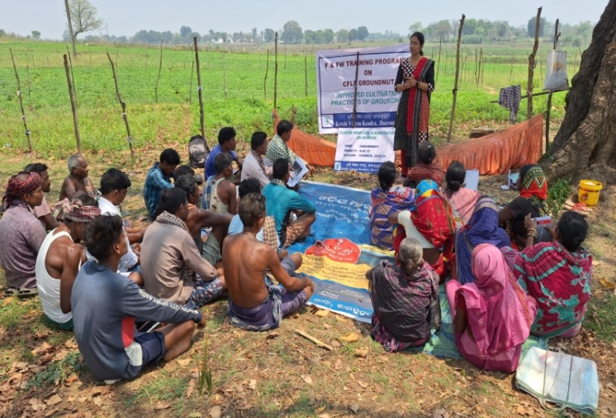 | 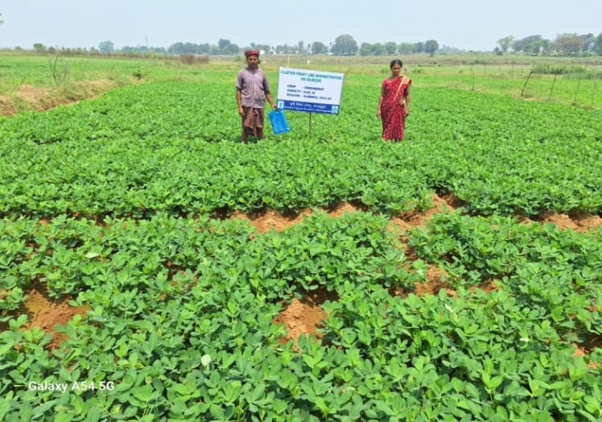
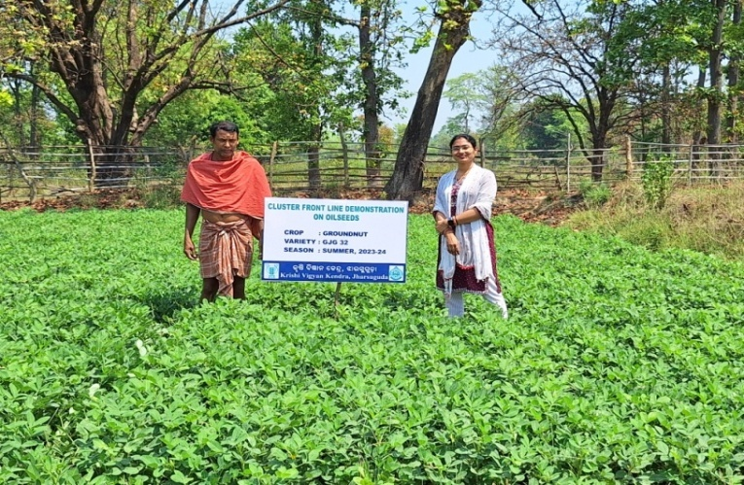 | 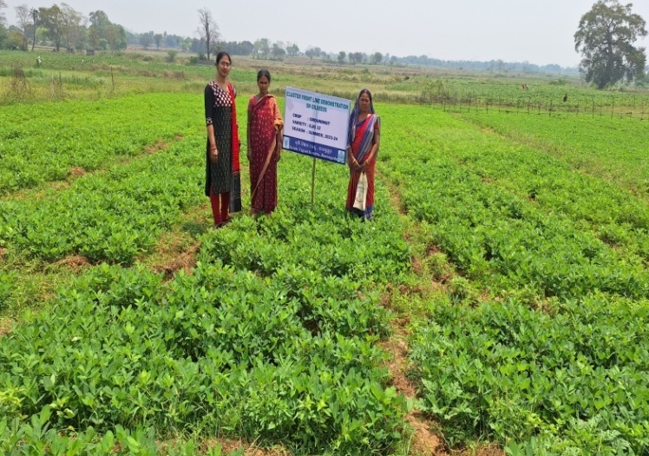
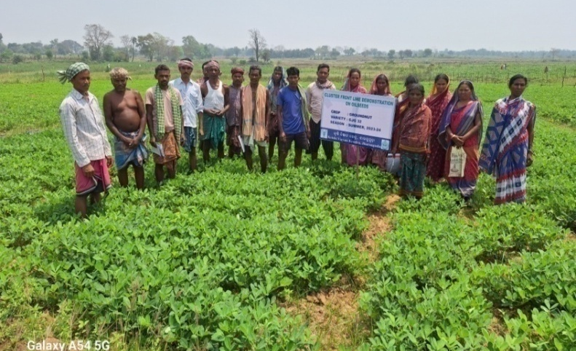 | 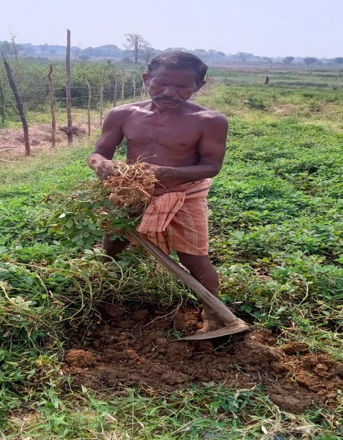

J. Details of budget utilization

Crop  (provide crop wise information ) | Items | Budget  Received  (Rs.) | Budget  Utilization  (Rs.) | Balance  (Rs.)
CFLD Groundnut | i) Critical input |  | 56352/-
CFLD Groundnut | ii) TA/DA/POL etc. for monitoring |  | -
CFLD Groundnut | iii) Extension Activities (Field day) |  | 3648/-
CFLD Groundnut | iv)Publication of literature |  | -
 | Total | 60,000/- | 60,000/- | Nil

  - Achievements on Training (Including the sponsored and FLD training programmes):

- Farmers and farm women (on campus)

Thematic Area | No. of Courses | No. of Participants |  |  |  |  |  |  |  |  |  | Grand Total
Thematic Area | No. of Courses | Other |  |  | SC |  |  |  | ST
 | No. of Courses | M | F | T | M | F |  | T | M | F | T | M | F | T
I. Crop Production
Weed Management
Resource Conservation Technologies
Cropping Systems
Crop Diversification
Integrated Farming
Micro irrigation/irrigation
Seed production
Nursery management
Integrated Crop Management
Soil & water conservation
Integrated nutrient Management
Production of organic inputs
Others
Total
II. Horticulture
a) Vegetable Crops
Production of low volume and high value crops
Off0season vegetables
Nursery raising
Exotic vegetables
Export potential vegetables
Grading and standardization
Protective cultivation
Others
Total (a)
b) Fruits
Training and Pruning
Layout and Management of Orchards
Cultivation of Fruit
Management of young plants/orchards
Rejuvenation of old orchards
Export potential fruits
Micro irrigation systems of orchards
Plant propagation techniques
Others
Total (b)
c) Ornamental Plants
Nursery Management
Management of potted plants
Export potential of ornamental plants
Propagation techniques of Ornamental Plants
Others
Total (c)
d) Plantation crops
Production and Management technology
Processing and value addition
Others
Total (d)
e) Tuber crops
Production and Management technology
Processing and value addition
Others
Total (e)
f) Spices
Production and Management technology
Processing and value addition
Others
Total (f)
g) Medicinal and Aromatic Plants
Nursery management
Production and management technology
Post harvest technology and value addition
Others
Total (g)
Total(a-g)
III. Soil Health and Fertility Management
Soil fertility management
Integrated water management
Integrated Nutrient Management
Production and use of organic inputs
Management of Problematic soils
Micro nutrient deficiency in crops
Nutrient Use Efficiency
Balance Use of fertilizer
Soil & water testing
others
Total
IV. Livestock Production and Management
Dairy Management
Poultry Management
Piggery Management
Rabbit Management
Animal Nutrition Management
Disease Management
Feed & fodder technologies
Production of quality animal products
Others
Total
V. Home Science/Women empowerment
Household food security by kitchen gardening and nutrition gardening
Design and development of low/minimum cost diet
Designing and development for high nutrient efficiency diet
Minimization of nutrient loss in processing
Processing & cooking
Gender mainstreaming through SHGs
Storage loss minimization techniques
Value addition
Women empowerment
Location specific drudgery reduction technologies
Rural Crafts
Women and child care
Others
Total
VI. Agril. Engineering
Farm machinery & its maintenance | 1 | 4 | 5 | 9 | 3 | 9 |  | 12 | 5 | 4 | 9 | 12 | 18 | 30
Installation and maintenance of micro irrigation systems
Use of Plastics in farming practices
Production of small tools and implements
Repair and maintenance of farm machinery and implements
Small scale processing and value addition
Post Harvest Technology
Others
Total | 1 | 4 | 5 | 9 | 3 | 9 |  | 12 | 5 | 4 | 9 | 12 | 18 | 30
VII. Plant Protection
Integrated Pest Management
Integrated Disease Management
Bio0control of pests and diseases
Production of bio control agents and bio pesticides
Others
Total
VIII. Fisheries
Integrated fish farming
Carp breeding and hatchery management
Carp fry and fingerling rearing
Composite fish culture
Hatchery management and culture of freshwater prawn
Breeding and culture of ornamental fishes
Portable plastic carp hatchery
Pen culture of fish and prawn
Shrimp farming
Edible oyster farming
Pearl culture
Fish processing and value addition
Others
Total
IX. Production of Input at site
Seed Production
Planting material production
Bio0agents production
Bio0pesticides production
Bio0fertilizer production
Vermi0compost production
Organic manures production
Production of fry and fingerlings
Production of Bee0colonies and wax sheets
Small tools and implements
Production of livestock feed and fodder
Production of Fish feed
Mushroom production
Apiculture
Others
Total
X. Capacity Building and Group Dynamics
Leadership development
Group dynamics | 1 | 0 | 11 | 11 | 0 |  | 12 | 12 | 0 | 7 | 7 | 0 | 30 | 30
Formation and Management of SHGs
Mobilization of social capital
Entrepreneurial development of farmers/youths | 1 | 0 | 19 | 19 | 00 |  | 3 | 3 | 0 | 8 | 8 | 0 | 30 | 30
WTO and IPR issues
Others | 1 | 1 | 12 | 13 | 2 |  | 1 | 3 | 2 | 12 | 14 | 5 | 25 | 30
Total | 3 | 1 | 42 | 43 | 2 |  | 16 | 18 | 2 | 27 | 29 | 5 | 85 | 90
XI. Agro forestry
Production technologies
Nursery management
Integrated Farming Systems
Others
Total
XII. Others (Pl. Specify)
GRAND TOTAL | 4 | 5 | 47 | 52 | 5 |  | 25 | 30 | 7 | 31 | 38 | 17 | 103 | 120

B) Rural Youth (on campus)

Thematic Area | No. of Courses | No. of Participants |  |  |  |  |  |  |  |  |  | Grand Total
Thematic Area | No. of Courses | Other |  |  | SC |  |  |  | ST
 | No. of Courses | M | F | T | M | F |  | T | M | F | T | M | F | T
Nursery Management of Horticulture crops | 1 | 4 | 14 | 18 | 1 |  | 4 | 5 | 1 | 6 | 7 | 9 | 21 | 30
Training and pruning of orchards
Protected cultivation of vegetable crops
Commercial fruit production
Integrated farming
Seed production
Production of organic inputs | 1 | 0 | 11 | 11 | 0 |  | 11 | 11 | 0 | 8 | 8 | 0 | 30 | 30
Planting material production
Vermiculture
Mushroom Production | 2 | 0 | 28 | 28 | 0 |  | 13 | 13 | 0 | 9 | 9 | 0 | 50 | 50
Beekeeping
Sericulture
Repair and maintenance of farm machinery and implements
Value addition
Small scale processing
Post Harvest Technology
Tailoring and Stitching
Rural Crafts
Production of quality animal products
Dairying
Sheep and goat rearing
Quail farming
Piggery
Rabbit farming
Poultry production
Ornamental fisheries
Composite fish culture
Freshwater prawn culture
Shrimp farming
Pearl culture
Cold water fisheries
Fish harvest and processing technology
Fry and fingerling rearing
Others | 1 | 0 | 4 | 4 | 0 |  | 9 | 9 | 0 | 7 | 7 | 0 | 20 | 20
Total | 5 | 4 | 57 | 61 | 1 |  | 37 | 38 | 1 | 30 | 31 | 9 | 121 | 130

C) Extension Personnel (on campus)

Thematic Area | No. of Courses | No. of Participants |  |  |  |  |  |  |  |  | Grand Total
Thematic Area | No. of Courses | Other |  |  | SC |  |  | ST
 | No. of Courses | M | F | T | M | F | T | M | F | T | M | F | T
Productivity enhancement in field crops
Integrated Pest Management
Integrated Nutrient management
Rejuvenation of old orchards
Protected cultivation technology
Production and use of organic inputs | 1 | 4 | 1 | 5 | 2 | 7 | 9 | 1 | 5 | 6 | 7 | 13 | 20
Care and maintenance of farm machinery and implements
Gender mainstreaming through SHGs
Formation and Management of SHGs
Women and Child care
Low cost and nutrient efficient diet designing
Group Dynamics and farmers organization
Information networking among farmers
Capacity building for ICT application
Management in farm animals
Livestock feed and fodder production
Household food security
Other | 2 | 13 | 79 | 92 | 2 | 14 | 16 | 1 | 11 | 12 | 16 | 104 | 120
Total | 3 | 17 | 80 | 97 | 4 | 21 | 25 | 2 | 16 | 18 | 23 | 117 | 140
D) Farmers and farm women (off campus)

Thematic Area | No. of Courses | No. of Participants |  |  |  |  |  |  |  |  | Grand Total
Thematic Area | No. of Courses | Other |  |  | SC |  |  | ST
 | No. of Courses | M | F | T | M | F | T | M | F | T | M | F | T
I. Crop Production
Weed Management | 1 | 10 | 18 | 28 | 0 | 0 | 0 | 0 | 2 | 2 | 0 | 30 | 30
Resource Conservation Technologies
Cropping Systems | 1 | 0 | 0 | 0 | 11 | 17 | 28 | 0 | 2 | 2 | 11 | 19 | 30
Crop Diversification | 1 | 8 | 7 | 15 | 0 | 1 | 1 | 7 | 7 | 14 | 15 | 15 | 30
Integrated Farming
Micro irrigation/irrigation
Seed production | 2 | 13 | 23 | 36 | 0 | 14 | 14 | 1 | 11 | 12 | 14 | 46 | 60
Nursery management | 2 | 14 | 23 | 37 | 0 | 9 | 9 | 1 | 13 | 14 | 15 | 45 | 60
Integrated Crop Management | 4 | 17 | 56 | 47 | 1 | 4 | 5 | 10 | 32 | 42 | 28 | 92 | 120
Soil & water conservation
Integrated nutrient Management | 3 | 6 | 43 | 49 | 0 | 2 | 2 | 0 | 39 | 39 | 6 | 84 | 90
Production of organic inputs
Others | 2 | 15 | 1 | 16 | 0 | 0 | 0 | 27 | 17 | 42 | 42 | 18 | 60
Total | 16 | 83 | 171 | 228 | 12 | 47 | 59 | 46 | 123 | 167 | 131 | 349 | 480
II. Horticulture
a) Vegetable Crops
Production of low volume and high value crops
Off0season vegetables
Nursery raising | 1 | 1 | 14 | 15 | 1 | 12 | 13 | 1 | 1 | 2 | 3 | 27 | 30
Exotic vegetables
Export potential vegetables
Grading and standardization
Protective cultivation
Others | 3 | 32 | 18 | 50 | 1 | 2 | 3 | 26 | 11 | 37 | 59 | 31 | 90
Total (a) | 4 | 33 | 32 | 65 | 2 | 14 | 16 | 27 | 12 | 39 | 62 | 58 | 120
b) Fruits
Training and Pruning
Layout and Management of Orchards
Cultivation of Fruit
Management of young plants/orchards
Rejuvenation of old orchards
Export potential fruits
Micro irrigation systems of orchards
Plant propagation techniques
Others
Total (b)
c) Ornamental Plants
Nursery Management
Management of potted plants
Export potential of ornamental plants
Propagation techniques of Ornamental Plants
Others
Total (c)
d) Plantation crops
Production and Management technology
Processing and value addition
Others
Total (d)
e) Tuber crops
Production and Management technology
Processing and value addition
Others
Total (e)
f) Spices
Production and Management technology
Processing and value addition
Others
Total (f)
g) Medicinal and Aromatic Plants
Nursery management
Production and management technology
Post harvest technology and value addition
Others
Total (g)
Total(a-g)
III. Soil Health and Fertility Management
Soil fertility management
Integrated water management
Integrated Nutrient Management | 3 | 19 | 37 | 56 | 0 | 11 | 11 | 4 | 19 | 23 | 23 | 67 | 90
Production and use of organic inputs
Management of Problematic soils
Micro nutrient deficiency in crops
Nutrient Use Efficiency
Balance Use of fertilizer
Soil & water testing | 1 | 15 | 8 | 23 | 0 | 0 | 0 | 5 | 2 | 7 | 20 | 10 | 30
others
Total | 4 | 34 | 45 | 79 | 0 | 11 | 11 | 9 | 21 | 30 | 43 | 77 | 120
IV. Livestock Production and Management
Dairy Management
Poultry Management
Piggery Management
Rabbit Management
Animal Nutrition Management
Disease Management
Feed & fodder technologies
Production of quality animal products
Others
Total
V. Home Science/Women empowerment
Household food security by kitchen gardening and nutrition gardening
Design and development of low/minimum cost diet
Designing and development for high nutrient efficiency diet
Minimization of nutrient loss in processing
Processing & cooking
Gender mainstreaming through SHGs
Storage loss minimization techniques
Value addition
Women empowerment
Location specific drudgery reduction technologies
Rural Crafts
Women and child care
Others
Total
VI. Agril. Engineering
Farm machinery & its maintenance
Installation and maintenance of micro irrigation systems | 1 | 2 | 2 | 4 | 15 | 3 | 18 | 4 | 4 | 08 | 21 | 9 | 30
Use of Plastics in farming practices
Production of small tools and implements
Repair and maintenance of farm machinery and implements | 1 | 5 | 3 | 8 | 3 | 7 | 10 | 8 | 4 | 12 | 16 | 14 | 30
Small scale processing and value addition
Post Harvest Technology | 4 | 13 | 25 | 38 | 13 | 53 | 66 | 1 | 15 | 16 | 27 | 93 | 120
Others
Total | 6 | 20 | 30 | 50 | 31 | 63 | 94 | 13 | 23 | 36 | 64 | 116 | 180
VII. Plant Protection
Integrated Pest Management | 2 | 5 | 14 | 19 | 1 | 11 | 12 | 8 | 21 | 29 | 14 | 46 | 60
Integrated Disease Management | 3 | 33 | 39 | 72 | 0 | 4 | 4 | 0 | 14 | 14 | 33 | 57 | 90
Bio0control of pests and diseases
Production of bio control agents and bio pesticides
Others
Total | 5 | 38 | 53 | 91 | 1 | 15 | 16 | 8 | 35 | 43 | 47 | 103 | 150
VIII. Fisheries
Integrated fish farming
Carp breeding and hatchery management
Carp fry and fingerling rearing
Composite fish culture
Hatchery management and culture of freshwater prawn
Breeding and culture of ornamental fishes
Portable plastic carp hatchery
Pen culture of fish and prawn
Shrimp farming
Edible oyster farming
Pearl culture
Fish processing and value addition
Others
Total
IX. Production of Input at site
Seed Production
Planting material production
Bio-agents production
Bio-pesticides production
Bio-fertilizer production
Vermi-compost production
Organic manures production
Production of fry and fingerlings
Production of Bee-colonies and wax sheets
Small tools and implements
Production of livestock feed and fodder
Production of Fish feed
Mushroom production | 1 | 2 | 10 | 12 | 1 | 13 | 14 | 0 | 4 | 4 | 3 | 27 | 30
Apiculture
Others
Total | 1 | 2 | 10 | 12 | 1 | 13 | 14 | 0 | 4 | 4 | 3 | 27 | 30
X. Capacity Building and Group Dynamics
Leadership development
Group dynamics
Formation and Management of SHGs
Mobilization of social capital
Entrepreneurial development of farmers/youths
WTO and IPR issues
Others
Total
XI. Agro forestry
Production technologies
Nursery management
Integrated Farming Systems
Others
Total
XII. Others (Pl. Specify)
GRAND TOTAL | 36 | 210 | 341 | 525 | 47 | 163 | 210 | 103 | 218 | 319 | 350 | 730 | 1080

E)RURAL YOUTH (Off Campus)

Thematic Area | No. of Courses | No. of Participants |  |  |  |  |  |  |  |  |  | Grand Total
Thematic Area | No. of Courses | Other |  |  | SC |  |  |  | ST
 | No. of Courses | M | F | T | M | F |  | T | M | F | T | M | F | T
Nursery Management of Horticulture crops
Training and pruning of orchards
Protected cultivation of vegetable crops
Commercial fruit production
Integrated farming
Seed production
Production of organic inputs
Planting material production
Vermiculture
Mushroom Production
Beekeeping
Sericulture
Repair and maintenance of farm machinery and implements
Value addition
Small scale processing
Post Harvest Technology
Tailoring and Stitching
Rural Crafts
Production of quality animal products
Dairying
Sheep and goat rearing
Quail farming
Piggery
Rabbit farming
Poultry production
Ornamental fisheries
Composite fish culture
Freshwater prawn culture
Shrimp farming
Pearl culture
Cold water fisheries
Fish harvest and processing technology
Fry and fingerling rearing
Others
Total

F) Extension Personnel (Off Campus)

Thematic Area | No. of Courses | No. of Participants |  |  |  |  |  |  |  |  |  | Grand Total
Thematic Area | No. of Courses | Other |  |  | SC |  |  |  | ST
 | No. of Courses | M | F | T | M | F |  | T | M | F | T | M | F | T
Productivity enhancement in field crops
Integrated Pest Management
Integrated Nutrient management
Rejuvenation of old orchards
Protected cultivation technology
Production and use of organic inputs
Care and maintenance of farm machinery and implements
Gender mainstreaming through SHGs
Formation and Management of SHGs
Women and Child care
Low cost and nutrient efficient diet designing
Group Dynamics and farmers organization
Information networking among farmers
Capacity building for ICT application
Management in farm animals
Livestock feed and fodder production
Household food security
Other
Total

G) Consolidated table (ON and OFF Campus)
i. Farmers& Farm Women
Thematic Area | No. of Courses | No. of Participants |  |  |  |  |  |  |  |  | Grand Total
Thematic Area | No. of Courses | Other |  |  | SC |  |  | ST
 | No. of Courses | M | F | T | M | F | T | M | F | T | M | F | T
I. Crop Production
Weed Management | 1 | 10 | 18 | 28 | 0 | 0 | 0 | 0 | 2 | 2 | 0 | 30 | 30
Resource Conservation Technologies
Cropping Systems | 1 | 0 | 0 | 0 | 11 | 17 | 28 | 0 | 2 | 2 | 11 | 19 | 30
Crop Diversification | 1 | 8 | 7 | 15 | 0 | 1 | 1 | 7 | 7 | 14 | 15 | 15 | 30
Integrated Farming
Micro irrigation/irrigation
Seed production | 2 | 13 | 23 | 36 | 0 | 14 | 14 | 1 | 11 | 12 | 14 | 46 | 60
Nursery management | 2 | 14 | 23 | 37 | 0 | 9 | 9 | 1 | 13 | 14 | 15 | 45 | 60
Integrated Crop Management | 4 | 17 | 56 | 47 | 1 | 4 | 5 | 10 | 32 | 42 | 28 | 92 | 120
Soil & water conservation
Integrated nutrient Management | 3 | 6 | 43 | 49 | 0 | 2 | 2 | 0 | 39 | 39 | 6 | 84 | 90
Production of organic inputs
Others | 2 | 15 | 1 | 16 | 0 | 0 | 0 | 27 | 17 | 42 | 42 | 18 | 60
Total | 16 | 83 | 171 | 228 | 12 | 47 | 59 | 46 | 123 | 167 | 131 | 349 | 480
II. Horticulture
a) Vegetable Crops
Production of low volume and high value crops
Off-season vegetables
Nursery raising | 1 | 1 | 14 | 15 | 1 | 12 | 13 | 1 | 1 | 2 | 3 | 27 | 30
Exotic vegetables
Export potential vegetables
Grading and standardization
Protective cultivation
Others | 3 | 32 | 18 | 50 | 1 | 2 | 3 | 26 | 11 | 37 | 59 | 31 | 90
Total (a) | 4 | 33 | 32 | 65 | 2 | 14 | 16 | 27 | 12 | 39 | 62 | 58 | 120
b) Fruits
Training and Pruning
Layout and Management of Orchards
Cultivation of Fruit
Management of young plants/orchards
Rejuvenation of old orchards
Export potential fruits
Micro irrigation systems of orchards
Plant propagation techniques
Others
Total (b)
c) Ornamental Plants
Nursery Management
Management of potted plants
Export potential of ornamental plants
Propagation techniques of Ornamental Plants
Others
Total (c)
d) Plantation crops
Production and Management technology
Processing and value addition
Others
Total (d)
e) Tuber crops
Production and Management technology
Processing and value addition
Others
Total (e)
f) Spices
Production and Management technology
Processing and value addition
Others
Total (f)
g) Medicinal and Aromatic Plants
Nursery management
Production and management technology
Post harvest technology and value addition
Others
Total (g)
Total(a-g)
III. Soil Health and Fertility Management
Soil fertility management
Integrated water management
Integrated Nutrient Management | 3 | 19 | 37 | 56 | 0 | 11 | 11 | 4 | 19 | 23 | 23 | 67 | 90
Production and use of organic inputs
Management of Problematic soils
Micro nutrient deficiency in crops
Nutrient Use Efficiency
Balance Use of fertilizer
Soil & water testing | 1 | 15 | 8 | 23 | 0 | 0 | 0 | 5 | 2 | 7 | 20 | 10 | 30
others
Total | 4 | 34 | 45 | 79 | 0 | 11 | 11 | 9 | 21 | 30 | 43 | 77 | 120
IV. Livestock Production and Management
Dairy Management
Poultry Management
Piggery Management
Rabbit Management
Animal Nutrition Management
Disease Management
Feed & fodder technologies
Production of quality animal products
Others
Total
V. Home Science/Women empowerment
Household food security by kitchen gardening and nutrition gardening
Design and development of low/minimum cost diet
Designing and development for high nutrient efficiency diet
Minimization of nutrient loss in processing
Processing & cooking
Gender mainstreaming through SHGs
Storage loss minimization techniques
Value addition
Women empowerment
Location specific drudgery reduction technologies
Rural Crafts
Women and child care
Others
Total
VI. Agril. Engineering
Farm machinery & its maintenance | 1 | 4 | 5 | 9 | 3 | 9 | 12 | 5 | 4 | 9 | 12 | 18 | 30
Installation and maintenance of micro irrigation systems | 1 | 2 | 2 | 4 | 15 | 3 | 18 | 4 | 4 | 08 | 21 | 9 | 30
Use of Plastics in farming practices
Production of small tools and implements
Repair and maintenance of farm machinery and implements | 1 | 5 | 3 | 8 | 3 | 7 | 10 | 8 | 4 | 12 | 16 | 14 | 30
Small scale processing and value addition
Post Harvest Technology | 4 | 13 | 25 | 38 | 13 | 53 | 66 | 1 | 15 | 16 | 27 | 93 | 120
Others
Total | 7 | 24 | 35 | 59 | 34 | 72 | 106 | 18 | 27 | 45 | 76 | 134 | 210
VII. Plant Protection
Integrated Pest Management | 2 | 5 | 14 | 19 | 1 | 11 | 12 | 8 | 21 | 29 | 14 | 46 | 60
Integrated Disease Management | 3 | 33 | 39 | 72 | 0 | 4 | 4 | 0 | 14 | 14 | 33 | 57 | 90
Bio0control of pests and diseases
Production of bio control agents and bio pesticides
Others
Total | 5 | 38 | 53 | 91 | 1 | 15 | 16 | 8 | 35 | 43 | 47 | 103 | 150
VIII. Fisheries
Integrated fish farming
Carp breeding and hatchery management
Carp fry and fingerling rearing
Composite fish culture
Hatchery management and culture of freshwater prawn
Breeding and culture of ornamental fishes
Portable plastic carp hatchery
Pen culture of fish and prawn
Shrimp farming
Edible oyster farming
Pearl culture
Fish processing and value addition
Others
Total
IX. Production of Input at site
Seed Production
Planting material production
Bio-agents production
Bio-pesticides production
Bio-fertilizer production
Vermi-compost production
Organic manures production
Production of fry and fingerlings
Production of Bee-colonies and wax sheets
Small tools and implements
Production of livestock feed and fodder
Production of Fish feed
Mushroom production | 1 | 2 | 10 | 12 | 1 | 13 | 14 | 0 | 4 | 4 | 3 | 27 | 30
Apiculture
Others
Total | 1 | 2 | 10 | 12 | 1 | 13 | 14 | 0 | 4 | 4 | 3 | 27 | 30
X. Capacity Building and Group Dynamics
Leadership development
Group dynamics | 1 | 0 | 11 | 11 | 0 | 12 | 12 | 0 | 7 | 7 | 0 | 30 | 30
Formation and Management of SHGs
Mobilization of social capital
Entrepreneurial development of farmers/youths | 1 | 0 | 19 | 19 | 00 | 3 | 3 | 0 | 8 | 8 | 0 | 30 | 30
WTO and IPR issues
Others | 1 | 1 | 12 | 13 | 2 | 1 | 3 | 2 | 12 | 14 | 5 | 25 | 30
Total | 3 | 1 | 42 | 43 | 2 | 16 | 18 | 2 | 27 | 29 | 5 | 85 | 90
XI. Agro forestry
Production technologies
Nursery management
Integrated Farming Systems
Others
Total
XII. Others (Pl. Specify)
GRAND TOTAL | 40 | 215 | 388 | 577 | 52 | 188 | 240 | 110 | 249 | 357 | 367 | 833 | 1200

ii. RURAL YOUTH (On and Off Campus)

Thematic Area | No. of Courses | No. of Participants |  |  |  |  |  |  |  |  |  | Grand Total
Thematic Area | No. of Courses | Other |  |  | SC |  |  |  | ST
 | No. of Courses | M | F | T | M | F |  | T | M | F | T | M | F | T
Nursery Management of Horticulture crops | 1 | 4 | 14 | 18 | 1 |  | 4 | 5 | 1 | 6 | 7 | 9 | 21 | 30
Training and pruning of orchards
Protected cultivation of vegetable crops
Commercial fruit production
Integrated farming
Seed production
Production of organic inputs | 1 | 0 | 11 | 11 | 0 |  | 11 | 11 | 0 | 8 | 8 | 0 | 30 | 30
Planting material production
Vermiculture
Mushroom Production | 2 | 0 | 28 | 28 | 0 |  | 13 | 13 | 0 | 9 | 9 | 0 | 50 | 50
Beekeeping
Sericulture
Repair and maintenance of farm machinery and implements
Value addition
Small scale processing
Post Harvest Technology
Tailoring and Stitching
Rural Crafts
Production of quality animal products
Dairying
Sheep and goat rearing
Quail farming
Piggery
Rabbit farming
Poultry production
Ornamental fisheries
Composite fish culture
Freshwater prawn culture
Shrimp farming
Pearl culture
Cold water fisheries
Fish harvest and processing technology
Fry and fingerling rearing
Others | 1 | 0 | 4 | 4 | 0 |  | 9 | 9 | 0 | 7 | 7 | 0 | 20 | 20
Total | 5 | 4 | 57 | 61 | 1 |  | 37 | 38 | 1 | 30 | 31 | 9 | 121 | 130

iii. Extension Personnel (On and Off Campus)

Thematic Area | No. of Courses | No. of Participants |  |  |  |  |  |  |  |  | Grand Total
Thematic Area | No. of Courses | Other |  |  | SC |  |  | ST
 | No. of Courses | M | F | T | M | F | T | M | F | T | M | F | T
Productivity enhancement in field crops
Integrated Pest Management
Integrated Nutrient management
Rejuvenation of old orchards
Protected cultivation technology
Production and use of organic inputs | 1 | 4 | 1 | 5 | 2 | 7 | 9 | 1 | 5 | 6 | 7 | 13 | 20
Care and maintenance of farm machinery and implements
Gender mainstreaming through SHGs
Formation and Management of SHGs
Women and Child care
Low cost and nutrient efficient diet designing
Group Dynamics and farmers organization
Information networking among farmers
Capacity building for ICT application
Management in farm animals
Livestock feed and fodder production
Household food security
Other | 2 | 13 | 79 | 92 | 2 | 14 | 16 | 1 | 11 | 12 | 16 | 104 | 120
Total | 3 | 17 | 80 | 97 | 4 | 21 | 25 | 2 | 16 | 18 | 23 | 117 | 140

Please furnish the details of training programmes as Annexure in the proforma given below
Discipline | Clientele | Title of the training programme | Duration in days | Venue (Off / On Campus) | Number of participants |  |  | Number of SC/ST
 |  |  |  |  | Male | Female | Total | Male | Female | Total
Crop Production | F&FW | Nursery management in rice | 1 | Off | 8 | 22 | 30 | 1 | 13
Crop Production | F&FW | Improved cultivation practices of fingermillet | 1 | Off | 12 | 18 | 30 | 9 | 12 | 21
Crop Production | F&FW | INM in rice | 1 | Off | 0 | 30 | 30 | 0 | 25 | 25
Crop Production | F&FW | Improved cultivation practices of maize | 1 | Off | 2 | 28 | 30 | 2 | 20 | 22
Crop Production | F&FW | IWM in rice | 1 | Off | 10 | 20 | 30 | 0 | 2 | 2
Crop Production | F&FW | Crop rotation and crop diversification | 1 | Off | 15 | 15 | 30 | 7 | 8 | 15
Crop Production | F&FW | Seed treatment and seed inoculation in agril. crops | 1 | Off | 17 | 13 | 30 | 14 | 13 | 27
Crop Production | F&FW | Production technology of sweetcorn | 1 | Off | 0 | 30 | 30 | 0 | 4 | 4
Crop Production | F&FW | INM in mustard | 1 | Off | 6 | 24 | 30 | 0 | 0 | 0
Crop Production | F&FW | Suitable crops for rice-fallow and its management | 1 | Off | 11 | 19 | 30 | 11 | 19 | 30
Crop Production | F&FW | Improved cultivation practices of summer groundnut | 1 | Off | 14 | 16 | 30 | 0 | 0 | 0
Crop Production | F&FW | Oyster mushroom production | 1 | Off | 3 | 27 | 30 | 1 | 17 | 18
Crop Production | F&FW | Nutrient management in greengram and blackgram | 1 | Off | 0 | 30 | 30 | 0 | 16 | 16
Crop Production | F&FW | Soil sample collection and SHC analysis | 1 | Off | 20 | 10 | 30 | 5 | 2 | 7
Crop Production | F&FW | Green manuring | 1 | Off | 25 | 5 | 30 | 13 | 4 | 17
Crop Production | RY | Production and use of organic inputs in crop production | 2 | On | 0 | 30 | 30 | 0 | 19 | 19
Crop Production | RY | Commercial Azolla production | 2 | On | 0 | 20 | 20 | 0 | 16 | 16
Crop Production | RY | Commercial Oyster mushroom production | 2 | On | 0 | 20 | 20 | 0 | 12 | 12
Crop Production | Voc. | Paddy straw mushroom production | 5 | On | 0 | 30 | 30 | 0 | 10 | 10
Agriculture Extension | F&FW | ICT in Agriculture | 1 | On | 5 | 25 | 30 | 4 | 13 | 17
Agriculture Extension | F&FW | Group based input management practices for farmer groups | 1 | On | 0 | 30 | 30 | 0 | 19 | 19
Agriculture Extension | F&FW | Entrepreneurship development & management | 1 | On | 0 | 30 | 30 | 0 | 11 | 11
PlantScience (Seed Sci.) | F&FW | Nursery management in rice | 1 | Off | 7 | 23 | 30 | 0 | 9 | 9
PlantScience (Seed Sci.) | F&FW | Stem Borer and BPH management in rice | 1 | Off | 5 | 25 | 30 | 3 | 16 | 19
PlantScience (Seed Sci.) | F&FW | Management of FAW in Maize | 1 | Off | 9 | 21 | 30 | 6 | 16 | 22
PlantScience (Seed Sci.) | F&FW | Quality enhancement techniques in rice | 1 | Off | 15 | 15 | 30 | 1 | 2 | 3
PlantScience (Seed Sci.) | F&FW | Seed production in rice | 1 | Off | 13 | 17 | 30 | 1 | 3 | 4
PlantScience (Seed Sci.) | F&FW | Rooted seedling raising technique in marigold | 1 | Off | 11 | 19 | 30 | 0 | 5 | 5
PlantScience (Seed Sci.) | F&FW | Nursery management of tomato | 1 | Off | 28 | 2 | 30 | 12 | 1 | 13
PlantScience (Seed Sci.) | F&FW | Seed treatment and use of biofertilizers in pulses | 1 | Off | 0 | 30 | 30 | 0 | 9 | 9
PlantScience (Seed Sci.) | F&FW | Use of Arka vegetable Special in hybrid Tomato | 1 | Off | 8 | 22 | 30 | 3 | 19 | 22
PlantScience (Seed Sci.) | F&FW | Seed treatment and nursery management in brinjal | 1 | Off | 20 | 10 | 30 | 15 | 7 | 22
PlantScience (Seed Sci.) | F&FW | Fruit and shoot borer management in brinjal | 1 | Off | 13 | 17 | 30 | 0 | 4 | 4
Plant Science (Seed Sci.) | F&FW | Scientific method of green gram seed production | 1 | Off | 1 | 29 | 30 | 0 | 22 | 22
Plant Science (Seed Sci.) | F&FW | Precautionary measures and management of black tip in mango | 1 | Off | 20 | 10 | 30 | 0 | 0 | 0
Plant Science (Seed Sci.) | F&FW | storage grain pest management in green gram | 1 | Off | 9 | 21 | 30 | 3 | 13 | 16
Plant Science (Seed Sci.) | F&FW | Post-Harvest Management of groundnut | 1 | Off | 7 | 23 | 30 | 2 | 6 | 8
PlantScience (Seed Sci.) | Voc | Quality planting materials & seedling production | 5 | On | 9 | 21 | 30 | 2 | 10 | 12
PlantScience (Seed Sci.) | IS | Natural farming for sustainable agriculture | 1 | On | 9 | 11 | 20 | 3 | 3 | 6
PlantScience (Seed Sci.) | IS | Workshop FPO | 1 | On | 7 | 93 | 100 | 0 | 22 | 22
Ag. Eng. | F&FW | Use of Small tools & implements for drudgery reduction of farm women | 1 | Off | 7 | 23 | 30 | 0 | 8 | 8
Ag. Eng. | F&FW | Different line sowing implements for cereal and pulses | 1 | Off | 14 | 16 | 30 | 11 | 12 | 23
Ag. Eng. | F&FW | Use of different weeders in rice | 1 | Off | 16 | 14 | 30 | 1 | 1 | 2
Ag. Eng. | F&FW | Use of solar energy in agril | 1 | Off | 4 | 26 | 30 | 2 | 12 | 14
Ag. Eng. | F&FW | Use of different sprayers and dusters | 1 | On | 1 | 29 | 30 | 1 | 17 | 18
Ag. Eng. | F&FW | Utility of micro irrigation | 1 | Off | 17 | 13 | 30 | 5 | 13 | 18
Ag. Eng. | F&FW | Value addition of fruits and vegetables | 1 | Off | 17 | 13 | 30 | 16 | 11 | 27

H) Vocational training programmes for Rural Youth

a) Details of training programmes for Rural Youth
Crop / Enterprise | Identified Thrust Area | Training title* | Duration (days) | No. of Participants |  |  | Self employed after training |  |  | Number of persons employed else where
 |  |  |  | Male | Female | Total | Type of units | Number  of units | Number of persons employed
Mushroom prouction | IGA | Commercial Production of Paddy straw mushroom | 5 | 0 | 30 | 30 | Mushroom unit | 8 | 29
QPM | IGA | Quality planting materials & seedling production | 5 | 9 | 21 | 30 | QPM | 5 | 9
*training title should specify the major technology /skill transferred
b) Details of participation
Thematic Area | No. of Courses | No. of Participants |  |  |  |  |  |  |  |  | Grand Total
Thematic Area | No. of Courses | Other |  |  | SC |  |  | ST
 | No. of Courses | M | F | T | M | F | T | M | F | T | M | F |  | T
Crop production and management
Commercial floriculture
Commercial fruit production
Commercial vegetable production
Integrated crop management
Organic farming
Other
Total
Post harvest technology and value addition
Value addition
Other
Total
Livestock and fisheries
Dairy farming
Composite fish culture
Sheep and goat rearing
Piggery
Poultry farming
Other
Total
Income generation activities
Vermicomposting
Production of bioagents, biopesticides,
biofertilizers etc.
Repair and maintenance of farm machinery &imlements
Rural Crafts
Seed production
Sericulture
Mushroom cultivation | 1 | 0 | 20 | 20 | 0 | 3 | 3 | 0 | 7 | 7 | 0 |  | 30 | 30
Nursery, grafting etc.
Tailoring, stitching, embroidery, dying etc.
Agril. Para-workers, para-vet training
Other
Total
Agricultural Extension
Capacity building and group dynamics
Other
Total
Grand Total

I) Sponsored Training Programmes
a) Details of Sponsored Training Programme
Sl.No | Title | Thematic area | Month | Duration (days) | Client | No. of courses | No. of participants | Sponsoring Agency
Sl.No | Title | Thematic area |  |  | PF/RY/EF | No. of courses | No. of participants | Sponsoring Agency
 | Paddy straw mushroom production | Income generation activities | July | 5 | PF/RY | 1 | 20 | OMBADC, Govt. of Odisha
 | Nursery Raising of vegetables | Nursery raising | July | 5 | PF/RY | 2 | 40 | OMBADC, Govt. of Odisha
 | Poultry Farming for Meat Production | Poultry farming | Aug | 4 | EF | 1 | 20 | OMBADC, Govt. of Odisha
 | Vermicompost Production | Income generation activities | Aug | 4 | EF | 1 | 20 | OMBADC, Govt. of Odisha
 | Poultry Farming | Poultry farming | Sept | 5 | PF/RY | 1 | 20 | OMBADC, Govt. of Odisha
 | Mushroom spawn production | Income generation activities | Sept | 5 | PF/RY | 1 | 20 | OMBADC, Govt. of Odisha
 | Vermicompost Production | Income generation activities | Oct., Jan | 5 | PF/RY | 2 | 40 | OMBADC, Govt. of Odisha
 | Mushroom production for sustainable enterprise | Income generation activities | Nov | 4 | EF | 1 | 20 | OMBADC, Govt. of Odisha
 | Scientific Bee Keeping | Apiculture | Oct., Feb | 5 | PF/RY | 2 | 40 | OMBADC, Govt. of Odisha
 | Use & operation of farm implements / machineries | Farm mechanisation | Dec | 5 | PF/RY | 1 | 20 | OMBADC, Govt. of Odisha
 | Coimmercial oyster mushroom production | Income generation activities | Dec | 5 | PF/RY | 1 | 20 | OMBADC, Govt. of Odisha
 | Scientific Bee Keeping | Apiculture | Jan | 4 | EF | 1 | 20 | OMBADC, Govt. of Odisha
 | Biofloc fish production | Pisciculture | Jan | 5 | PF/RY | 1 | 20 | OMBADC, Govt. of Odisha

b) Details of participation

Thematic Area | No. of Courses | No. of Participants |  |  |  |  |  |  |  |  | Grand Total
Thematic Area | No. of Courses | Other |  |  | SC |  |  | ST
 | No. of Courses | M | F | T | M | F | T | M | F | T | M | F |  | T
Crop production and management
Increasing production and productivity of crops
Commercial production of vegetables
Production and value addition
Fruit Plants
Ornamental plants
Spices crops
Soil health and fertility management
Production of Inputs at site
Methods of protective cultivation
Other
Total
Post harvest technology and value addition
Processing and value addition
Other
Total
Farm machinery
Farm machinery, tools and implements
Other
Total
Livestock and fisheries
Livestock production and management
Animal Nutrition Management
Animal Disease Management
Fisheries Nutrition
Fisheries Management
Other
Total
Home Science
Household nutritional security
Economic empowerment of women
Drudgery reduction of women
Other
Total
Agricultural Extension
Capacity Building and Group Dynamics
Other
Total
Grant Total
Good quality photographs of training activity:

3.4. A. Extension Activities (including activities of FLD programmes)
Nature of Extension Activity | No. of activities | Farmers |  |  |  | Extension Officials |  |  | Total
Nature of Extension Activity | No. of activities | M | F | T | SC/ ST  (% of total) | Male | Female | Total | Male | Female | Total
Field Day | 5 | 74 | 86 | 160 | 45 | 3 | 1 | 4 | 77 | 87 | 164
Kisan Mela | 2 | 213 | 189 | 402 | 30 | 17 | 9 | 26 | 230 | 198 | 428
Kisan Ghosthi | 1 | 112 | 89 | 201 | 22 | 11 | 8 | 19 | 120 | 108 | 228
Exhibition | 5 | 1194 | 1171 | 2365 | 34 | 32 | 17 | 49 | 1226 | 1188 | 2414
Film Show | 6 | 108 | 75 | 185 | 10 | 10 | 5 | 15 | 118 | 80 | 198
Method Demonstrations | 24 | 345 | 375 | 720 | 51 | 21 | 12 | 33 | 366 | 387 | 753
Farmers Seminar | 1 | 32 | 68 | 100 | 20 | 6 | 5 | 11 | 38 | 79 | 111
Workshop | 3 | 123 | 61 | 184 | 17 | 24 | 12 | 36 | 147 | 73 | 220
Group meetings | 20 | 252 | 83 | 335 | 14 | 34 | 13 | 47 | 286 | 96 | 382
Lectures delivered as resource persons | 34 | 395 | 213 | 608 | 35 | 51 | 23 | 74 | 446 | 236 | 682
Advisory Services | 30 | 20524 | 6072 | 26596 | 12 | 214 | 110 | 324 | 20738 | 6182 | 26920
Scientific visit to farmers field | 46 | 438 | 183 | 621 | 13 | 24 | 9 | 33 | 462 | 192 | 654
Farmers visit to KVK | 54 | 147 | 132 | 279 | 10 | 18 | 12 | 30 | 165 | 144 | 309
Diagnostic visits | 17 | 132 | 93 | 225 | 8 | 18 | 7 | 25 | 150 | 100 | 250
Exposure visits | 16 | 106 | 214 | 320 | 23 | 7 | 17 | 18 | 113 | 231 | 344
Ex-trainees Sammelan | 0 | 0 | 0 | 0 | 0 | 0 | 0 | 0 | 0 | 0 | 0
Soil health Camp | 0 | 0 | 0 | 0 | 0 | 0 | 0 | 0 | 0 | 0 | 0
Animal Health Camp | 0 | 0 | 0 | 0 | 0 | 0 | 0 | 0 | 0 | 0 | 0
Agri mobile clinic | 0 | 0 | 0 | 0 | 0 | 0 | 0 | 0 | 0 | 0 | 0
Soil test campaigns | 0 | 0 | 0 | 0 | 0 | 0 | 0 | 0 | 0 | 0 | 0
Farm Science Club Conveners meet | 0 | 0 | 0 | 0 | 0 | 0 | 0 | 0 | 0 | 0 | 0
Self Help Group Conveners meetings | 0 | 0 | 0 | 0 | 0 | 0 | 0 | 0 | 0 | 0 | 0
MahilaMandals Conveners meetings | 0 | 0 | 0 | 0 | 0 | 0 | 0 | 0 | 0 | 0 | 0
Celebration of important days ( International Womens Day, Vanomahostav, University Foundation Day, World Food Day, Mahila Kisan Diwas , World Soil Day, Agriculture Extension day, KissanDiwas, PM Kisan Samman Sammelan) | 16 | 398 | 448 | 846 | 42 | 28 | 35 | 63 | 426 | 483 | 909
Sankalp Se Siddhi | 0 | 0 | 0 | 0 | 0 | 0 | 0 | 0 | 0 | 0 | 0
Swatchta Hi Sewa | 23 | 213 | 427 | 640 | 37 | 8 | 14 | 22 | 221 | 449 | 670
MahilaKisan Divas | 1 | 0 | 30 | 30 | 5 | 2 | 1 | 3 | 2 | 33 | 35
Any Other (Specify)
Total | 304 | 24806 | 10009 | 34817 | 428 | 528 | 310 | 832 | 25331 | 10346 | 35671

B. Other Extension activities
Nature of Extension Activity | No. of activities
Newspaper coverage | 5
Radio talks | 3
TV talks | 0
Popular articles | 7
Extension Literature | 5
Other, if any

Good quality photographs of Extension activity:

3.5 a. Production and supply of Technological products

Village seed

Crop | Variety | Quantity of seed  (q) | Value  (Rs) | No. of farmers involved in village seed production | Number of farmers  to whom seed provided
 |  |  |  |  | SC |  | ST |  | Other |  | Total
 |  |  |  |  | M | F | M | F | M | F | M | F
Total

KVK farm

Crop | Variety | Quantity of seed  (q) | Value  (Rs) | Number of farmers  to whom seed provided
 |  |  |  | SC |  | ST |  | Other |  | Total
 |  |  |  | M | F | M | F | M | F | M | F
Dhaincha | Local | 1.2 | 9360 | 2 | 1 | 0 | 0 | 4 | 2 | 6 | 3
Grand Total |  | 1.2 | 9360 | 2 | 1 | 0 | 0 | 4 | 2 | 6 | 3
Good quality photographs of seed production:

Production of planting materials by the KVKs

Crop | Variety | No. of planting materials | Value  (Rs) | Number of farmers  to whom planting material provided
 |  |  |  | SC |  | ST |  | Other |  | Total
 |  |  |  | M | F | M | F | M | F | M | F
Vegetable seedlings
Cauliflower |  | 254 | 635 | 5 | 1 | 0 | 0 | 4 | 1 | 9 | 2
Cabbage |  | 258 | 645 | 2 | 0 | 4 | 2 | 1 | 0 | 7 | 2
Tomato |  | 14524 | 36310 | 11 | 8 | 5 | 7 | 4 | 9 | 20 | 24
Brinjal |  | 6398 | 9597 | 9 | 0 | 4 | 2 | 14 | 3 | 27 | 5
Chilli |  | 1462 | 3655 | 0 | 2 | 4 | 5 | 7 | 5 | 11 | 12
Onion |  | 0 | 0 |  |  |  |  |  |  | 0 | 0
Others |  | 10091 | 20182 | 5 | 1 | 0 | 4 | 7 | 0 | 12 | 5
Fruits
Mango
Guava
Lime
Papaya |  | 59 | 1475 | 1 | 0 | 4 | 0 | 1 | 0 | 6 | 0
Banana |  | 0 |  |  |  |  |  |  |  | 0 | 0
Others |  | 70 | 1050 | 0 | 4 | 2 | 1 | 5 | 1 | 7 | 6
Ornamental plants
Medicinal and Aromatic
Plantation
Spices
Turmeric
Tuber
Elephant yams
Fodder crop saplings
Forest Species
Others, pl.specify
Total |  | 33116 | 73549 | 33 | 16 | 23 | 21 | 43 | 19 | 99 | 56
Good quality photographs of planting materials:

Production of Bio-Products

Name of product | Quantity | Value (Rs.) | No. of Farmers benefitted
Name of product | Kg | Value (Rs.)
 |  |  | SC |  | ST |  | Other |  | Total
 |  |  | M | F | M | F | M | F | M | F
Bio-fertilizers
Bio-pesticide
Bio-fungicide
Bio-agents
Others, please specify. (Vermicompost) | 777 | 15540 | 4 | 8 | 1 | 2 | 1 | 4 | 6 | 14
Total |  |  | 4 | 8 | 1 | 2 | 1 | 4 | 6 | 14

Good quality photographs of bio-products:

Production of livestock materials
Particulars of Live stock | Name of the breed | Number | Value (Rs.) | No. of Farmers benefitted
 |  |  |  | SC |  | ST |  | Other |  | Total
 |  |  |  | M | F | M | F | M | F | M | F
Dairy animals
Cows
Buffaloes
Calves
Others (Pl. specify)
Small ruminants
Sheep
Goat
Other, please specify
Poultry
Broilers
Layers
Duals (broiler and layer)
Japanese Quail
Turkey
Emu
Ducks
Others (Pl. specify)
Piggery
Piglet
Hog
Others (Pl. specify)
Fisheries
Indian carp
Exotic carp
Mixed carp
Fish fingerlings
Spawn
Others (Pl. specify)
Grand Total
Good quality photographs of livestock and fisheries:

3.5. b. Seed Hub Programme-“Creation of Seed Hubs for Increasing Indigenous Production of Pulses in India”
i) Name of Seed Hub Centre:

Name of Nodal Officer :
Address :
e-mail :
Phone No. :
Mobile :

ii) Quality Seed Production Reports
Season | Crop | Variety | Production (q)
Season | Crop | Variety | Target | Area sown (ha) | Production | Category of Seed  (F/S, C/S)
Kharif 2023
Rabi 2021-22
Summer/Spring 2023
Kharif 2023
Rabi 2022-2023

iii) Financial Progress
Fund received  (2020-21, 2021-22, 2022-23 and 2023-24) | Expenditure (Rs. in lakhs) |  | Unspent balance  (Rs. in lakhs) | Remarks
Fund received  (2020-21, 2021-22, 2022-23 and 2023-24) | Infrastructure | Revolving fund | Unspent balance  (Rs. in lakhs) | Remarks
2020-21
2021-22
2022-23
2023-24

iv) Infrastructure Development

Item | Progress
Seed processing unit
Seed storage structure

3.6. (A) Literature Developed/Published (with full title, author & reference)

Item | Title | Author’s name | Number | Circulation
Research paper | Induced Resistance Mechanism in Plant and Its Importance in Agriculture | Rai, Anuj Kumar, Laxmi Priya Sahoo, Monalisha Sahoo, Tania Seth, and Chakradhar Patra
 | Yield gap analysis of Nizer  (Guizotia abyssinica ,L) in  North Eastern Ghat Zone of  Odisha | S. R. Dash,  N. Bar,  M. Bhol,  B. R. Pattanaik, &amp;  S. Panda
 | Impact of Hasanta Rice on Yield  and Brown Plant Hopper  Incidence in Rain-Fed Semi-  Lowland Ecosystems: A  Farmer-Centric Study | Rai, A. K., S. Panda, T.C.  Panda, S. R. Dash, P.J.  Mishra, A. Phonglosa, and  C. Patra.
 | Plant Growth and Yield  Dynamics in Tomato  Cultivation: Insights from Front  Line Demonstrations | Rai, A. K., S. Panda, T.C.  Panda, P.J. Mishra, A.  Phonglosa, and A. Rai.
Seminar/conference/ symposia papers
Books
Bulletins
News letter | Sabujima | Dr. Samir Ranjan Dash, Dr. Anuj Ku. Rai, Ms. Susmita Panda | 500 | 500
Popular Articles
Book Chapter
Extension Pamphlets/ literature | Azolla farminmg | Dr. Samir Ranjan Dash, Dr. Anuj Ku. Rai, Ms. Susmita Panda | 500 | 500
 | Oyster mushroom production | Dr. Samir Ranjan Dash,,Ms. Susmita Panda | 500 | 500
 | Scientific mustard cultivation | Dr. Samir Ranjan Dash,,Ms. Susmita Panda, Dr. Anuj Ku. Rai, | 500 | 500
 | Improved cultivation practices of groundnut | Dr. Samir Ranjan Dash,,Ms. Susmita Panda, Dr. Anuj Ku. Rai, Dr. Tarak Ch. Panda | 500 | 500
Technical reports
Electronic Publication (CD/DVD etc.)
TOTAL |  |  | 2500 | 2500

N.B.: Please enclose a copy of each. In case of literature prepared in local language please indicate the title in English

(B) Details of HRD programmes undergone by KVK personnel:

Sl. No. | Name of programme | Name of course | Name of KVK personnel and designation | Date and Duration | Organized by
1. | Refresher training prog. |  | Mrs. Susmita Panda, SMS (Agro) | 12.02.2024 & 13.02.2024 (2 days) | DEE, OUAT, BBSR
2.
3.
4.
5.
6.
7.

3.7. Success stories/Case studies, if any (two or three pages write-up on 1-2best case(s) with suitable action photographs)
Name of farmer | Mr. Saroj Sahu
Address | Village : Tharkashpur  GP : Loisingh  Block : Jharsuguda
Contact details (Phone, mobile, email Id) | Mob. No.- 7683967227
Landholding (in ha.) | 3.5 ha
Name and description of the farm/ enterprise | Vegetable Nursery  Cultivation of field crops and Vegetables.
Economic impact | His annual Income from Agriculture and allied sector is around 6-7 lakhs.
Social impact | Mr. Saroj Sahu is president of Dibyashakti Farmers Club and working for upliftment of farmers community of his locality.
Awards and Recognition | - Best vegetable chasi from Horticulture Dept..in 2022  - Best Farmer Award , OUAT Farmers Fair 2025
Horizontal/ Vertical spread | He is sharing his knowledge and experience on agricultural practices with farmers of nearby 5-6 villages.
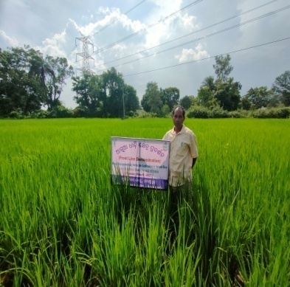 | 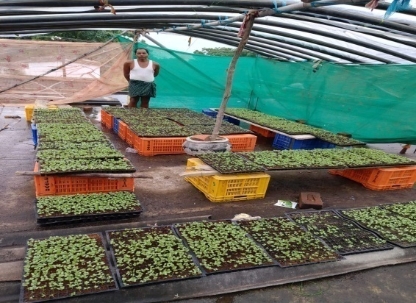
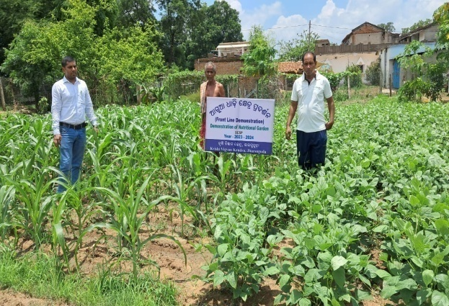 | 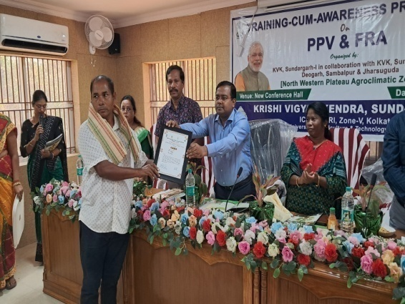

Mr. Saroj Sahu is a progressive farmer of KVK adopted village Tharkaspur of Jharsuguda district. Round the year he is growing various crops like rice, maize, mustard, sesamum and vegetables. By adopting improved technologies shared by KVK, SarojSahu has increased his farm profits. As a result, he now has a higher economic status, enabling him to provide better educational opportunities for his children. He participated in Skill development training program on nursery raising of vegetables for QPM production and now he has started his own Vegetable nursery where he is growing vegetable seedlings for his own farm as well as for farmers of nearby villages.

3.8. Give details of innovative methodology or innovative technology of Transfer of Technology developed and used during the year

Sl. No. | Name/ Title of the technology | Name/ Details of the Innovator(s) | Brief details of the Innovative Technology

3.9. a. Give details of indigenous technology practiced by the farmers in the KVK operational area which can be considered for technology development (in detail with suitable photographs)

Sl. No. | Crop / Enterprise | ITK Practiced | Purpose of ITK
1 | Cattle | Herbal treatment using turmeric Bahada and Camphor paste | Treatment of FMD
2 | Poultry | Use of Neem and Turmeric paste | Treatment of fowl pox

b. Give details of organic farming practiced by the farmer

Sl. No. | Crop / Enterprise | Area (ha)/ No. covered | Production | No. of farmers involved | Market available (Y/N)
 | Vegetable & Fruits | 81 | 13000 q | 265 | Y

3.10. Indicate the specific training need analysis tools/methodology followed by KVKs

Sl. No. | Brief details of the tool/ methodology followed | Purpose for which the tool was followed
- PRA method | Identification of problems, problem analysis, Database formation and primary data collection. | - PRA method
- Farmers interaction and group discussion | Verification of the problem and prioritization of the problem | - Farmers interaction and group discussion
- Training need assessment | Technological gap analysis, need based problem identification | - Training need assessment

3.11. a. Details of equipment available inSoiland Water Testing Laboratory

Sl. No | Name of the Equipment | Qty.
1 | Automatic Nitrogen Analyzer with digestion unit | 1
2 | MridaParikshak soil testing kit | 2
3 | Precision Analytical Balance | 1
4 | pH, EC, TDS meter | 1
5 | Digital soil moisture meter | 1
6 | Digital balance | 1
7 | Flame Photometer | 1
8 | Spectro Photometer | 1
9 | Double distillation unit | 1
10 | DAPS power supply | 1
11 | Rotary Shaker | 1
12 | GPS set | 1

3.11.b. Details of samples analyzed so far :
Number of soil samples analyzed |  |  | No. of Farmers | No. of Villages | Amount realized  (in Rs.)
Through mini soil testing kit/labs | Through soil testing laboratory | Total
100 | 0 | 100 | 485 | 7

3.11.c. Details onWorld Soil Day

Sl.  No. | Activity | No. of Participants | No. of VIPs | Name (s) of VIP(s) | Number of Soil Health Cards distributed | No. of farmers benefitted
1 | Farmers –Scientist Interaction | 100 | 1 | ADM, Jharsguda | 60 | 325

3.12. Activities of rain water harvesting structure and micro irrigation system

No of training programme | No of demonstrations | No of plant material produced | Visit by the farmers | Visit by the officials
3  Awareness and Training Programme | 1 | _ | 74 | 7

3.13. Technology week celebration

Type of activities | No. of activities | Number of participants | Related crop/livestock technology

3.14. RAWE/ FETprogramme - is KVK involved? (Y/N)

No of student trained | No of days stayed

ARS trainees trained | No of days stayed

3.15. List of VIP visitors (Minister/ MP/MLA/DM/VC/ZilaSabhadipati/Other Head of Organization/Foreigners)

Date | Name of the person | Purpose of visit
5.11.2024 | Dr. AvijitHalder, Principal Scientist , ICAR-ATARI, Kolkata, Zone V | Visited KVK Jharsuguda

- IMPACT

  - Impact of KVK activities (Not to be restricted for reporting period).

Name of specific technology/skill transferred | No. of participants | % of adoption | Change in income (Rs.)
Name of specific technology/skill transferred | No. of participants | % of adoption | Before (Rs./Unit) | After (Rs./Unit)
Improved method of Groundnut cultivation with HYV- Kadiri Lepakshi | 45 | 70 | 40000 | 50200
Drought tolerant paddy variety Sahabhagidhan | 60 | 62 | 17500 | 24000
Improved method of Greengram cultivation with HYV. | 50 | 64 | 24000 | 32000
Weed management in paddy | 30 | 80 | 19000 | 23000
Sweetcorn cultivation variety –Sugar 75 | 70 | 65 | 25000 | 85000
Backyard Poultry rearing | 80 | 45 | 380/bird | 650/bird
Mushroom production techniques | 90 | 55 | 150/bed | 220/bed
Stress tolerant Poultry rearing –Kadaknath | 70 | 65 | 280/bird | 450/bird
Cultivation of BM-2 Marigold | 60 | 62 | 170000 | 240000

NB: Should be based on actual study, questionnaire/group discussion etc. with ex-participants

4.2. Cases of large scale adoption
(Please furnish detailed information for each case)
Horizontal spread of technologies
Technology | Horizontal spread
Drought tolerant paddy variety Sahabhagidhan | 520 ha
Herbicide application in Rice | 1250 ha
BPH management in Rice | 218 ha
Millet Cultivation variety-Arjun | 60 ha
Sweetcorn cultivation | 82 ha
Cultivation of marigold variety BM-2 | 8 ha
Backyard Poultry rearing –Kadaknath | 25 villages
Nutrient management in Groundnut | 108 ha
YMV resistant greengram cultivation | 250 ha
Mushroom Cultivation | 17 village

4.3.Details of impact analysis of KVK activities carried out during the reporting period

Sl. No. | Brief details of technology | Impact of the technology in subjective terms | Impact of the technology in objective terms
1 | Herbicide application in Rice | Adoption percentage- 80%, Horizontal spread-12000 ha | Yield -46 q/ha
2 | Stress tolerant poultry breed Kadaknath | Adoption percentage- 50%, Horizontal spread-12 units
3 | Oyster mushroom production using crumpled straw | Adoption percentage- 60%, Horizontal spread-15 units

4.4. Details of innovations recorded by the KVK

Thematic area | Agriculture Engineering
Name of the Innovation | Power tiller operated Paddy Thresher
Details of Innovator | Name of farmer: SushantaNaik  Address: Ghantamal, PO-Jhirlapalli, Block- Kolabira,  Dist- Jharsuguda, Contact No.:9777468457  Age-62 Years, Education-Matriculate, Land Holding-5.0 acre.
Back ground of innovation | Threshing of paddy is expensive by using paddy combine harvester and dependent on availability of harvester in time.
Technology details | Power tiller operated Paddy Thresher is made up of wood, which is on an average weight of 3.0 qntl. and drawn by power tiller for threshing of paddy.
Practical utility of innovation | It can be made with local available materials , simple and easy to operate.

4.5. Details of entrepreneurship development

Entrepreneurship development
Name of the enterprise
Name & complete address of the entrepreneur
Role of KVK with quantitative data support:

Timeline of the entrepreneurship development

Technical Components of the Enterprise

Status of entrepreneur before and after the enterprise
Present working condition of enterprise in terms of raw materials availability, labour availability, consumer preference, marketing the product etc. ( Economic viability of the enterprise):
Horizontal spread of enterprise

4.6. Any other initiative taken by the KVK

5. LINKAGES
5.1. Functional linkage with different organizations
Name of organization | Nature of linkage
Regional Research & Technology Transfer Station, Chiplima, Sambalpur | Agro Inputs and Technical assistance
Central Horticultural Experiment station, Bhubaneswar | Resource person, Technology and technical assistance, Agro Input supply
Central Tuber Crop Research Institute, Bhubaneswar | Programme implementation ,convergence mode action , resource person, technical assistance, funding agency, input supply
National Rice Research Institute, Cuttack | Programme implementation, Resource person, technical assistance, funding agency, input supply
Department of Agriculture, Jharsuguda | Programme implementation , convergence mode action ,Resource person, technical assistance, funding agency, input supply
Department of Horticulture, Jharsuguda | Programme implementation , convergence mode action ,Resource person, technical assistance and assistance in infrastructure development
Department of Fishery, Jharsuguda | Programme implementation , convergence mode action , Resource person, technical assistance, Agro input supply
Watershed Development, Jharsuguda | Agro Input supply, seed certification, procurement of seed.
Animal Resource department, Jharsuguda | Supply of farm implements, Agro inputs.
Odisha State seed corporation, Bargarh | Farmers club formation, Resource person,
Odisha Agro Industries corporation, Jharsuguda | Suggestion in formation of technical programmes, Crop insurance.
NABARD, Sundergarh | Agro Input supply, convergence mode action
Lead bank, SBI, Jharsuguda | Resource person, Technical assistance for capacity building
SEWA, Kolabira, (NGOs) | Programme implementation, convergence mode action, Resource person, Technical guidance
AJKA,Lakhanpur, Jharsuguda | Resource person and technical guidance

5.2. List of special programmes undertaken during 2024by the KVK, which have been financed by ATMA/ Central Govt/ State Govt./NABARD/NHM/NFDB/Other Agencies (information of previous years should not be provided)

a) Programmes for infrastructure development

Name of the programme/scheme | Purpose of programme | Date/ Month of initiation | Funding agency | Amount (Rs.)
CBSAE/OMBADC, Govt. of Odisha | - Skill Development  - Establishment of Agri-Enterprise at KVK | December 2022 | CBSAE/OMBADC, Govt. of Odisha | 83.0 lakh
(b) Programme for other activities (training, FLD,OFT, Mela, Exhibition etc.)

Name of the programme/scheme | Purpose of programme | Date/ Month of initiation | Funding agency | Amount (Rs.)
CBSAE/OMBADC, Govt. of Odisha | Capacity Building | December 2022 | CBSAE/OMBADC, Govt. of Odisha

- PERFORMANCE OF INFRASTRUCTURE IN KVK

6.1. Performance of demonstration units (other than instructional farm)

Sl. No. | Name of demo Unit | Year of estt. | Area(Sq.mt) | Details of production |  |  | Amount (Rs.) |  | Remarks
 |  |  |  | Variety/breed | Produce | Qty. | Cost of inputs | Gross income | Remarks
1. | Poly House | 2013 | 120 | HYV & Local | Seedling & saplings | 100000 | 30000 | 120000 | Distributed to farmers
2.
3.
4.
5.
6.
7.
 | Total

6.2. Performance of Instructional Farm (Crops)
Name  Of the crop | Date of sowing | Date of harvest | Area (ha) | Details of production |  |  | Amount (Rs.) |  | Remarks
 |  | Date of harvest | Area (ha) | Variety | Type of Produce | Qty.(q) | Cost of inputs | Gross income | Remarks

  - Performance of Production Units (bio-agents / bio-pesticides/ bio-fertilizers etc.,)

Sl.  No. | Name of the Product | Qty. (Kg) | Amount (Rs.) |  | Remarks
Sl.  No. | Name of the Product | Qty. (Kg) | Cost of inputs | Gross income | Remarks
1. | Vermicompost | 1000 | 8000 | 22000 | Distributed to farmers

  - Performance of instructional farm (livestock and fisheries production)

Sl.  No | Name  of the animal / bird / aquatics | Details of production |  |  | Amount (Rs.) |  | Remarks
Sl.  No | Name  of the animal / bird / aquatics | Breed | Type of Produce | Qty. | Cost of inputs | Gross income | Remarks
1.
2.
3.

  - Utilization of hostel facilities

Accommodation available (No. of beds)

Months | No. of trainees stayed | Trainee days  (days stayed) | Reason for short fall (if any)
Feb, 2024 | 20 | 5
July, 2024 | 20 | 5
July, 2024 | 20 | 5
Aug, 2024 | 20 | 5
Aug, 2024 | 20 | 5
Sept, 2024 | 20 | 5
Sept, 2024 | 20 | 5
Oct. , 2024 | 20 | 5
Nov, 2024 | 20 | 5
Oct, 2024 | 20 | 5
Dec, 2024 | 20 | 5
Dec, 2024 | 20 | 5
Total : | 240 | 60
(For whole of the year)

  - Utilization of staff quarters

Whether staff quarters has been completed:

No. of staffquarters: 06

Date of completion:2012

Occupancy details:
Months | Q I | QII | Q III | QIV | Q V | QVI*
January | √ | - | - | √ | √
February | √ | - | - | √ | √
March | √ | - | - | √ | √
April | √ | - | - | √ | √
May | √ | - | - | √ | √
June | √ | - | - | √ | √
July | √ | - | - | √ | √
August | √ | - | - | √ | √
September | √ | - | - | √ | √
October | √ | - | - | √ | √
November | √ | - | - | √ | √
December | √ | - | - | √ | √
* Needs major repairing

- FINANCIAL PERFORMANCE

7.1. Details of KVK Bank accounts
Bank account | Name of the bank | Location | Account Number
Contingency | State Bank of India | Main Road, Jharsuguda | 11346748214
Revolving Fund | State Bank of India | Main Road, Jharsuguda | 30938306848

  - Utilization of funds under CFLD on Oilseed (Rs. In Lakhs)

Item | Released by ICAR |  | Expenditure |  | Unspent balance as on -
Item | Kharif | Rabi | Kharif | Rabi | Unspent balance as on -
Groundnut (Summer) |  | 0.6 |  | 0.6 | Nil

7.3. Utilization of funds under CFLD on Pulses (Rs. In Lakhs)
Item | Released by ICAR |  | Expenditure |  | Unspent balance as on 1st April 2013
Item | Kharif | Rabi | Kharif | Rabi | Unspent balance as on 1st April 2013

  - Utilization of KVK funds during the year 2024-25(Not audited)

Sl.  No. | Particulars | Sanctioned |  | Released |  | Expenditure
A. Recurring Contingencies
1 | Pay & Allowances
2 | Traveling allowances | 1,50,000/- |  | 1,50,000/- |  | 1,47,367/-
3 | Contingencies
4 | General | 8,48,700/- |  | 8,48,700/ |  | 8,48,700/-
5 | SCSP | 9,99,000/- |  | 9,99,000/ |  | 9,99,000/-
6 | HRD | 30000/- |  | 30000/- |  | 00
7 | Swachhta Expenditure | 30800/- |  | 30800/- |  | 30800/-
8 | PM kisan Program | 35423/- |  | 35423/- |  | 35423/-
TOTAL (A) |  | 2093923/- |  | 2093923/- |  | 2061290/-
B. Non-Recurring Contingencies
1 | Construction of demo unit | 3,50,000/- |  | 3,50,000/- |  | 3,50,000/-
2 | Library | 10,000/- |  | 10,000/- |  | 10,000/-
3
4
TOTAL (B) |  | 360000/- |  | 360000/ |  | 360000/-
C. REVOLVING FUND
GRAND TOTAL (A+B+C)

7.5. Status of revolving fund (Rs. in lakh) for last five years

Year | Opening balance as on 1st April | Income during the year | Expenditure during the year | Net balance in hand as on 1st April of each year (Kind + cash)
2020-21 | 100000 | 305408 | 81324 | 73075
2021-22 | 73075 | 601659 | 574334 | 100000
2022-23 | 100000 | 248542 | 198542 | 150000
2023-24 | 150000 | 405118 | 215551 | 339567
2024-25 | 339567 | 270192 | 352858  (3.0 lakhs has been deposited to DEE, OUAT, Bhubaneswar) | 256901

  - (i) Number of SHGs formed by KVKs
(ii) Association of KVKs with SHGs formed by other organizations indicating the area of SHG activities
(iii) Details of marketing channels created for the SHGs

  - Joint activity carried out with line departments and ATMA

Nameof activity | Number of activity | Season | With line department | With ATMA | With both
Diagnostic Field Visit for BPH and Stem borer incidence | 6 | Kharif, 2024 | Agriculture department, Jharsuguda | _
Field days | 5 | Kharif & Rabi | Agriculture and Horticulture Dept., Jharsuiguda | _
World Soil day | 1 | Rabi 2024-25  (05.12.2024) | Agriculture department, Jharsuguda | Yes | Yes
District level millet day | 1 | Rabi, 2024-25 | Agriculture department, Jharsuguda
Matsya and Prani Sampada Mela | 1 (2 days) | Rabi, 2024-25 | Dept of Animal husbandry and Dept. of Fisheries
Krushi Jantrapati Mel a | 1 (5 days) | Rabi, 2024-25 | Agriculture and Horticulture Dept., Jharsuiguda
Farmers training | 4 | Kharif & Rabi |  | ATMA

8. Other information

8.1. Prevalent diseases in Crops

Name of the disease | Crop | Date of outbreak | Area affected (in ha) | % Commodity loss | Preventive measures taken for area (in ha)
BPH | Paddy | October and November | 120 | 20 | 90
Rhizome Rot | Ginger | October-December | 20 | 30 | 15
Wilt in Solanaceous crop | Potato, Tomato and Brinjal | November and December | 40 | 28 | 16

8.2. Prevalent diseases in Livestock/Fishery
Name of the disease | Species affected | Date of outbreak | Number of death/ Morbidity rate (%) | Number of animals vaccinated | Preventive measures taken in pond (in ha)

9.1. Nehru YuvaKendra(NYK) Training

Title of the training programme | Period |  | No. of the participant |  | Amount of Fund Received (Rs)
 | From | To | M | F

9.2. PPV & FR Sensitization training Programme
Date of organizing the programme | Resource Person | No. of participants | Registration (crop wise)
 |  |  | Name of crop | No. of registration

9.3. mKisanPortal (National Farmers’ Portal/ SMSPortal)

Type of message | No. of messages | No. of farmers covered
Crop | 7 | 25000
Livestock | 2
Fishery
Weather | 6
Marketing
Awareness
Training information
Other | 2
Total | 17 | 25000

9.4. KVK Portal and Mobile App

Sl. No. | Particulars | Description
1. | No. of visitors visited the portal | 2560
2. | No. of farmers registered in the portal
3. | Mobile Apps developed by KVK
4. | Name of the App
5. | Language of the App
6. | Meant for crop/ livestock/ fishery/ others
7. | No. of times downloaded

9.5. a. Observation of Swachh Bharat Programme
Date/ Duration of Observation | Activities undertaken
In 1st week of every month | Cleaning of office, campus and farm
Observation of Swachhata Pakhwada | Awareness campaign , meeting and cleaning

b. Details of Swachhta activities with expenditure

Activities | Number | Expenditure (in Rs.)
- Digitization of office records/ e-office | 8 | 0
- Basic maintenance | 4 | 2000/-
- Sanitation and SBM | 6 | 2500/-
- Cleaning and beautification of surrounding areas | 5 | 2000/-
- Vermicomposting/  Composting of biodegradable waste management & other activities on generate of wealth for waste | 6 | 24000/-
- Used water for agriculture/ horticulture application | 1 | -
- Swachhta Awareness at local level | 5 | -
- Swachhta Workshops | 1 | -
- Swachhta Pledge | 2 | -
- Display and Banner | 2 | 300/-
- Foster healthy competition | - | -
- Involvement of print and electronic media | - | -
- Involving the farmers, farm women and village youth in the adopted villages (no of adopted village) | 2 | -
- No of Staff members involved in the activities | 8 | -
- No of VIP/VVIPs involved in the activities | - | -
16. Any other specific activity (in details) | - | -
Total |  | 30800/-

9.6. Observation of National Science day

Date of Observation | Activities undertaken

9.7. Programme with SeemaSurakshaBal/ BSF
Title of Programme | Date | No. of participants

9.8. Agriculture Knowledge in rural school

Name and address of school | Date of visit to school | Areas covered | Teaching aids used
Give good quality 1-2 photograph(s)

9.9. Details of ‘Pre-Rabi Campaign’ / ‘Pre-Kharif Campaign’ Programme

Date ofprogramme | No. of Union Ministers attended the programme | No. of Hon’ble MPs (Loksabha/ Rajyasabha) participated | No. of State Govt. Ministers | Participants (No.) |  |  |  |  |  |  | Coverage by Door Darshan (Yes/No) | Coverage by other channels (Number)
 |  |  |  | MLAs Attended the programme | Chairman ZilaPanchayat | Distt. Collector/ DM | Bank Officials | Farmers | Govt. Officials, PRI members etc. | Total | Coverage by Door Darshan (Yes/No) | Coverage by other channels (Number)
Please provide good quality photographs:
9.10. Details of Swachhta Hi Suraksha/ SwachhtaPakhwadaprogramme organized

Sl.  No. | Activity | No. of villages Involved | No. of Participants | No. of VIPs | Name (s) of VIP(s)
1 | Awareness programme | 3 | 90 | -- | --
Please provide good quality photographs:

9.11. Details of MahilaKisan Divas programme organized

Sl.  No. | Activity | No. of villages Involved | No. of Participants | No. of VIPs | Name (s) of VIP(s)
1 | Training cum awareness programme | 1 | 40 | -- | --
Please provide good quality photographs:

9.12. No. of Progressive/Innovative/Lead farmer identified (category wise)

Sl.  No. | Name of Farmer | Address of the farmer with contact no. | Innovation/ Leading in enterprise
1. | Naresh Neti | At-H. Kantapali, Block-Jharsuguda  Mob no.9439420491 | IFS model
2. | Sri Prasanta Patel | At-Sodamal, Block-Kolabira  Mob no.8114644654 | IFS model
3. | Sri SusantaNaik | At-Ghantamal,Block-Kolabira  Jharsuguda  Mob no.9777468457 | Integrated Farming
4. | Sri DuryadhanSahu | At- Kureimal, Block-Lakhanpur  Mob no.8260596362 | Banana cultivation
5 | Sri Narsingha Patel | At-Ghantamal, Block-Kolabira  Jharsuguda, Mob no.9777468457 | Sweet corn and Sunflower cultivation
7. | Smt. Nalini Patel | Village- keldamal,Block-kolabira  Dist- Jharsuguda768202  Mob no. 668172971 | Banana Cultivation
8 | Smt. Sarojini Bhainsal | Village- Saletikra,Block-Jharsuguda  Dist- Jharsuguda-768202  Mob no. 8658678466 | Pond based IFS model
9. | Ms. SunitaNaik | Village- Talpatia,Block-Jharsuguda  Dist- Jharsuguda-768202  Mob no. -9438047109 | Mushroom and Mushroom spawn production
10 | Sri SarojSahu | Village- Tharkaspur,Block-Jharsuguda  Dist- Jharsuguda-768202  Mob no. -7683967227 | Vegetable production
11 | Sri Mitrabhanu Patel | Village- Gudigaon,Block-Jharsuguda  Dist- Jharsuguda-768202  Mob no. - 9556899125 | IFS model
12 | Mrs. Rukmani Seth | Village- Tihadipali,Block-Jharsuguda  Dist- Jharsuguda  Mob no. - 8455999949 | Mushroom production and vermicomposting

9.13. Revenue generation
Sl.No. | Name of Head | Income(Rs.) | Sponsoring agency
1.
2.
3.

9.14. Resource Generation:
Sl.No. | Name of the programme | Purpose of the programme | Sources of fund | Amount  (Rs. lakhs) | Infrastructure created

9.15. Performance of Automatic Weather Station in KVK
Date of establishment | Source of funding i.e. IMD/ICAR/Others (pl. specify) | Present status of functioning
2011 | CRIDA, Hyderabad | Not Functioning

9.16. Contingent crop planning

Name of the state | Name of district/KVK | Thematic area | Number of programmes organized | Number of Farmers contacted | A brief about contingent plan executed by the KVK
Odisha | Jharsuguda | Disease and pest management, drought management | 10 | 160 | Diagnostic visit, field visit to the disease and pest affected area of crop .  Advisory crop management,  Rhizome rot management in Ginger

10. Report on Cereal Systems Initiative for South Asia (CSISA)

- Year:
- Introduction / General Information:

 | Title | Objective | Treatment details | Date of sowing | Replication | Result with photographs
Experiment 1
Experiment 2
Experiment 3
…
..
Others (If any)
Please provide good quality photographs:

11. Details ofDAPST/ TSP

- Achievements of physical output under TSP during 2024

Progress of DAPST for the year 2024 (Jan. to Dec., 2024)
Name of KVK
Sl.No. | Item/Activity |  | Units | Targets/Achievements |  | No. of Beneficiaries
Sl.No. |  |  | Units | Annual Targets | Achievements | Annual Targets | Achievements
1 | Trainings (Capacity building/ Skill Development etc.) |  | No.
1 | 1.1 | 1-3 days | No.
1 | 1.2 | 4-10 days | No.
1 | 1.3 | 2-4 weeks | No.
1 | 1.4 | More than 4 weeks | No.
2 | On Farm Trials (OFTs) |  | No.
3 | Front Line Demonstrations (FLDs) and other demonstrations |  | No.
4 | Awareness camps, exposure visits etc. |  | No.
5 | Input Distribution
5 | 5.1 | Seeds (Field Crops) | Tonnes
5 | 5.2 | Seeds (High Value Crops, spices etc.) | kg
5 | 5.3 | Seeds (Root & Tuber Crops) | tonnes
5 | 5.4 | Nursery plants | No.
5 | 5.5 | Cutting , slips, suckers, etc | No.
5 | 5.6 | Mushroom Spawns/ Bio-Fertilizers (in Packets) | Packets
5 | 5.7 | Honey Bee Colonies | No.
5 | 5.8 | Animals-large (Cattle/ Buffalo/ camel/horse/donkey/Mithun/Yak etc.) | No.
5 | 5.9 | Animals-small (pig, sheep, goat etc.) | No.
5 | 5.1 | Poultry chicks / duckling etc | No.
5 | 5.11 | Fish Spawns/ fingerlings | No.
5 | 5.12 | Small equipment's (upto Rs 2000) | No.
5 | 5.13 | Medium Equipment's/ machinery (upto Rs 25000) | No.
5 | 5.14 | Large Equipment's / machinery (> Rs. 25000) | No.
5 | 5.15 | Infrastructure / Civil Works/ Ponds etc | No.
5 | 5.16 | Setting up plant nursery/ seed farm/ hatchery | No.
5 | 5.17 | Land development/ Reclamation / Conservation | hectares
5 | 5.18 | Fertilizers (NPK)/ Secondary fertilizers | tonnes
5 | 5.19 | Micro nutrients | tonnes
5 | 5.2 | FYM/ Vermicompost | tonnes
5 | 5.21 | Soil amendments (Gypsum, lime etc.) | tonnes
5 | 5.22 | Plant protection chemicals | kg
5 | 5.23 | Plant growth Promoter | kg
5 | 5.24 | Animal Feed | tonnes
5 | 5.25 | Animal Fodder | tonnes
5 | 5.26 | Animal medicines | doses
5 | 5.27 | Any other (Liquid PSB etc.) | Litre
6 | Services/Facilitation
6 | 6.1 | Animal Health Camps | No.
6 | 6.2 | Artificial Insemination / Vaccination | No.
6 | 6.3 | Veterinary Services (Hospitalization, on-site treatment, PD, surgery etc) | No.
6 | 6.4 | Testing samples of Soil, plant, water, feed, fodder and livestock | No.
6 | 6.5 | Promotion of agri-entrepreneurship | No.
6 | 6.6 | Promotion of IFS, IOFS, Natural Farming, Nutrigarden, kitchen garden, orchards etc | No.
6 | 6.7 | Creation of market links of farm produces | No.
6 | 6.8 | Use of Institute Facilities (Processing etc.) (in Hours) | Hours
6 | 6.9 | Subsidies/ Assistance (50% of Project cost, Max. Rs 10,000/beneficiary) | No.
7 | Distribution of Literature |  | No.
8 | Employment generation for livelihood |  | (Man-months)
9 | Fellowship, Stipends or Scholarship |  | No.
10 | Area oriented R&D Activity (project addressing the problems of agri. Sector faced by the SC/STs and benefit directly, which is measurable and identifiable |  | No. of projects
11 | Monitoring & Evaluation of DAPSC/ST (upto 3%)
12 | Any other (specify)

- Fund received under TSP in 2024-25 (Rs. In lakh):

12. Details of DAPSC/ SCSP

- Achievements of physical output under SCSP during 2024

Progress of DAPSC for the year 2024 (Jan. to Dec., 2024)

Name of KVK
Sl.No. | Item/Activity |  | Units | Targets/Achievements |  | No. of Beneficiaries
Sl.No. |  |  | Units | Annual Targets | Achievements | Annual Targets | Achievements
1 | Trainings (Capacity building/ Skill Development etc.) |  | No.
1 | 1.1 | 1-3 days | No. | 60 | 53 | 1680 | 1590
1 | 1.2 | 4-10 days | No. | 20 | 18 | 400 | 380
1 | 1.3 | 2-4 weeks | No. | 0 | 0 | 0 | 0
1 | 1.4 | More than 4 weeks | No. | 0 | 0 | 0 | 0
2 | On Farm Trials (OFTs) |  | No. | 8 | 8 | 62 | 62
3 | Front Line Demonstrations (FLDs) and other demonstrations |  | No. | 28 | 28 | 300 | 389
4 | Awareness camps, exposure visits etc. |  | No. | 26 | 29 | 700 | 730
5 | Input Distribution
5 | 5.1 | Seeds (Field Crops) | Tonnes | 1.36 | 1.785 | 85 | 90
5 | 5.2 | Seeds (High Value Crops, spices etc.) | kg | 0 | 0 | 0 | 0
5 | 5.3 | Seeds (Root & Tuber Crops) | tonnes | 0 | 0 | 0 | 0
5 | 5.4 | Nursery plants | No. | 50000 | 44000 | 30 | 30
5 | 5.5 | Cutting , slips, suckers, etc | No. | 0 | 0 | 0 | 0
5 | 5.6 | Mushroom Spawns/ Bio-Fertilizers (in Packets) | Packets | 1020 | 1020 | 60 | 50
5 | 5.7 | Honey Bee Colonies | No. | 4 | 0 | 4 | 0
5 | 5.8 | Animals-large (Cattle/ Buffalo/ camel/horse/donkey/Mithun/Yak etc.) | No. | 0 | 0 | 0 | 0
5 | 5.9 | Animals-small (pig, sheep, goat etc.) | No. | 0 | 0 | 0 | 0
5 | 5.1 | Poultry chicks / duckling etc | No. | 1000 | 874 | 30 | 40
5 | 5.11 | Fish Spawns/ fingerlings | No. | 0 | 0 | 0 | 0
5 | 5.12 | Small equipment's (upto Rs 2000) | No. | 10 | 10 | 30 | 30
5 | 5.13 | Medium Equipment's/ machinery (upto Rs 25000) | No. | 20 | 20 | 60 | 60
5 | 5.14 | Large Equipment's / machinery (> Rs. 25000) | No. | 0 | 0 | 0 | 0
5 | 5.15 | Infrastructure / Civil Works/ Ponds etc | No. | 0 | 0 | 0 | 0
5 | 5.16 | Setting up plant nursery/ seed farm/ hatchery | No. | 0 | 0 | 0 | 0
5 | 5.17 | Land development/ Reclamation / Conservation | hectares | 0 | 0 | 0 | 0
5 | 5.18 | Fertilizers (NPK)/ Secondary fertilizers | tonnes | 0.6 | 0.6 | 30 | 30
5 | 5.19 | Micro nutrients | tonnes | 0.1 | 0.05 | 20 | 10
5 | 5.2 | FYM/ Vermicompost | tonnes | 0 | 0 | 0 | 0
5 | 5.21 | Soil amendments (Gypsum, lime etc.) | tonnes | 0 | 0 | 0 | 0
5 | 5.22 | Plant protection chemicals | kg | 7 | 7 | 31 | 48
5 | 5.23 | Plant growth Promoter | kg | 0 | 0 | 0 | 0
5 | 5.24 | Animal Feed | tonnes | 0 | 0 | 0 | 0
5 | 5.25 | Animal Fodder | tonnes | 0 | 0 | 0 | 0
5 | 5.26 | Animal medicines | doses | 0 | 0 | 0 | 0
5 | 5.27 | Any other (Liquid PSB etc.) | Litre | 0 | 0 | 0 | 0
6 | Services/Facilitation
6 | 6.1 | Animal Health Camps | No. | 1 | 0 | 50 | 0
6 | 6.2 | Artificial Insemination / Vaccination | No. | 0 | 0 | 0 | 0
6 | 6.3 | Veterinary Services (Hospitalization, on-site treatment, PD, surgery etc) | No. | 0 | 0 | 0 | 0
6 | 6.4 | Testing samples of Soil, plant, water, feed, fodder and livestock | No. | 100 | 114 | 450 | 537
6 | 6.5 | Promotion of agri-entrepreneurship | No. | 0 | 0 | 0 | 0
6 | 6.6 | Promotion of IFS, IOFS, Natural Farming, Nutrigarden, kitchen garden, orchards etc | No. | 6 | 6 | 300 | 325
6 | 6.7 | Creation of market links of farm produces | No. | 0 | 0 | 0 | 0
6 | 6.8 | Use of Institute Facilities (Processing etc.) (in Hours) | Hours | 0 | 0 | 0 | 0
6 | 6.9 | Subsidies/ Assistance (50% of Project cost, Max. Rs 10,000/beneficiary) | No. | 0 | 0 | 0 | 0
7 | Distribution of Literature |  | No. | 12 | 18 | 1680 | 1820
8 | Employment generation for livelihood |  | (Man-months) | 0 | 0 | 0 | 0
9 | Fellowship, Stipends or Scholarship |  | No. | 0 | 0 | 0 | 0
10 | Area oriented R&D Activity (project addressing the problems of agri. Sector faced by the SC/STs and benefit directly, which is measurable and identifiable |  | No. of projects | 0 | 0 | 0 | 0
11 | Monitoring & Evaluation of DAPSC/ST (upto 3%) |  |  | 0 | 0 | 0 | 0
12 | Any other (specify)

- Fund received under SCSP in 2024-25 (Rs. In lakh): 9,99,000/-

13.Progress report of NICRA KVK (Technology Demonstration component) during the period
(Applicable for KVKs identified under NICRA)

Natural Resource Management
Name of intervention undertaken | Numbers under taken | No of units | Area (ha) | No of farmers covered / benefitted |  |  |  |  |  |  |  |  |  | Remarks
 |  |  |  | SC |  | ST |  |  | Other |  | Total
 |  |  |  | M | F |  | M | F | M | F | M | F | T

Crop Management

Name of intervention undertaken | Area (ha) | No of farmers covered / benefitted |  |  |  |  |  |  |  |  |  | Remarks
 |  | SC |  | ST |  |  | Other |  | Total
 |  | M | F |  | M | F | M | F | M | F | T

Livestock and fisheries

Name of intervention undertaken | Number of animals covered | No of units | Area (ha) | No of farmers covered / benefitted |  |  |  |  |  |  |  |  |  | Remarks
 |  |  |  | SC |  | ST |  |  | Other |  | Total
 |  |  |  | M | F |  | M | F | M | F | M | F | T

Institutional interventions

Name of intervention undertaken | No of units | Area (ha) | No of farmers covered / benefitted |  |  |  |  |  |  |  |  |  | Remarks
 |  |  | SC |  | ST |  |  | Other |  | Total
 |  |  | M | F |  | M | F | M | F | M | F | T

Capacity building
Thematic area | No of Courses | No of beneficiaries
 |  | SC | ST |  |  | Other |  |  | Total
 |  | M | F | M | F |  | M | F | M | F | T

Extension activities
Thematic area | No of activities | No of beneficiaries
 |  | SC | ST |  |  | Other |  |  | Total
 |  | M | F | M | F |  | M | F | M | F | T

Detailed report should be provided in the circulated Performa

Technology (ies) popularized/ scaled up during the year

a)
b)
c)

14. Awards/Recognition received by the KVK

Sl. No. | Name of the Award | Year | Conferring Authority | Amount | Purpose

Award received by Farmers from the KVK district
Sl. No. | Name of the Award | Name of the Farmer | Year | Conferring Authority | Amount | Purpose

15. Any significant achievement of the KVK with facts and figures as well as quality photograph

- Number of commodity based organizations/ farmers’ cooperative society/ FPO formed/ associated with during last one year (Details of the group/society may be indicated)

Sl. No. | Name of the organization/ Society | Trust Deed No.& date | Date of Trust Registration  Address | Proposed Activity | Commodity Identified | No. of Members | Financial position  (Rupees in lakh) | Success indicator

- Integrated Farming System (IFS)
Details of KVK Demo. Unit
Sl.  No. | Module details (Component-wise) | Area under IFS (ha) | Production (Commodity-wise) | Cost of production in Rs. (Component-wise) | Value realized in Rs. (Commodity-wise) | No. of farmer adopted practicing IFS | % Change in adoption during the year
1 | Mango Progeny Nursery | 0.6 | Graft | 12000 | -- | -- | --
2 | Mango Orchard | 1.0 | Mango (8q) | 35000 | 16000 | 16 | --
3 | Mixed fruit orchard | 0.2 | Guava (1 q) | 18000 | 2000 | 06 | --
4 | Poultry unit | - | Chicks | 50602 | 93050 | 7 | --
5 | Vermicompost unit | 6 Unit | Vermicompost and vermin | 8290 | 15000 | 15 | --

- Information on Visit of Ministers to KVKs, if any (Please provide good quality photographs)

Date of Visit | Name of Hon’ble Minister | Name of Ministry | Salient points in his/ her observation  (2-3 bulleted points)

- a) Information on ASCI Skill Development Training Programme, if undertaken during 2024

Name of the Job role | Name of the certified Trainer of KVK for the Job role | Date of start of training | Date of completion of training | No. of participants |  |  |  |  |  | Whether uploaded to SIP Portal (Y/N) | Fund utilized for the training (Rs.)
 |  |  |  | SC |  | ST |  | Other |  | Whether uploaded to SIP Portal (Y/N) | Fund utilized for the training (Rs.)
 |  |  |  | M | F | M | F | M | F | Whether uploaded to SIP Portal (Y/N) | Fund utilized for the training (Rs.)
(Please provide good quality photographs)

b) Information on Skill Development Training Programme (Other than ASCI or less than 200 hrs., if any) if undertaken during 2024

Thematic area of training | Title of the training | Duration (in hrs.) | No. of participants |  |  |  |  |  |  |  |  | Fund utilized for the training (Rs.)
 |  |  | SC |  | ST |  | Other |  | Total
 |  |  | M | F | M | F | M | F | M | F | T
- Information on NARI Project(if applicable)

Name of Nodal Officer | No. of OFT on specified aspects | Title(s) of OFT | No. of FLD on specified aspects | No. of capacity development programme on specified aspects | Total no. of farm women/ girls involved in the project | Details of Issues related to gender mainstreaming addressed through the project

- Any other programme organized by KVK, not covered above

Sl.  No. | Name of the programme | Date of the programme | Venue | Purpose | No. of participants

- Good quality action photographs of overall achievements of KVK during the year (best 10)
***
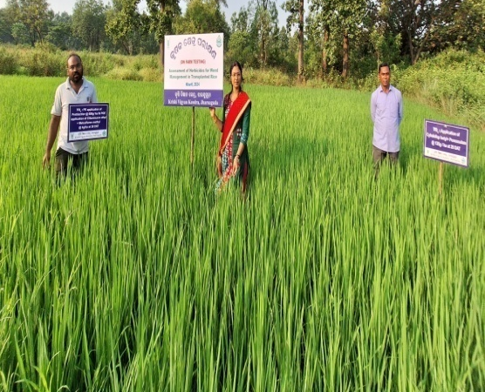 | 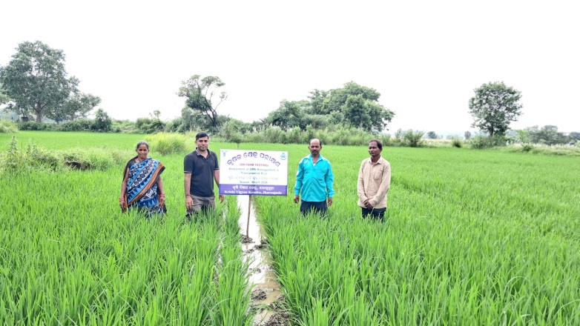 | 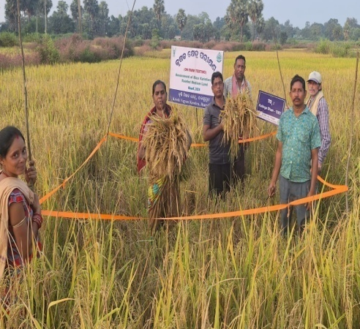
Assessment of herbicides for weed management in transplanted rice | Assessment of BPH management in transplanted rice | Assessment of Rice varieties for rain fed medium land
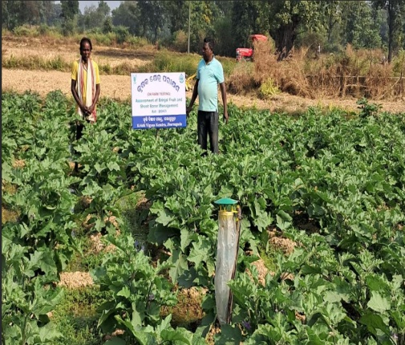 | 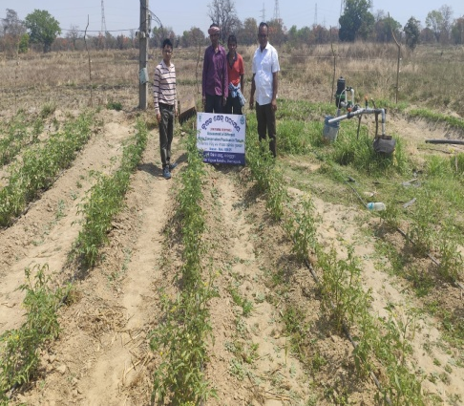 | 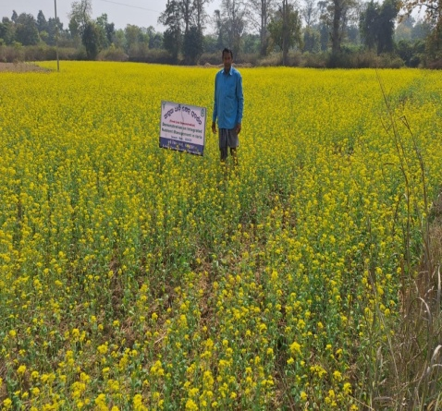
Assessment of Brinjal shoot and fruit borer management | Assessment of different water conservation practices in tomato | Demonstration on INM in toria
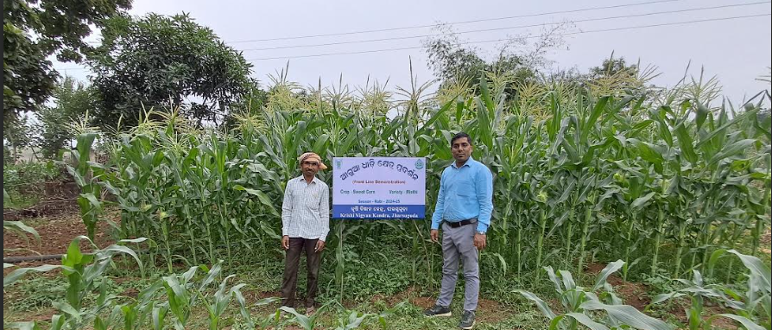 | 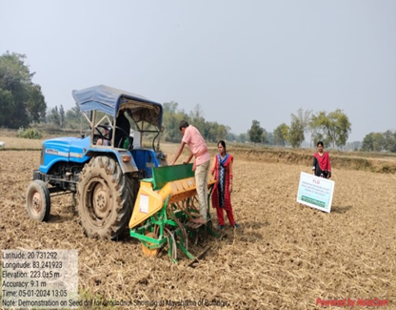 | 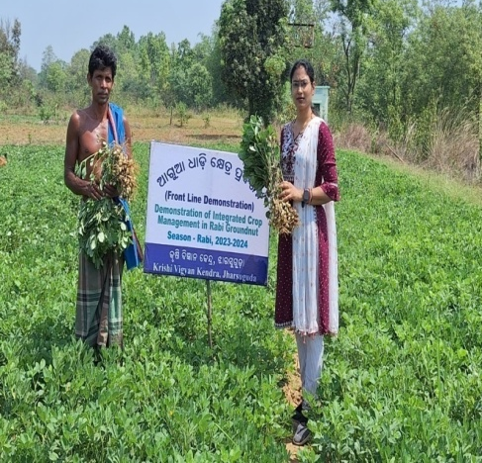
Demonstration on sweetcorn var. Misthi | Demonstration on seed cum fertilizer drill in groundnut | Demonstration on Integrated crop management in groundnut
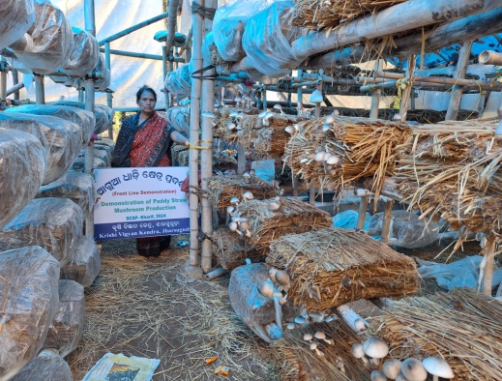 | 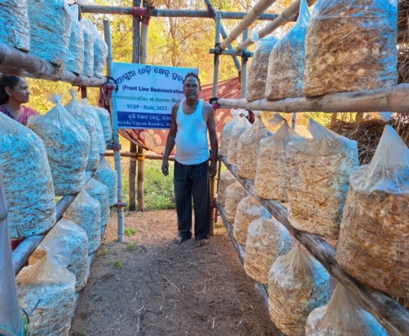 | 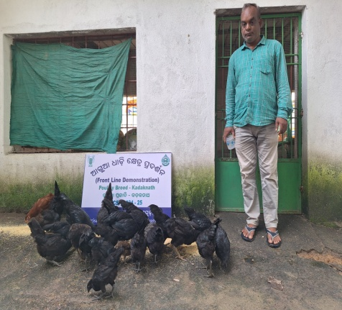
Demonstration of paddy straw mushroom cultivation | Demonstration on Cultivation of Oyster mushroom by using crumbled straw | Demonstration of stress tolerant poultry breed Kadaknath
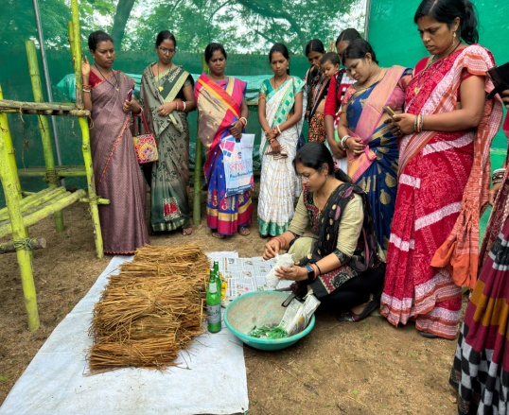 | 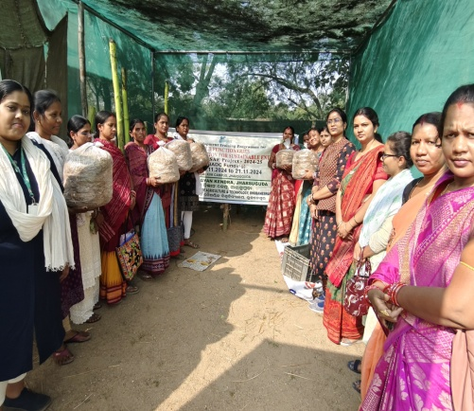 | 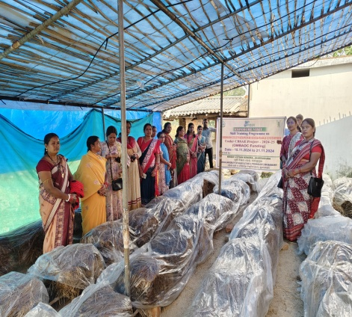
Skill Training on Mushroom Cultivation
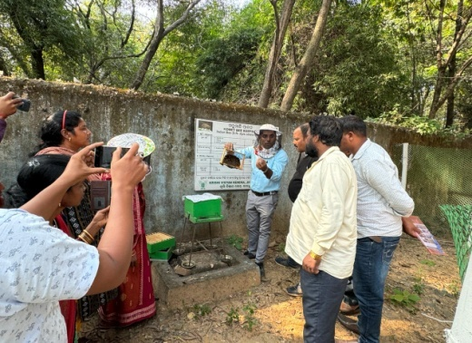 | 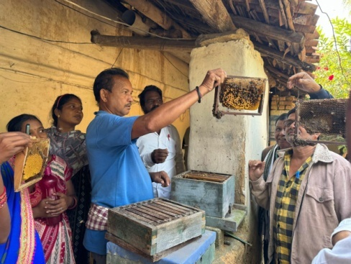 | 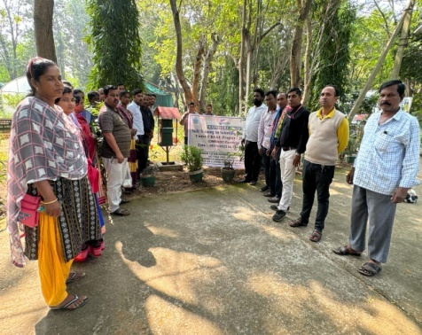
Skill Training on Scientific Bee Keeping
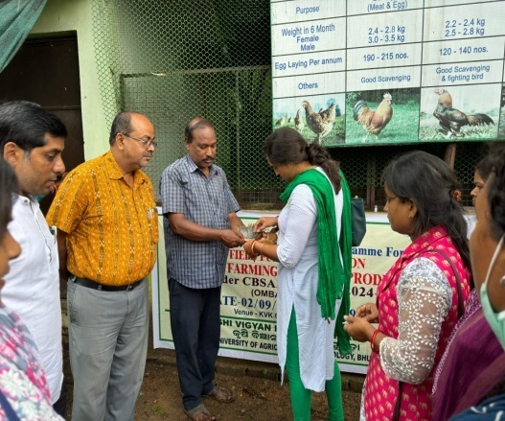 | 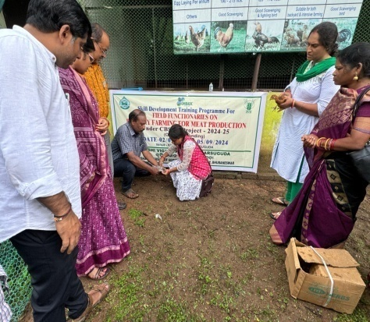 | 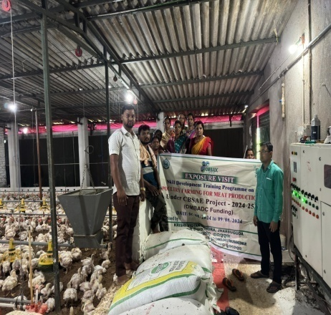
Skill Training on Poultry Farming
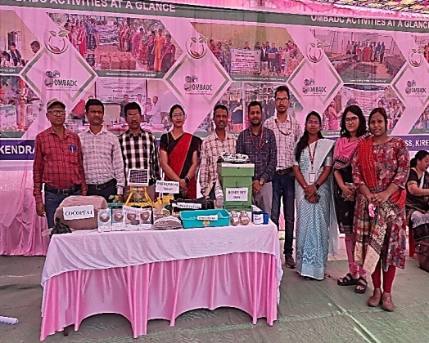 | 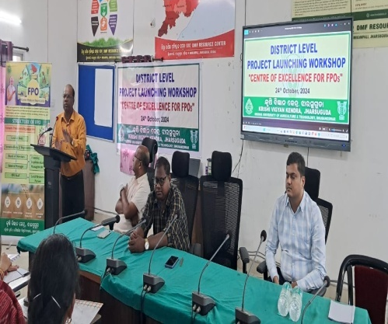 | 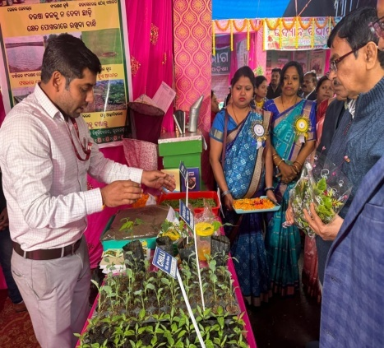
Extension activities
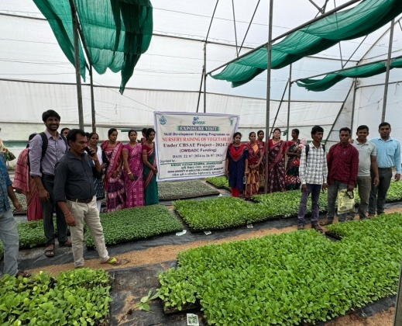 | 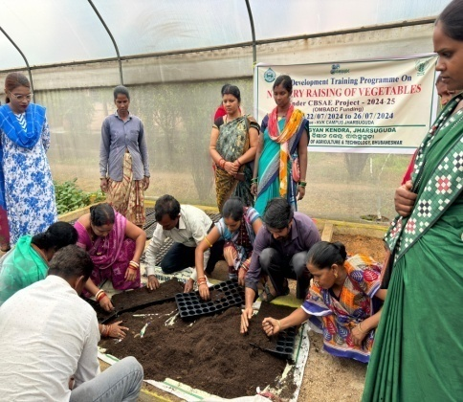 | 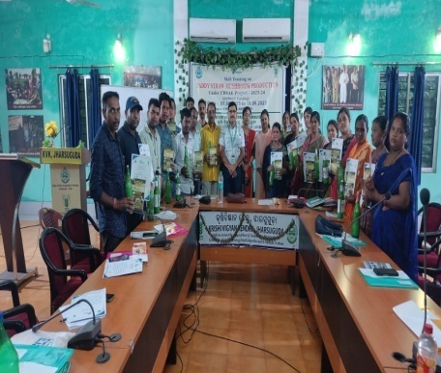
Skill Development Training on Nursery raising of vegetables

