PROFORMA FOR ANNUAL REPORT2023 (January-December 2023)

1. GENERAL INFORMATION ABOUT THE KVK

1.1. Name and address of KVK with phone, fax and e-mail

Address | Telephone |  | E mail
 | Office | FAX
Krishi Vigyan Kendra  At/Po- Badmal  Jharsuguda, Pin-768202 | Office | FAX | kvkjharsuguda.ouat@gmail.com  kvk.jharsuguda@ouat.ac.in

1.2 .Name and address of host organization with phone, fax and e-mail

Address | Telephone |  | E mail
Address | Office | FAX
Odisha University of Agriculture & Technology, Bhubaneswar, Odisha. | 0674-2397818/919  0674-2397424 | 0674-2397818/919 | registrarouat@gmail.com

1.3. Name of Senior Scientist and Head with phone & mobile No.

Name | Telephone / Contact
 | Residence | Mobile | Email
Dr. Samir Ranjan Dash | KVK, Jharsuguda | 9438531167

1.4. Year of sanction of KVK:2006

1.5. Staff Position (as on 1stJanuary, 2023)

Sl.  No. | Sanctioned post | Name of the incumbent | Designation | Discipline | Pay  Scale with present basic | Date of joining | Permanent/Temporary | Category (SC/ST/  OBC/  Others)
1 | Senior Scientist& Head | Dr. Samir Ranjan Dash | Sr. Scientist & Head | Extension Education | 89800 | 01.08.2022 | Temporary | Other
2 | Subject Matter  Specialist | Dr. Anuj Kumar Rai | Scientist | Plant Science | 20590 with AGP 6000 | 07.06.21 | Temporary | Other
3 | Subject Matter  Specialist | Ms. Susmita Panda | Scientist | Agronomy | 61300 | 01.08.22 | Temporary | Other
4 | Subject Matter  Specialist | Vacant | - | - | - | - | - | -
5 | Subject Matter  Specialist | Vacant | - | - | - | - | - | -
6 | Subject Matter  Specialist | Vacant | - | - | - | - | - | -
7 | Subject Matter  Specialist | Vacant | - | - | - | - | - | -
8 | Programme Assistant | Vacant | - | - | - | - | - | -
9 | Computer  Programmer | Sri Bishnu Ranjan Padhi | Computer Programmer | B.E (Computer Sc.) | 62200 | 11.08.2014 | Temporary | Other
10 | Farm Manager | Vacant | - | - | - | - | - | -
11 | Accountant / Superintendent | Vacant | - | - | - | - | - | -
12 | Stenographer | Vacant | - | - | - | - | - | -
13. | Driver | Sri SamantaMallick | Driver | - | 24500 | 28.07.2015 | Temporary | SC
14. | Driver | Manoj Kumar Sahoo | Driver | - | 29300 | 20.09.2017 | Temporary | Others
15. | Supporting staff | Kamala Nag | Peon -cum -Watchman | - | 23600 | 29.07.2008 | Temporary | SC
16. | Supporting staff | Vacant | - | - | - | - | - | -

1.6. Total land with KVK (in ha) :
S. No. | Item | Area (ha)
1 | Under Buildings | 0.3
2. | Under Demonstration Units | 0.4
3. | Under Crops | 1.34
4. | Orchard/Agro-forestry | 2.0
5. | Others with details ( Lawn Area , Road | 0.7
6. | Land under encroachment | 1.0
 | Total | 5.74

Total area should be matched with breakup

1.7. Infrastructure Development:

- Buildings and others
S. No. | Name of infrastructure | Not yet started | Completed up to plinth level | Completed up to lintel level | Completed up to roof level | Totally completed | Plinth area (sq.m) | Under use or not* | Source of funding
1. | Administrative  Building | - | - | - | - | Completed | 1500 | Under Use | ICAR
2. | Farmers Hostel | - | - | - | - | Completed | 1500 | Under use | ICAR
3. | Staff Quarters (6) | - | - | - | - | Completed | 1400 | Under use | ICAR
4. | Piggery unit | - | - | - | -
5 | Fencing | - | - | - | - | Completed | -- | Under Use | ICAR & RKVY
6 | Rain Water harvesting structure | - | - | - | - | Completed | 1800 | Under Use | ICAR & RKVY
7 | Threshing floor | - | - | - | - | Completed | 600 | Under Use | ICAR
8 | Farm godown | - | - | - | -
9. | Dairy unit | - | - | - | -
10. | Poultry unit | - | - | - | - | Completed | 20 | Under Use | RKVY
11. | Goatary unit | - | - | - | - | - | - | - | -
12. | Mushroom Lab | - | - | - | - | Completed | 15 | Under Use | RKVY
13. | Mushroom production unit | - | - | - | - | Completed | 20 | Under use | ICAR
14. | Shade house | - | - | - | - | Completed | 50 | Under use | ICAR
15. | Soil test Lab | - | - | - | - | Completed | 20 | Under use | ICAR
16 | Duckery unit | - | - | - | - | Completed | 20 | Under Use | ICAR
17 | Vermicompost Unit | - | - | - | - | Completed | 15 | Under Use | RKVY
18 | Poly House | - | - | - | - | Completed | 80 | Under Use | RKVY
19 | Azolla Unit | - | - | - | - | Completed | 20 | Under Use | ICAR
20 | Overhead Tank with irrigation system |  |  |  |  | Completed | 2000 Ltr, | Under Use | ICAR

* If not in use then since when and reason for non-use
\

B) Vehicles
Type of vehicle | Year of purchase | Cost (Rs.) | Total km. Run | Present status
Bolero | 2017 | 8,00,000 | 84494 | Good
Motor Cycle | 2012 | 50000 | 34640 | Good
Tractor | 2023 | 750000 | 27 hrs | Good

C) Equipment & AV aids
Name of equipment | Year of purchase | Cost (Rs.) | Present status | Source of fund
a. Lab equipment
Soil Testing Lab. Equipment | 2017 | 1700000 | Good | ICAR
Mushroom Spawn production equipment | 2011 | 250000 | Good | RKVY
b. Farm machinery
Tractor | 2006 | 700000 | Condemned | ICAR
c.AV Aids
LCD | 2012 | 50000 | Good | ICAR
Television | 2013 | 40000 | Not working | ICAR
Sound System | 2011 | 50000 | Good | ICAR
Conference table Audio System | 2017 | 64000 | Good | ICAR
Smart Television | 2021 | 34000 | Good | ICAR
All-in-One | 2020 | 40000 | Good | ICAR
Dell Laptop | 2021 | 40000 | Good | ICAR
Printer | 2022 | 20000 | Good | ICAR

D) Farm implements
Name of equipment | Year of purchase | Cost (Rs.) | Present status | Source of fund
Cultivator | 2006 | 30000 | Not Good | ICAR
Brush Cutter | 2017 | 42000 | Good | ICAR
Manual Rice Thresher | 2012 | 4500 | Good | ICAR
Manual Rice Winnower | 2012 | 5000 | Good | ICAR
Ridger | 2021 | 20000 | Good | ICAR

1.8. Detailsof SAC meeting* conducted in the year

Sl.No. | Date | Number of Participants | Salient Recommendations | Action taken | If not conducted, state reason
1. | 19.01.2023 | 28 | 1. Awareness and training on Natural farming, organic inputs and its production and importance for sustainable agriculture | - Demonstration of vermicompost production using poly vermi bed (20 Nos.)  - Demonstration of rhizobium seed inoculation in Groundnut (2 ha)  - Management of Brinjal fruit and shoot borer using trichocard (1 ha)  - Demonstration of Arka vegetable special in hybrid tomato (2.0 ha )  - Demonstration of bio-fertizer and micronutrients in Toria. (3.0 ha)  - (Application of Azotobactor& PSB along with 50-25-25 kg N-P2O5-K2O kg/ha, Application of 25 kg ZnSo4 and 1 kg B per hectare)  - Skill Training programme of 5 day duration on vermicompost production and organic farming(4 Nos. with 80 participants) conducted under CBSAE development project  - Publication of booklet on Vermicompost production (500 Nos.)  - Demonstration of T. Chilonisinmaize conducted during kharif 2023 in 10 ha  - Demonstration of Azolla Cultivation under SCSP programme (40 units)  - Publication of Booklet on Azolla Farming ( 500 Copies)  - Conducted Rural youth training programme on Azolla production
 |  |  | 2. Intervention on weed management practices in Rice and oilseed crops | - Weed management in Groundnut variety Dharani , area-10 ha , no. of demonstration -25 in village Rautbahal and Guchhapalli (Weed management by Imazethapyr@ 75 gma.i/ha at 15-20 DAS), Rabi 2022-23  - Herbicidal weed management in groundnut by pre-emergence application of Oxyfluorfen (@0.04kg a.i/ha) , variety K-1812 (Kadiri Lepakshi) in 6.0 ha in Rabi 2023-24  - Demonstration of herbicide (Penuxsulam (2.67%) @ 1.0 litre /ha as post emergence) for weed management in upland rice  - Assessment of herbicides for weed management in transplanted rice (2 ha)  - TO1-Application of Cyhalofop butyl + Penoxulam @ 135g/ha at 20DAT  - TO2-Pre-emergence application of Pretilachlor @500 g/ha fb post emergence application of Chlorimuron ethyl + Metsulfuron methyl @ 4 g/ha at 20DAT
 |  |  | 3.Agri-entrepreneurship and IFS models may be developed | - Four no. of IFS models are developed in villages- Chandinimal, Pudapalli, Saletikra ,Gudigaon  - 1. Farmer- Sri Rohit Pradhan  - Village Chandinimal ( Poultry + Duckery+ Goatery+ Fish+ Vegetables) ,Area- 1.0 ha , Gross income –Rs.3.2 Lakhs  - 2. Farmer- Sri Mitrabhanu Patel  - Village Gudigaon ( Dairy + Goatery + Fish+ Vegetables + Fruit) ,Area- 1.0 ha ,  - Gross income –Rs.2.8 Lakhs  - 3. Farm Woman – Smt. SarojiniBhainsa  - Village Saletikra (Vegetables + Mango+ Vegetables + Poultry + Fish),Area -0.8 ha , Gross income –Rs.2.6 Lakhs  - 4. Farmer- Sri Lambodar Sahu  - Village Pudapalli - (Rice+Vegetables+ Mushroom+ Sugarcane ), Gross income –Rs.2.4 Lakhs
 |  |  | 4. Demonstration on Poultry breed Kaveri may be conducted | - FLD on poultry breed Kaveri in Kharif 2023 in villages Chandinimal, Keldamal and Banjari, H.Katapalli under SCSP programme (1000 birds)  - Assessment of comparative performance of Kaveri and Vanaraja poultry in backyard system (Rabi 2022-23)  - Body wt./Bird/year – Kaveri -2.5 kg, Vanaraja – 2.2 kg , FP- 1.4 kg
 |  |  | 5. Demonstration on feed management in fish | - Demonstration of stunted fingerlings in seasonal pond  - Stocking of stunted fingerling @5000 no./ha  - (Catla + Rohu + Pangasius + Mrigal = 3:2:2:3) with feed management  - Yield -31.0q/ha (Pangasius -13.5 + IMC- 17.5)  - Demonstration of fish feed probiotics (Lactobacillus and Saccharomyces @ 2% ) No. of demonstration -10 Nos.
 |  |  | 6. Intervention on Dhaincha for green manuring in Rice | - Seed production of Dhaincha , 1.4 q in KVK farm  - Training programme conducted on green manuring inRice ( 4 Nos. )
 |  |  | 7. Oyster mushroom cultivation with crumbled rice straw | - Demonstration on Cultivation of Oyster mushroom by using crumbled straw (No. of beds -500 , No. of Demonstration – 10 units)  Yield -1.6 kg/bed with return Rs.1500 /10 bed  - Skill Training programme of 5 day duration on Oyster mushroom production (2 Nos. with 40 participants) were conducted under CBSAE development project  - Publication of booklet on “Oyster Mushroom Cultivation ”in Odia (500 copies)
 |  |  | 8. Intervention on Nursery development for quality planting materials | - Skill Training on Nursery raising (1 Nos. with 20 participants) conducted under CBSAE development project  - One lakh two thousand seedlings and saplings of HYV vegetables, Papaya (Red Lady, Ranchi Dwarf) , Drumstick (ODC 3), Tomato(Arka Samrat), Marigold (BM-2) were raised and distributed to the farmers through Odisha Livilihood Mission and other programmes of KVKs  - Saplings were distributed to the farmers during various flagship programmes like Vanomahostav, PoshanAbhijan
 |  |  | 9. Promotion of natural farming, bio pesticides and bio inputs by training and awareness programme | - Demonstration of T. Chilonisinmaize conducted during kharif 2023 in 10 ha  - OFT on Management of Brinjal fruit and shoot borer using Pheromone trap and Tricho card (1 ha)  - Demonstration of seed inoculation with bio fertilizer (Rhizobium, Azotobacter and PSB) conducted in Toria and Groundnut (4 .0 ha)  - Demonstration of Azolla Cultivation under SCSP programme (40 units)  - Publication of Booklet on Azolla Farming ( 500 Copies)  - Conducted Rural youth training programme on Azolla production
 |  |  | 10. Convergence mode of activities in watershed areas | - Joint diagnostic field visit with Dept. of Agriculture, Jharsuguda for BPH and stem borer management, visited G.P -Loisingh, H. Katapalli ,Rampella ,Kolabira,Parmanpur,Kumarbandha of Jharsuguda district  - Awareness programme for pest management and agro advisory by KVK witth CDAO , Jgarsuguda  - Participation in Millet mission with P.D, ATMA and Odisha Millet mission. Conducted district level millet recipe competition , Seminar for promotion of millet  - Conducted capacity building programme for para-extension workers . (120 participants)  - Joint celebration of World soil day , Farm mechanisation mela and exhibition with Dept. of Agriculture, Jharsuguda  - Verification of planting materials ,InstallatofSabji Cooler ion and training programme conducted for Udyan Sathi of Dept. of Horticulture , Jharsuguda  - Skill training for income generation to WSHGs members in collaboration with OLM , Jharsuguda under CBSAE development project.( 8 nos. of Training with 160 participants)  - Training for FPOs members with SEWA NGO Kolabira ( 50 Participants)  - Participation of KVK in District level “Matsya O Prani Sampad Mela” with ARD, Jharsuguda  - Participation in awareness programme , drone demonstration and use of nanofertlizer in 78 GP of Jharsuguda under VBSY programme with CDO, DRDA, Jharsuguda ( 29.11.23 to 19.12.23)  - Participation in World Fishery day 2023 , Dept. of Fishery, Jharsuguda
 |  |  | 11. Training on water management particularly on micro irrigation system | - Awareness on soil and water management in crop production under Jal Shakti Abhiyan programme conducted at village DurlaAbhiyanga and Sialrama (110 Nos.)
 |  |  | 12. Training on value addition of vegetables and millets | - Participation of KVK on Millet Day organised by OMM (10.11.2022)  - Participation of KVK in International convention on Millets (09.11.2023)  - Conducted 02 nos. of training programme on package and practices of finger millet with post harvest management ( Participant -80)
 |  |  | 13.Varietal trial on pulses (Blackgram/Greengram) may be taken up | - Assessment of YMV tolerant varieties of green gram (IPM-02-14 , Yield- 7.3q/ha)and Virat, Yield 8.1q/ha)  - Demonstration of foliar spray of 2% Urea phosphate at 20 and 35 DAS in greengram
 |  |  | 14. Demonstration on Rhizome rot management in ginger may be taken up | - Conducted training programmes on Rhizome treatment and post harvest management of Ginger in Lakhanpur block. (2 Nos., 60 Participants)
 |  |  | 15. Intervention on pest and disease management, processing & value addition in ginger and chilli may be taken up | - Conducted training programmes on thrip management in chili . ( 2 Nos. , 50 participants)
* Salient recommendation of SAC in bullet form
Attach a copy of SAC proceedings along with list of participants

Members present in18thScientific Advisory Committee Meeting held on dt.14.12.2022
1 | Dr. Hemanta Kumar Sahoo, DDE, DEE, OUAT, Bhubaneswar | Chairman
2 | Dr. S.K Mandal,PrincipalScientist,ICAR-ATARI, Kolkata | Member
3 | Dr. Pramod Kumar Panda, Principal Scientist, IIWM, Bhubaneswar | Member
4 | Sri Manoranjan Nanda, ADH, Jharsuguda | Member
5 | Dr. Dayasagar Daria, CDVO, Jharsuguda | Member
6 | Sri Lingraj Pradhan, BAO, Jharsuguda | Member
7 | Sri Prasanna Kumar Dash, P.D Watershed, Jharsuguda | Member
8 | Dr. Prasant Kumar Katra,ADVO, Jharsuguda | Member
9 | Sri Arpira Pritam, AFO, Jharsuguda | Member
10 | Dr. Sanjeeb Biswasi, Sr. Scientist, RRTTS, Kirei, Sundargarh
11 | Sri Rashmi Ranjan Mohanty, ASCO, Jharsuguda | Member
12 | Sri Sushil Kumar Dash, Secretary SEWA, Kolabira | Member
13 | Sri. Gautam Behera, Secretary AJKA, Lakhanpur, Jarsuguda | --
14 | Sri. Ashis Kumar Mohanty, Scientist (Hort.), KVK, Sundargarh-I
15 | Sri. Santanu Kumar pati, PM, AFPRO, Jharsuguda
16 | Sri. Sanjay Kumar Dash, Ag. Consultant , AFPRO, Jharsuguda | Member
17 | Kaubantta Sahu, Akashvani, Sambalpur
18 | Sri. Pradeep Kumar Swain, JE, OAIC, Jharsuguda
19 | Sri Saroj Sahu, Progressive Farmer, Tharkashpur, Jharsuguda | Member
20 | Sri Lambodar Barik, Progressive Farmer,Pudapali, Jharsuguda | Member
21 | Smt. Kamalini Singh, Progressive Farm woman , Pandripathar, Jharsuguda | Member
22 | Smt. Gitanjali Naik , Progressive Farm woman, Sialrama, Jharsuguda | Member
23 | Sri. Jakshya Sahu, Progressive Farmer,Jamera, Jharsuguda | --
24 | Sr. Jogeshwar Barik, Progressive Farmer,Jamera, Jharsuguda | --
25 | Sri. Mangalu Naik, Progressive Farmer,Sialrama, Jharsuguda | --
26 | Ms. Susmita Panda, Scientist (Agronomy) | --
27 | Dr. Anuj Kumar Rai, Scientist, KVK Jharsuguda | --
28 | Dr. Samir Ranjan Dash, Sr. Scientist & Head, KVK, Jharsuguda | Member -Secretary

2.a. District level data on agriculture, livestock and farming situation (2023)
Sl. no. | Item | Information
1 | Major Farming system/enterprise | Rainfed
2 | Agro-climatic Zone | Western Central Table Land Zone and North Western Plateau Zone
3 | Agro ecological situation | Undulating sub mountainous tract rainfed,Plateau Rainfed  Lateritic low rainfall.
4 | Soil type | The soil is mostly lateritic. Red and Yellow soils are found in small patches of Kolabira block only. Soil reaction is generally acidic in Jharsuguda, Lakhanpur and Kirimira and almost neutral in Laikera and Kolabira block.
5 | Productivity of major 2-3 crops under cereals, pulses, oilseeds, vegetables, fruits and others | Rice-2255kg/ha,Maize-2670kg/ha, Greengram- 442 kg/ha, Blackgram-417 kg/ha, Kulthi-455kg/ha, Groundnut-1291kg/ha, Sesamum-402 kg/ha,Mustard-405kg/ha, Potato-13600kg/ha, Onion- 10000kg/ha, Chilli-976 kg/ha, Turmeric-6200 kg/ha, Ginger-5250kg/ha.
6 | Mean yearly temperature, rainfall, humidity of the district | 42˚ C & 12˚ C, 1362.8mm, 55%
7 | Production of major livestock products like milk, egg, meat etc. | Milk- 14.41 000’MT, Meat- 1256.55MT, Egg- 9.76 Million, 5421 MT

Note: Please give recent data only

2.b. Details of operational area / villages (2023)

Sl.  No. | Name of District | Name of the block | Name of the villages | Major crops  & enterprises | Major problems identified (crop-wise) | Identified Thrust Areas
1 | Jharsuguda | Jharsuguda | Jamera, Tharkaspur, Durlaga, Tihadipali | Rice, Greengram, Brinjal, Tomato, Mustard, Mushroom | Rice-Local variety, Stem borer, BPH, Blast, BLB, BPHand Weed problem  Greengram-Local variety, YMV incidence,  Brinjal- Local variety, disease and pest incidence  Tomato- Local variety, disease and pest incidence  Mustard- Local variety, disease and pest incidence  Mushroom- Low yield | - Varietal replacement  - Disease and pest management  - Weed management  - Integrated nutrient management.  - Improved Production practices
2 | Jharsuguda | Kolabira | Gudigaon , Siriapalli, Ghantamal, | Rice, Sesamum, Mustard, Greengram, Potato, Onion, Cauliflower, Cabbage, Tomato,  Marigold | RiceRice-Local variety, Stem borer, BPH, Blast, BLB and Weed problem  Sesamum-Local variety, disease and pest incidence.  Tomato- Local variety, disease and pest incidence  Potato- Blight problem and local variety.  Onion- Low yield due to local variety.  Cauliflower- Local variety, disease and pest  Mustard- Local variety, disease and pest incidence  Marigold- Local variety, disease and pest incidence | - Varietal replacement  - Disease and pest management  - Weed management  - Integrated nutrient management.
3 | Jharsuguda | Kirmira | Bhaunra, Sulehi, Sialrama | Rice, Greengram, Brinjal, Tomato, Potato,Chilli, Groundnut | Rice-Local variety, Stem borer, BPH, Blast, BLB and Weed problem  Greengram- Local variety, YMV incidence, Improper nutrient management  Brinjal- Local variety, disease and pest incidence  Tomato- Local variety, disease and pest incidence  Potato- Blight problem and local variety.  Chilli- Local variety, disease and pest incidence  Groundnut- Low yield, disease and pest incidence, Improper nutrient management | - Varietal replacement  - Disease and pest management  - Weed management  - Integrated nutrient management  - .Integrated Crop Management
4 | Jharsuguda | Laikera | Rengalbeda, Routbahal | Rice,Greengram, Mustard,Sesamum,  Brinjal, Tomato, Cabbage, Cauliflower, Chilli, maize and Sweet corn | Rice-Local variety, Stem borer, BPH, Blast, BLB and Weed problem  Sesamum-Local variety, disease and pest incidence.  Tomato- Local variety, wilting, blossom end rot  Brinjal- Local variety, wilting , Fruit and shoot borer  Cauliflower- Local variety, disease and pest incidence.  Cabbage- Local variety, disease and pest incidence.  Chilli- Local variety, leaf curl and thrips , wilting  Maize- Local variety, disease and pest incidence.  Sweet Corn- Low yield, disease and pest incidence. | - Varietal replacement  - Disease and pest management  - Weed management  - Integrated nutrient management.
5. | Jharsuguda | Lakhanapur | Kureimal, Baddhara, Atabira ,Bhikampalli | Rice, Greengram, Groundnut, Potato, Tomato, Ginger, Pointed gourd, Mustard, Maize | Rice-Local variety, Stem borer, BPH, Blast, BLB and Weed problem  Greengram- Local variety, YMV incidence Brinjal- Local variety, wilting , Fruit and shoot borer  Tomato- Local variety, wilting, blossom end rot  Groundnut- Local variety, Tikka disease  Potato- Blight problem and local variety.  Ginger- Rhizome rot, local variety  Pointed Gourd- Root rot, local variety  Mustard- Local variety, disease and pest incidence  Maize- Local variety, disease and pest incidence. | - Varietal replacement  - Disease and pest management  - Weed management  - Integrated nutrient management.

2. c. Details of village adoption programme:

Name of the villages adopted by PC and SMS (2023) for its development and action plan

Name of village | Block | Action taken for development
Siriapali | Kolabira | Execution of action plan 2022
Mauliberna | Lakhanapur | Execution of action plan 2023
Udiapli | Laikera | Execution of action plan 2023
Tharkaspur | Jharsuguda | Execution of action plan 2022
Jamera | Jharsuguda | Execution of action plan 2022

2.1 Priority thrust areas
S. No | Thrust area
1. | - Crop diversification and varietal replacement
2. | - Integrated Nutrient Management
3. | - Production of quality planting materials
4. | - IPM, IDM & IWM in rice
5. | - Women empowerment through Income Generating Activities
6. | - Promotion of Nutritional garden
7. | - Breed up-gradation of livestock and poultry
8. | - Livestock disease management
9. | - Production of organic inputs and promotion of organic farming
10. | - Nursery raising of vegetable seedlings and its management
11. | - Cultivation of High value & commercial horticultural crops
12. | - Post-harvest technology and value addition of fruits and vegetables
13. | - Market led production strategies
14. | - Promotion of Integrated farming system
15. | - Formation and strengthening of FPOs

3. TECHNICAL ACHIEVEMENTS

3.A.Details of target and achievement of mandatory activities by KVK during the year

OFT |  |  |  |  |  |  |  |  |  |  |  | FLD
No. of technologies tested: 05 |  |  |  |  |  |  |  |  |  |  |  | No. of technologies demonstrated: 21
Number of OFTs |  | Number of farmers |  |  |  |  |  |  |  |  |  | Number of FLDs |  | Number of farmers
Target | Achievement | Target | Achievement |  |  |  |  |  |  |  |  | Target | Achievement | Target | Achievement
 |  |  | SC |  | ST |  | Others |  | Total |  |  |  |  |  | SC |  | ST |  | Others |  | Total
 |  |  | M | F | M | F | M | F | M | F | T |  |  |  | M | F | M | F | M | F | M | F | T
05 | 05 | 35 | 5 | 2 | 4 | 4 | 12 | 8 | 21 | 14 | 35 | 21 | 21 | 240 | 18 | 26 | 33 | 37 | 58 | 68 | 109 | 131 | 240

Training |  |  |  |  |  |  |  |  |  |  |  | Extension activities
Number of Courses |  | Number of Participants |  |  |  |  |  |  |  |  |  | Number of activities |  | Number of participants
Target | Achievement | Target | Achievement |  |  |  |  |  |  |  |  | Target | Achievement | Target | Achievement
 |  |  | SC |  | ST |  | Others |  | Total |  |  |  |  |  | SC |  | ST |  | Others |  | Total
 |  |  | M | F | M | F | M | F | M | F | T |  |  |  | M | F | M | F | M | F | M | F | T
60 | 53 | 1500 | 55 | 256 | 105 | 240 | 53 | 282 | 441 | 925 | 1366 | 171 | 167 | 4000 | 436 | 366 | 415 | 542 | 907 | 934 | 1758 | 1842 | 3600

Impact of capacity building |  |  |  |  |  |  |  |  |  |  | Impact of Extension activities
Number of Participants trained |  | Number of Trainees got employment (self/ wage/ entrepreneur/ engaged as skilled manpower) |  |  |  |  |  |  |  |  |  | Number of Participants attended |  | Number of participants got employment (self/ wage/ entrepreneur/ engaged as skilled manpower)
Target | Achievement | SC |  | ST |  | Others |  | Total |  |  |  | Target | Achievement | SC |  | ST |  | Others |  | Total
 |  | M | F | M | F | M | F | M | F | T |  |  |  | M | F | M | F | M | F | M | F | T

Seed production (q) |  | Planting material (in Lakh)
Target | Achievement | Target | Achievement
1.5 | 1.4 | 1.05 | 0.34

Livestock strains and fish fingerlings produced (in lakh)* |  | Soil, water, plant, manures samples tested (in lakh)
Target | Achievement | Target | Achievement
0.10 | 0.015 | 0.001 | 0.001
- * Give no. only in case of fish fingerlings

Publication by KVKs
Item | Number | No. circulated | No. of Research papers in NAAS rated Journals | Highest NAAS rating of any publication | Average NAAS rating of the publications | Details of awarded publication, if any | Details of Award given to the publication
Research paper | 2
Seminar/conference/ symposia papers | 1
Books
Bulletins
News letter | 1 | 500
Popular Articles
Book Chapter
Extension Pamphlets/ literature | 12 | 1800
Technical reports | 5
Electronic Publication (CD/DVD etc)
TOTAL | 21

3.1 Achievements on technologies assessed and refined

OFT-1

1. | Title of On farm Trial | Assessment of Rice varieties for rain fed medium land
2. | Problem diagnosed | Less yield due to cultivation of low yielding varieties of rice
3. | Details of technologies selected for assessment/refinement  (Mention either Assessed or Refined) | Farmers Practice- MTU-1010 ( 125 days duration Medium slender grain. Res to leaf blast, mod. tores brown t, sspoheath rot, SB and leaf folder, 3.5-4 t/ha)  TO₁- Kalinga dhan-1203, 132days duration, Good cooking quality, medium slender grain, Yield- 52q/ha. moderately resistant to sheath-rot, BPH, stem-borer and leaf folder.  TO₂- Kalinga dhan-1205, 135 days duration, Good cooking quality, medium slender grain, Yield- 51q/ha. resistant to leaf blast, sheath-rot, brown spot, tolerant to leaf folder, gundhi bug and stemborer.
4. | Source of Technology (ICAR/ AICRP/SAU/other, please specify) | TO₁ -OUAT, 2021  TO₂-OUAT, 2021
5. | Production system and thematic area | Rice based and Varietal Evaluation
6. | Performance of the Technology with performance indicators | FP- Yield 38.6q/ha with B:C of 1.73  TO₁ -Yield 47.5q/ha with B:C of 2.01  TO₂-Yield 44.3q/ha with B:C of 1.88
7. | Final recommendation for micro level situation | Kalinga dhan-1203 performed better as compared to Kalinga Dhan-1205
8. | Constraints identified and feedback for research
9. | Process of farmers participation and their reaction | Accepted by the farmers
Thematic area:
Problem definition:
Technology assessed:

Table:
Technology option | No. of trials | Yield component |  |  | Disease/ insect pest incidence (%) | Yield  (q/ha) | Cost of cultivation  (Rs./ha) | Gross return (Rs/ha) | Net return  (Rs./ha) | BC ratio
Technology option | No. of trials | No. of effective tillers/hill | No. ofgrainst per panicle | Test wt. (100 grain wt.)
FP | 7 | 11.5 | 178 | 22.7 |  | 38.6 |  | 84264 | 35564 | 1.73
TO1 | 7 | 15.3 | 198 | 24.2 |  | 47.5 |  | 103693 | 52192 | 2.01
TO2 | 7 | 13.8 | 191 | 23.5 |  | 44.3 |  | 96707 | 45207 | 1.88

OFT-2

1. | Title of On farm Trial | Assessment of herbicides for weed management in transplanted rice
2. | Problem diagnosed | Low yield due to heavy weed infestation in transplanted rice
3. | Details of technologies selected for assessment/refinement  (Mention either Assessed or Refined) | Farmers Practice- Manual weeding and application of Pretilachlor 50% E.C @500ml per acre  TO₁-Application of Cyhalofop butyl + Penoxulam @ 135g/ha at 20DAT  TO₂-Pre-emergence application of Pretilachlor @500 g/ha fb post emergence application of Chlorimuron ethyl + Metsulfuron methyl @ 4 g/ha at 20DAT
4. | Source of Technology (ICAR/ AICRP/SAU/other, please specify) | TO₁ -OUAT, Annual report, 2020  TO₂-OUAT, Annual report, 2015
5. | Production system and thematic area | Rice based and Weed management
6. | Performance of the Technology with performance indicators | FP- Yield 37.4q/ha with B:C of 1.78  TO₁ -Yield 41.5q/ha with B:C of 1.93  TO₂-Yield 43.1q/ha with B:C of 2.03
7. | Final recommendation for micro level situation | TO₂- Pre-emergence application of Pretilachlor @500 g/ha fb post emergence application of Chlorimuron ethyl + Metsulfuron methyl @ 4 g/ha at 20DAT
8. | Constraints identified and feedback for research
9. | Process of farmers participation and their reaction | Accepted by the farmers
Thematic area:
Problem definition:
Technology assessed:

Table:
Technology option | No. of trials | Weed infestation |  |  | Disease/ insect pest incidence (%) | Yield  (q/ha) | Cost of cultivation  (Rs./ha) | Gross return (Rs/ha) | Net return  (Rs./ha) | BC ratio
Technology option | No. of trials | Weed count (No/m²) | Dry matter of weed (g/m²) | Test wt. (100 grain wt.)
FP | 7 | 64 | 7.8 |  |  | 37.4 |  | 81644 | 35844 | 1.78
TO1 | 7 | 38 | 4.4 |  |  | 41.5 |  | 90595 | 43694 | 1.93
TO2 | 7 | 23 | 2.9 |  |  | 43.1 |  | 94087 | 47687 | 2.03

OFT-3

1. | Title of On farm Trial | Assessment of BPH management in transplanted ric
2. | Problem diagnosed | Low yield due to BPH incidence (Area-6000 ha)
3. | Details of technologies selected for assessment/refinement  (Mention either Assessed or Refined) | Farmers Practice- Spraying of Imidacloprid(17.8 SL) @ 100 ml per acre twice  TO₁-Skip row planting, draining the rice field for 3-4 days during the early stage of infestation, spraying of Pymetrozine 50 WG @ 300 g/ha at 60DAT  TO₂-Skip row planting, draining the rice field for 3-4 days during the early stage of infestation, spraying of Triflumezopyrim 10 SC @ 240 ml/ha (single spray at 65-70 DAT) is helpful
4. | Source of Technology (ICAR/ AICRP/SAU/other, please specify) | TO₁ -NRRI,Cuttack 2021.  TO₂-RRTTS, Chiplima 2022
5. | Production system and thematic area | Rice based and Plant protection
6. | Performance of the Technology with performance indicators | FP- Yield 38.6q/ha with B:C of 1.73  TO₁ -Yield 47.5q/ha with B:C of 2.01  TO₂-Yield 44.3q/ha with B:C of 1.88
7. | Final recommendation for micro level situation | Kalinga dhan-1203 performed better as compared to Kalinga Dhan-1205
8. | Constraints identified and feedback for research
9. | Process of farmers participation and their reaction | Accepted by the farmers
Thematic area:
Problem definition:
Technology assessed:

Table:
Technology option | No. of trials | Yield component |  |  | No. of hoppers/hill | Yield  (q/ha) | Cost of cultivation  (Rs./ha) | Gross return (Rs/ha) | Net return  (Rs./ha) | BC ratio
Technology option | No. of trials | No. of effective tillers/hill | No. of grains per panicle | Test wt. (100 grain wt.)
FP | 7 |  | 102.9 |  | 16.4 | 38.1 |  | 83058 | 39058 | 1.8
TO1 | 7 |  | 103.3 |  | 8.6 | 40.5 |  | 88290 | 43290 | 2.0
TO2 | 7 |  | 103.1 |  | 7.2 | 42.9 |  | 93522 | 48022 | 2.1

OFT-4

1. | Title of On farm Trial | Assessment of Brinjal shoot and fruit borer management
2. | Problem diagnosed | Low yield due to pest incidence
3. | Details of technologies selected for assessment/refinement  (Mention either Assessed or Refined) | Farmers Practice- Brinjal var. Blue star and non judicious use of Pesticides (Chloropyriphos, Triazophos@2ml/ltr.)  TO₁-Rynaxpyr (0.3 ml/l) application to control Brinjal shoot and fruit borer 30 DAT and another one 45DAT  TO₂-Spray Flubendiamide 480 SC @ 78.70 g ai/ha at 35DAT and Rynaxypyr 20 SC @ 33.33 ml ai/ha at 50DAT are effective in controlling shoot & fruit borer of brinjal
4. | Source of Technology (ICAR/ AICRP/SAU/other, please specify) | TO-I -Annual Report ,OUAT-2019  TO-II- Annual Report ,OUAT-2018
5. | Production system and thematic area | Pest Management
6. | Performance of the Technology with performance indicators | Continue
7. | Final recommendation for micro level situation
8. | Constraints identified and feedback for research
9. | Process of farmers participation and their reaction
Thematic area:
Problem definition:
Technology assessed:

Table:
Technology option | No. of trials | Yield component |  |  | Disease/ insect pest incidence (%) | Yield  (q/ha) | Cost of cultivation  (Rs./ha) | Gross return (Rs/ha) | Net return  (Rs./ha) | BC ratio
Technology option | No. of trials | No. of effective tillers/hill | No. of grainst per panicle | Test wt. (100 grain wt.)

OFT-5

Title | Technology
- Assessment of the performance of FPOs with varied levels of task and commodity to enhance income | Farmers Practice -Farmers marketing their produce through intermediaries  TO₁ -FPO dealing with a single commodity with a single task i.e., Millet-Marketing  TO₂ -FPO dealing with multi-commodity with multi-task i.e., Pulses, Crops Vegetable - sorting, grading, packing, value addition, branding, leveling and marketing

To access the performance of FPOs , a structured scheduled was developed to study the opinions from the Members about the role of FPOs in successful marketing of the produce. Different aspects were studied In relation to FPOs (3 point Likert scale- SA- Strongly agree, PA- Partially Agree, NA-Not Agree1. Social aspects 2.Technical aspects 3.Marketing aspects 4.Organisational aspects

Aspects (N=30) | TO₁(N=35) |  | TO₂ (N=35) |  | Stat analysis  Z calculated 2.86  Z tab 1.96  As Z cal> Z tab there is a significance difference between two sample means
 | Mean Score | Gap % | Mean Score | Gap %
Social Aspects | 2.12 | 29.8 | 2.06 | 30.8
Technical aspects | 1.95 | 35.6 | 1.77 | 38.2
Marketing aspects | 2.14 | 28.8 | 1.86 | 35.9
Organisational aspects | 1.93 | 39.8 | 1.78 | 31.3

TO₁- In TO₁ maximum gap were observed in organizational aspects where as in TO₂ technical gap were maximum. In both the groups responded were satisfied about the marketing aspects of the FPOs . As TO₂ is performed diversified activities emphasis should be more on strengthening of Technical aspects where as TO₁should focus on providing organizational and guidance for higher profitability

Name of the FPO | CBBO | Membership | Activities | Turn over (Rs.)
Sankalpa Producer Company Ltd, (2013) | AJKA | 975 | Input supply outlet , Vegetable Aggregation & marketing of organic paddy cultivation & marketing of aromatic paddy cultivation | 32,99,061 (2018-19)
Trimukhi Farmers Producer Company Limited (2018) | SEWA | 1000 | Millet production, procurement and marketing | 500000  (2018-19)
Results:

Good quality photographs of different treatments:

Please provide all the OFTs in same format

3.2 Achievements of Frontline Demonstrations

A. Details of FLDs conducted during the year

Cereals

_{Sl.}  _{No.} | _{Crop} | _{Thematic area} | Technology Demonstrated with detailed treatments | _{Area (ha)} |  | _{No. of farmers/}  _{demonstration} |  |  |  |  |  |  |  |  | Reasons for shortfall in achievement
 |  |  |  | _{Proposed} | _{Actual} | _{SC} |  | _{ST} |  | _{Others} |  | _{Total}
 |  |  |  |  |  | _{M} | _{F} | _{M} | _{F} | _{M} | _{F} | _{M} | _{F} | _{T}
_{1.} | _{Maize} | _{Varietal Replacement} | Maize var. Kalingaraj, Duration -85-100 days, Avg. yield-77-79 q/ha, Res. To common rust, Moderate Res. to MLB, TLB, Cyst nematode, MR to Fusarium stalk, charcoal rot, BLSB, Tolerant to drought. | ₅ | ₅ | ₅ | ₁ | ₃ | ₁ | ₈ | ₀ | ₁₆ | ₂ | ₁₈
_{2.} | _{Finger Millet} | _{Varietal Replacement} | Finger millet variety Arjun (OEB526), Maturity duration 110 days and average yield 20.7q/ha. with moderate resistance to leaf, neck and finger blast and brown seed | ₅ | ₅ | ₁ | ₅ | ₀ | ₁ | ₅ | ₀ | ₆ | ₆ | ₁₂
_{3.} | _{Maize} | _{IPM} | Seed treatment: Cyantraniliprole 19.8% + Thiamethoxam 19.8% FS  @ 6 ml/kg of seed will be effective for 15-20 days. Azadirachtin 1500ppm @ 5ml/l of water at 21DAS, Thiamethoxam 12.6% + Lambda cyhalothrin 9.5% ZC @125ml/ha at 35 DAS and 35 DAS | ₂ | ₂ | ₁ | ₃ | ₀ | ₀ | ₂ | ₄ | ₃ | ₇ | ₁₀
_{4.} | _{Rice} | _{Weed Management} | Application of Penuxulam (2.67%) @ 1.0 litre /ha as post emergence application at 12-15 DAT | ₂ | ₂ | ₁ | ₀ | ₁ | ₀ | ₆ | ₂ | ₈ | ₂ | ₁₀

Details of farming situation

Crop | Season | Farming situation (RF/Irrigated) | Soil type | Status of soil  (Kg/ha) |  |  | Previous crop | Sowing date | Harvest date | Seasonal rainfall (mm) | No. of rainy days
 |  |  |  | N | P₂O₅ | K₂O
Maize | Kharif | RF | Red-lateritic | - | - | - | Fallow | 11.07.23 | 26.10.32 | 1151 | 57 days
Finger Millet | Kharif | RF | Red-lateritic | - | - | - | Fallow | 21.07.23 | 10.11.23 | 1151 | 57 days
Maize | Kharif | Irrigated | Red-lateritic | - | - | - | Vegetables | 11.07.23 | 26.10.32 | 1151 | 57 days
Rice | Kharif | RF | Red-lateritic | - | - | - | Greengram | 29.07.2023 | 15.11.2023 | 1151 | 57 days

In both the Tables, information of same crop should be provided. For example, if in Table 3.2A crops are mentioned as a,b,c,d etc., in the table for Details of farming situation, the same crop should be mentioned in the identical sequence.

Performance of FLD

Oilseeds:

Frontline demonstrations on oilseed crops

Crop | Thematic Area | Name of the technology demonstrated | No. of Farmers | Area  (ha) | Yield (q/ha) |  | % Increase | *Economics of demonstration (Rs./ha) |  |  |  | *Economics of check  (Rs./ha)
 |  |  |  |  | Demo | Check | % Increase | Gross  Cost | Gross  Return | Net Return | **  BCR | Gross  Cost | Gross  Return | Net Return | **  BCR
Groundnut | Varietal Replacement | Very high yielding, profuse bearing Spanish variety with high oil and high protein. Multiple resistant for drought , pest and diseases. Stable yields ( 15-20q/ha) even under severe drought. | 15 | 5.0 | Continue
Toria | Integrated Nutrient Management | Seed inoculation with Azotobactor& PSB along with 50-25-25 kg N-P₂O₅-K₂O kg/ha, Application of 25 kg ZnSO₄ and 1 kg B per hectare | 10 | 2.0 | Continue
Groundnut | Crop management | Seed treatment with Rhizobium, Line sowing, 20-40-40 Kg NPK/ha along with 40 kg S/ha, Foliar spray of @0.03 % B twice at 10days interval starting from 30 days after sowing ,Pre-emergence Application of oxyfluorfen @ 0.04kg/ha | 10 | 2.0 | Continue
Total

* Economics to be worked out based on total cost of production per unit area and not on critical inputs alone.
** BCR= GROSS RETURN/GROSS COST

Pulses
Frontline demonstration on pulse crops
Crop | Thematic Area | Name of the technology demonstrated | No. of Farmers | Area  (ha) | Yield (q/ha) |  | % Increase | *Economics of demonstration (Rs./ha) |  |  |  | *Economics of check  (Rs./ha)
 |  |  |  |  | Demo | Check | % Increase | Gross  Cost | Gross  Return | Net Return | **  BCR | Gross  Cost | Gross  Return | Net Return | **  BCR
Greengram | Integrated Nutrient Management | Application of 75 % N+75% P + full dose of K+ Foliar spray of 2% Urea Phosphate(N:P:K:: 17:44:0) at 20 & 35 DAS in green gram | 10 | 2.0 | Continue
 | Total

* Economics to be worked out based on total cost of production per unit area and not on critical inputs alone.
** BCR= GROSS RETURN/GROSS COST

Other crops
Crop | Thematic area | Name of the technology demonstrated | No. of Farmer | Area  (ha) | Yield (q/ha) |  | % change in yield | Other parameters |  | *Economics of demonstration (Rs./ha) |  |  |  | *Economics of check  (Rs./ha)
 |  |  |  |  | Demons  ration | Check | % change in yield | Demo | Check | Gross  Cost | Gross  Return | Net Return | **  BCR | Gross  Cost | Gross  Return | Net Return | **  BCR
Rice | Weed Management | Application of Penuxulam (2.67%) @ 1.0 litre /ha as post emergence application at 12-15 DAT | 10 | 2 | 41.9 | 36.4 | 15 | Weed density (No./m²)  51 | Weed density (No./m²)  22 | 46000 | 91468 | 45468 | 1.99 | 45800 | 79460 | 33660 | 1.73
Maize | Varietal Replacement | Maize var. Kalingaraj, Duration -85-100 days, Avg. yield-77-79 q/ha, Res. To common rust, Moderate Res. to MLB, TLB, Cyst nematode, MR to Fusarium stalk, charcoal rot, BLSB, Tolerant to drought. | 18 | 5 | 45.8 | 37.4 | 18.34 | 45.8g seed index | 34.7g seed index | 41000 | 91600 | 50600 | 2.2 | 38500 | 74800 | 36300 | 1.9
Finger Millet | Varietal Replacement | Finger millet variety Arjun (OEB526), Maturity duration 110 days and average yield 20.7q/ha. with moderate resistance to leaf, neck and finger blast and brown seed | 12 | 5 | 2 | 1.4 | 30 | 2.0 tillers/hill | 1.4 tillers/hill | 23000 | 47037 | 24037 | 2 | 18500 | 33725 | 15225 | 1.8
Maize | IPM | Seed treatment: Cyantraniliprole 19.8% + Thiamethoxam 19.8% FS  @ 6 ml/kg of seed will be effective for 15-20 days. Azadirachtin 1500ppm @ 5ml/l of water at 21DAS, Thiamethoxam 12.6% + Lambda cyhalothrin 9.5% ZC @125ml/ha at 35 DAS and 35 DAS | 10 | 2 | 45.5 | 39.5 | 13.18681319 | pest infestation-15% | pest infestation-45% | 45800 | 95050 | 49295 | 2.1 | 42000 | 82550 | 40550 | 2
Marigold | Varietal Replacement | Dem. of Bidhan Marigold 2, Number of flowers per plant-128. The flowers are attractive, orange in colour, compact and found suitable for making garland | 11 | 0.4 | 104.7 | 78.5 | 25.02387775 | Nos of flowers/plant-87 | Nos of flowers/plant-61 | 80000 | 314100 | 234100 | 3.8 | 60000 | 172700 | 112700 | 2.9
Sweet Corn | Varietal Replacement | Misthi: - Average green cob yield- 11t/ha, TSS- 16-17% and duration -75-80 days | 10 | 0.4 | Continue
Tomato | IDM | Tomato variety- Arka Samrat  High yielding F1 hybrid developed by crossing IIHR-2835 X IIHR-2832. First F1 Hybrid with triple disease resistance to ToLCV, BW and early blight., average wt.- 90-110g, deep red and firm.,Yields:80-85 t/ha. in 140 days | 12 | 2 | Continue
Tomato | INM | Application of Arka vegetable special. (It contains micronutrients such as Zn, Fe, B, Cu, Mn, used as foliar spray in tomato crop. It enhances fruit set, fruit size, reduces pest and disease. | 10 | 2 | Continue
 | Total

Livestock
Category | Thematic  area | Name of the technology demonstrated | No. of Farmer | No.of units | Major parameters |  | % change in major parameter | Other parameter |  | *Economics of demonstration (Rs.) |  |  |  | *Economics of check  (Rs.)
 |  |  |  |  | Demons  ration | Check | % change in major parameter | Demons  ration | Check | Gross  Cost | Gross  Return | Net Return | **  BCR | Gross  Cost | Gross  Return | Net Return | **  BCR
Dairy
Cow
Buffalo
Poultry | IGA | Demonstration of stress tolerant poultry breed Kadaknath | 13 | 500 Nos. | Body wt./bird/6 month ( kg)-1.3 | Body wt./bird/6 month ( kg)-1.2 | 16.66 | Mortality  (%)-4 | Mortality  (%)-11 | 1700/  10  bird | 7100/  10  bird | 5400/  10  bird | 4.3 | 1300/  10bird | 4200/  10bird | 2900/10  bird | 3.2
Rabbitry
Pigerry
Sheep and goat
Duckery | IGA | Demonstration of Duck breed Khaki Campbel in backyard | 10 | 10 nos. | Body wt./bird/4 month ( kg)-1.7 | Body wt./bird/4 month ( kg)-1.1 | 50 | No. of Eggs/bird/Year -160 | No. of Eggs/bird/Year -110 | 1150/  10  bird | 3600/  10  bird | 2450/  10  bird | 3.1 | 900/  10  bird | 2400/  10  bird | 1500/  10  bird | 2.7
Others (pl.specify)
Total
* Economics to be worked out based on total cost of production per unit area and not on critical inputs alone.
** BCR= GROSS RETURN/GROSS COST

Fisheries
Category | Thematic area |  | Name of the technology demonstrated | No. of Farmer | No.of units | Major parameters |  | % change in major parameter | Other parameter |  | *Economics of demonstration (Rs.) |  |  |  | *Economics of check  (Rs.)
 |  |  |  |  |  | Demons  ration | Check | % change in major parameter | Demons  ration | Check | Gross  Cost | Gross  Return | Net Return | **  BCR | Gross  Cost | Gross  Return | Net Return | **  BCR
Common carps
Mussels
Ornamental fishes
Others (pl.specify)
 |  | Total
* Economics to be worked out based on total cost of production per unit area and not on critical inputs alone.
** BCR= GROSS RETURN/GROSS COST

Other enterprises
Category | Name of the technology demonstrated | No. of Farmer | No.of units | Major parameters |  | % change in major parameter | Other parameter |  | *Economics of demonstration (Rs.) or Rs./unit |  |  |  | *Economics of check  (Rs.) or Rs./unit
 |  |  |  | Demons  ration | Check | % change in major parameter | Demons  ration | Check | Gross  Cost | Gross  Return | Net Return | **  BCR | Gross  Cost | Gross  Return | Net Return | **  BCR
Paddy straw mushroom | Cultivation of Paddy straw mushroom in scientific method sp. V. Volvacea | 10 | 10 | Yield (Kg/bed)-1.2 | Yield (Kg/bed)-0.7 | 44 | - | - | 680/ 10 bed | 2400/ 10 bed | 1720/ 10 bed | 3.5 | 550/ 10 bed | 1680/ 10 bed | 1130/ 10 bed | 3.0
Oyster mushroom | Cultivation of Oyster mushroom by using crumbled straw | 10 | 10 | Yield (Kg/bed)-1.6 | _ | _ | _ | _ | 550/ 10 bed | 1600/ 10 bed | 1150/ 10 bed | 2.9 | _ | _ | _ | _
Vermicompost | Demonstration on vermicomposting using poly tank | 20 | 10 | Continue
Sericulture
Apiculture | Honey bee rearing in scientific method with species Apiscerenaindica | 3 | 3 | Continue
Others (pl.specify)
Total
* Economics to be worked out based on total cost of production per unit area and not on critical inputs alone.
** BCR= GROSS RETURN/GROSS COST

Other Demonstration programme

Title- | Demonstration on effectiveness of short technology videos on technology adoption
Details of Technology- | Preparation of small videos (1.5-2.0 minutes) on mushroom production and same will be sent through WhatsApp to the identified farmers
Observation Parameters | Farmers Practice |  | Recommended Practice
 | Mean Score | Gap % | Mean Score | Gap %
Informative | 2.5 | 16.6 | 2.76 | 8
Understandable | 2.16 | 28 | 2.8 | 6.7
Timeliness | 2.4 | 20 | 2.5 | 16.6
Applicability | 2.1 | 30 | 2.73 | 9
Sustainability | 1.96 | 20 | 2.53 | 15.6
Change in Knowledge | 1.83 | 39.0 | 2.63 | 12.3
Change in skill | 1.46 | 51.3 | 2.40 | 20.0
Change in adoption | 1.63 | 45.6 | 2.33 | 22.3
Result- | In demonstration practice, minimum gap is found in case of understanding of the message /technology and it is recommended to provide the video information in time . In farmers practice maximum gap is observed in case of skill up gradation and higher level of adoption is found in recommended practice

Women empowerment
Category | Name of technology | No. of demonstrations | Observations |  | Remarks
Category | Name of technology | No. of demonstrations | Demonstration | Check | Remarks
Farm Women
Pregnant women
Adolescent Girl
Other women
Children
Neonatal
Infants

Farm implements and machinery

Name of the implement | Crop | Name of the technology demonstrated | No. of Farmer | Area (ha) | Filed observation (output/man hour) |  | % change in major parameter | Labor reduction (man days) |  |  |  | Cost reduction (Rs./ha or Rs./Unit)
 |  |  |  |  | Demons  ration | Check | % change in major parameter
* Economics to be worked out based on total cost of production per unit area and not on critical inputs alone.
** BCR= GROSS RETURN/GROSS COST

Demonstration details on crop hybrids
Crop | Name of the Hybrid | No. of  farmers | Area  (ha) | Yield (q/ha) / major parameter |  |  | Economics (Rs./ha)
Cereals |  |  |  | Demo | Local check | % change | Gross  Cost | Gross  Return | Net  Return | BCR
Bajra
Maize | Kalingaraj | 18 | 5 | 45.8 | 37.4 | 18.34 | 41000 | 91600 | 50600 | 2.2
Rice
Sorghum
Wheat
Others (Sweetcorn) | Misthi | 10 | 0.4 | Continue

Total
Oilseeds
Castor
Mustard
Safflower
Sesame
Sunflower
Groundnut
Soybean
Others (Pl.specify)
Total
Pulses
Greengram
Blackgram
Bengalgram
Redgram
Others (Pl.specify)

Total
Vegetable crops
Bottle gourd
Capsicum
Cucumber
Tomato | Arka Samrat | 12 | 2.0 | Continue
Brinjal
Okra
Onion
Potato
Field bean
Others (Pl.specify)

Total
Commercial crops
Cotton
Coconut
Others (Pl.specify)

Total
Fodder crops
Napier (Fodder)
Maize (Fodder)
Sorghum (Fodder)
Others (Pl.specify)

Total

Good quality photographs of FLDs

Technical Feedback on the demonstrated technologies

Sl. No | Crop | Feed Back
1 | Rice | Accepted by the farmers
2 | Rice | This weed management practices gives higher yield
3 | Maize | Maize variety Kalingaraj gives higher yield and income
4 | Finger Millet | Accepted by the farmers
5 | Marigold | The net return is more and accepted by farmers
6 | Tomato | Triple resistant Tomato variety- Arka Rakshak is accepted by farmers
7 | Vegetables | Nutritional Garden ensuring Nutritional Security of farm families and accepted by farm women
8 | Mushroom cultivation | Good source of income for farm women
9 | Poultry production | The Kadaknath breed is well accepted by the farmers for higher price
10 | Duckery | Khaki Campbel is more profitable as having high production potential in terms of egg production and body weight gain
11 | Common carps | Stocking of stunted fingerling @5000 no./ha  (Catla + Rohu + Pangasius + Mrigal = 3:2:2:3) with feed management gives more yield (31.0q/ha)
12 | Vermicomposting | Good source of income for farmers
13 | Bee Keeping | Good source of income for farmers

Extension and Training activities under FLD

Sl.No. | Activity | Date | No. of activities organized | Number of participants | Remarks
1. | Field days | November 2023 | 2 | 100 | Maize and Sweet Corn
2. | Farmers Training
3. | Media coverage
4. | Training for extension functionaries

Performance of the demonstration under CFLD on Pulse and Oilseed Crops during Kharif2023 and Rabi 2022-23:

- Technical Parameters:
Sl.  No. | Crop demonstrated |  | Existing (Farmer's) variety name |  |  | Existing yield  (q/ha) | Yield gap (Kg/ha)  w.r.to |  |  |  |  | Name of Variety + Technology  demonstrated |  | Number of farmers |  | Area in ha | Yield obtained (q/ha) |  |  |  |  |  |  | Yield gap minimized  (%)
 |  |  |  |  |  |  | District  yield (D) |  | State  yield (S) | Potential  yield (P)
 |  |  |  |  |  |  |  |  |  |  |  |  |  |  |  |  | Max. |  |  | Min. |  | Av. |  | D |  | S | P
1 |  | Groundnut |  | Local | 15.6 |  | 1268 | 1787 |  |  | 2600 |  | New var.(Dharani) and Seed treatment withCarbendazim @ 2g/kg seed & need based PP chemicals | 25 | 10 |  |  | 18.9 | 16.7 |  | 17.8 |  | 38.9 |  | 0 |  |  | 31.53
1 |  | Greengram |  | Chaiti mung | 6.1 |  | 450 | 490 |  |  | 1100 |  | Var.Virat, Seed treatment with Carbendazim @ 2g/kg seed, Seed innoculation with liquid Rhizobium, & need based PP chemicals along with yellow sticky traps | 25 | 10 |  |  | 8.9 | 6.7 |  | 7.8 |  | 42 |  | 46 |  |  | 29

- Economic parameters
Sl.  No. | Variety demonstrated & Technology demonstrated | Farmer’s Existing plot |  |  |  | Demonstration plot
Sl.  No. | Variety demonstrated & Technology demonstrated | Gross Cost  (Rs/ha) | Gross return  (Rs/ha) | Net Return  (Rs/ha) | B:C  ratio | Gross Cost  (Rs/ha) | Gross return  (Rs/ha) | Net Return  (Rs/ha) | B:C  ratio
1 | New var.(Dharani) and Seed treatment with Carbendazim @ 2g/kg seed &neeed based PP chemicals | 32000 | 68000 | 36000 | 2.1 | 38000 | 89000 | 51000 | 2.3
2 | Var.Virat, Seed treatment with Carbendazim @ 2g/kg seed, Seed innoculation with liquid Rhizobium, & need based PP chemicals along with yellow sticky traps | 30800 | 47305 | 16505 | 1.53 | 32500 | 60489 | 27989 | 1.86

- Socio-economic impact parameters
Sl.  No. | Crop and variety  Demonstrated | Total Produce  Obtained (kg) | Produce sold  (Kg/household) | Selling  Rate  (Rs/Kg) | Produce used for own sowing (Kg) | Produce distributed to other farmers (Kg) | Purpose for which income gained was utilized | Employment Generated (Mandays/house hold)
1 | New var.(Dharani) and Seed treatment with Carbendazim @ 2g/kg seed &neeed based PP chemicals | 44530 | 300 | 50 | 150 | 100 | Farming and household expenses | 50
2 | Greengram var. IPM 205-07 (Virat) | 7800 | 150 | 77.55 | 50 | 20 | Farming and household expenses | 30

- Oilseed Farmers’ perception of the intervention demonstrated
Sl.  No. | Technologies demonstrated  (with name) | Farmers' Perception parameters
Sl.  No. | Technologies demonstrated  (with name) | Suitability to their farming system | Likings  (Preference) | Affordability | Any negative effect | Is Technology acceptable to all in the group/village | Suggestions, for change/improvement, if any
1 | New var.(Dharani) and Seed treatment with Carbendazim @ 2g/kg seed &neeed based PP chemicals | Yes | Good | 90 | No | Yes | -

- Specific Characteristics of Technology and Performance

Specific Characteristic | Performance | Performance of Technology vis-a vis Local Check | Farmers Feedback
Total Package and practices with improved variety | Good | 14.1 % more yield over local check | Accepted by the farmers
- Extension activities under FLD conducted:
Sl. No. | Extension Activities organized | Date and place of activity | Number of farmer attended
1 | Group Meeting | 21.12.22, Routbahal | 25
2 | Group Meeting | 26.12.22, Guchhapali | 15
3 | Training and group meeting | 24.02.2023 | 25
4 | Field Day on Groundnut | 24.03.23,Routbahal | 30
5 | Training and group meeting | 06.02.2023, Jamera | 25
6 | Field Day on Greengram | 23.03.23, Jamera | 30

- Sequential good quality photographs (as per crop stages i.e. growth & development)
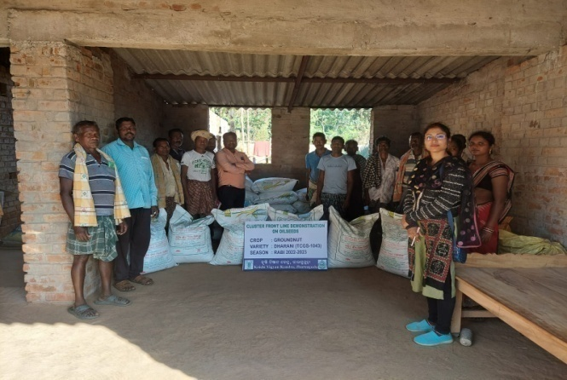 | 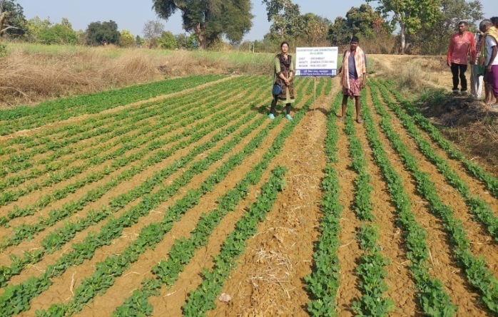
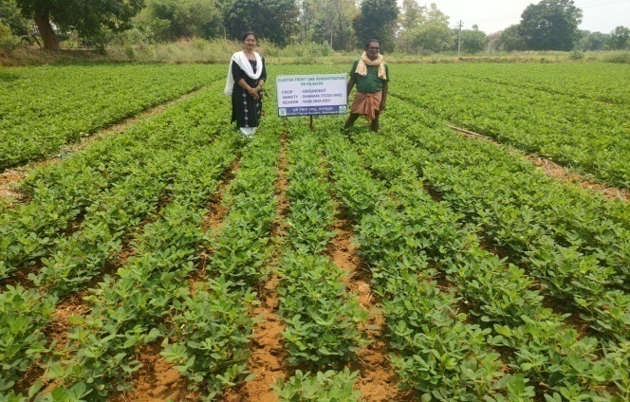 | 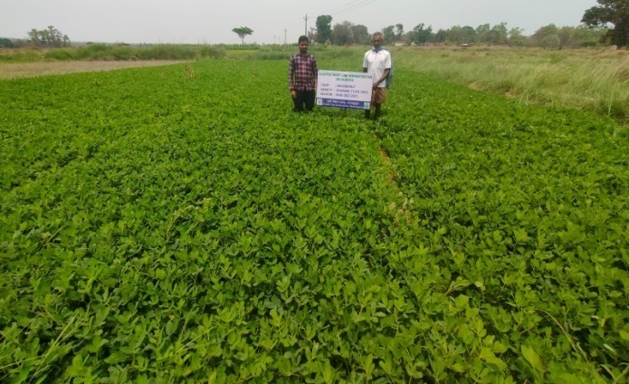
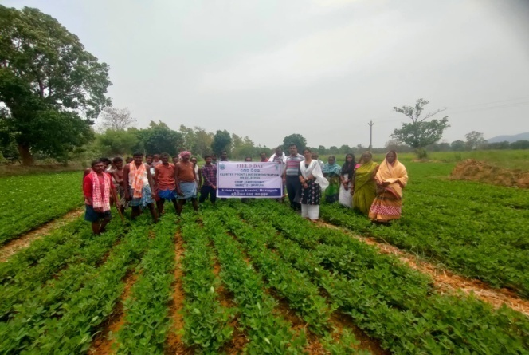 | 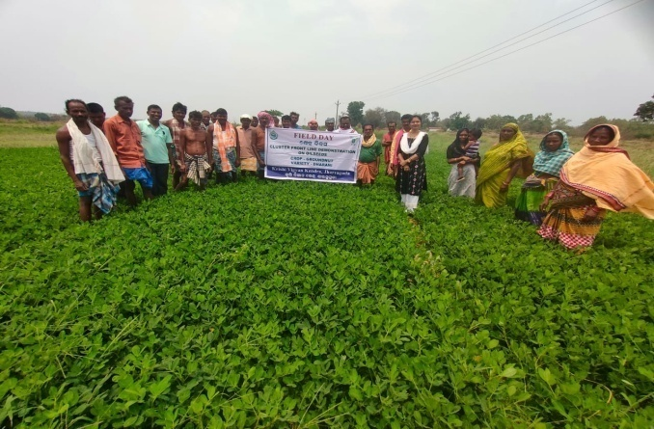
CFLD on Groundnut- Variety Dharani

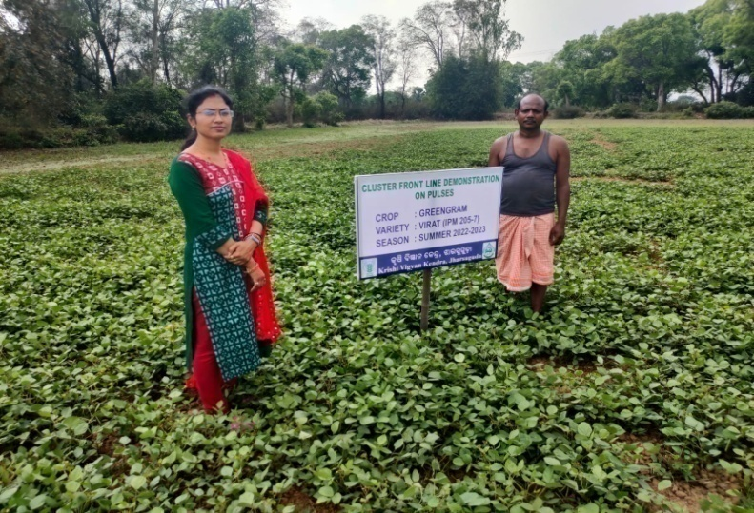 | 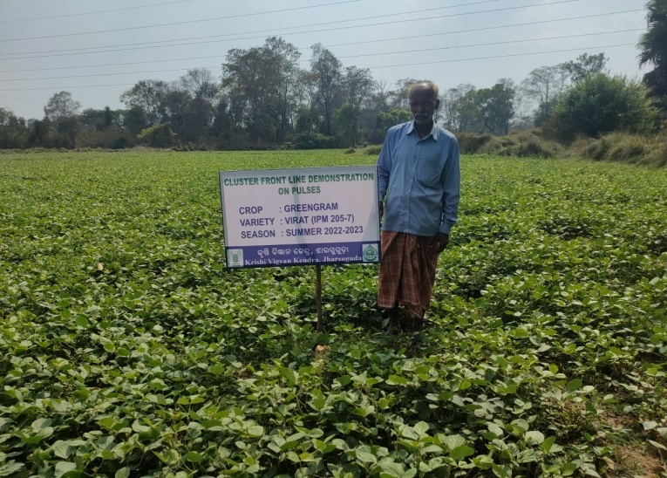
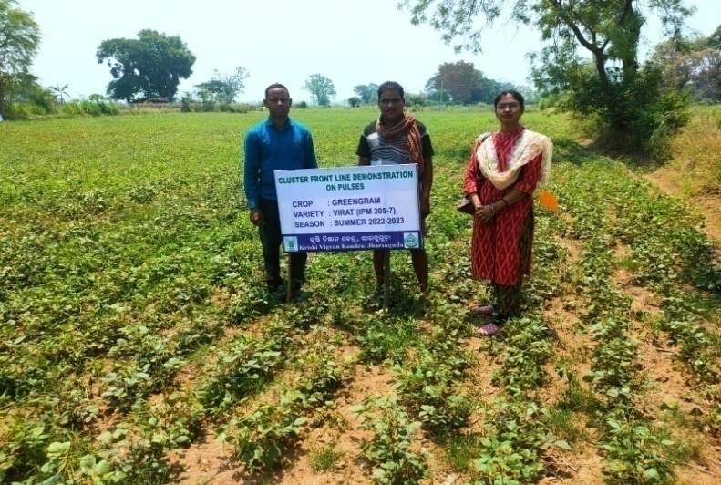 | 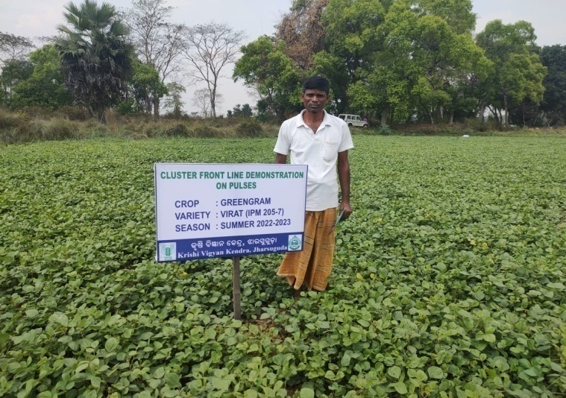
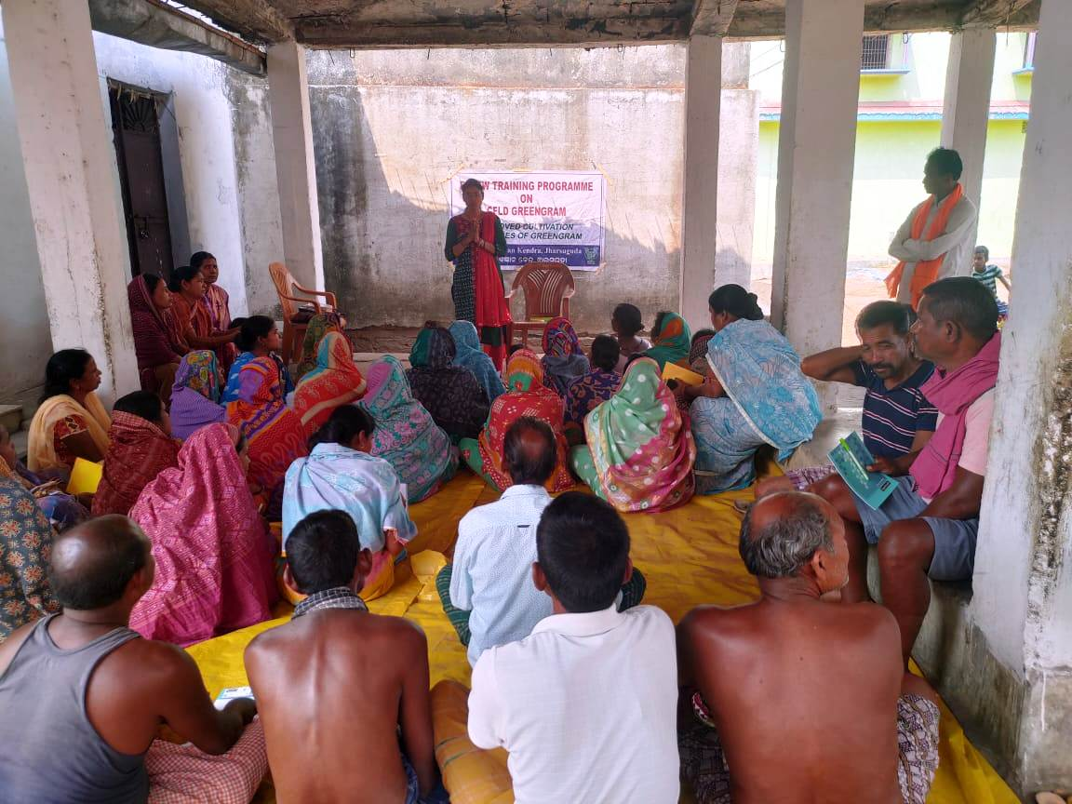 | 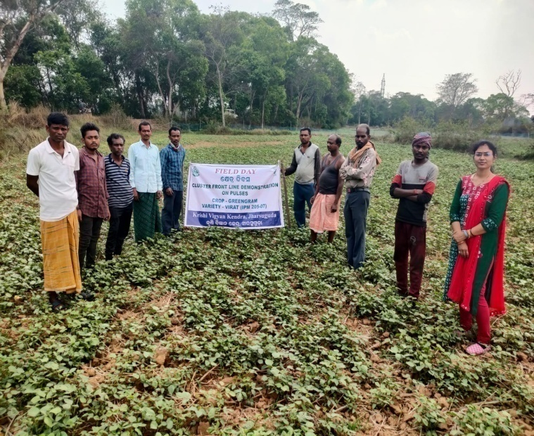
CFLD on Greengram- Variety Virat

- Farmers' training photographs
- Quality ActionPhotographs of field visits/field days and technology demonstrated.

J. Details of budget utilization

Crop  (provide crop wise information ) | Items | Budget  Received  (Rs.) | Budget  Utilization  (Rs.) | Balance  (Rs.)
CFLD Oilseeds | i) Critical input | 120000 | 106530
CFLD Oilseeds | ii) TA/DA/POL etc. for monitoring |  | 6575
CFLD Oilseeds | iii) Extension Activities (Field day) |  | 6895
CFLD Oilseeds | iv)Publication of literature |  | --
 | Total | 120000 | 120000 | Nil

Crop  (provide crop wise information ) | Items | Budget  Received  (Rs.) | Budget  Utilization  (Rs.) | Balance  (Rs.)
CFLD Pulses | i) Critical input | 88800 | 60270 | Nil
CFLD Pulses | ii) TA/DA/POL etc. for monitoring | 88800 | 4000 | Nil
CFLD Pulses | iii) Extension Activities (Field day) | 88800 | 9530 | Nil
CFLD Pulses | iv)Publication of literature | 88800 | 15000 | Nil
 | Total | 88800 | 88800

  - Achievements on Training (Including the sponsored and FLD training programmes):

- Farmers and farm women (on campus)

Thematic Area | No. of Courses | No. of Participants |  |  |  |  |  |  |  |  |  | Grand Total
Thematic Area | No. of Courses | Other |  |  | SC |  |  |  | ST
 | No. of Courses | M | F | T | M | F |  | T | M | F | T | M | F | T
I. Crop Production
Weed Management
Resource Conservation Technologies
Cropping Systems
Crop Diversification
Integrated Farming
Micro irrigation/irrigation
Seed production
Nursery management
Integrated Crop Management | 1 | 2 | 11 | 13 | - | 8 |  | 8 | - | 9 | 9 | 2 | 28 | 30
Soil & water conservation
Integrated nutrient Management
Production of organic inputs
Others
Total | 1 | 2 | 11 | 13 | - | 8 |  | 8 | - | 9 | 9 | 2 | 28 | 30
II. Horticulture
a) Vegetable Crops
Production of low volume and high value crops
Off0season vegetables
Nursery raising
Exotic vegetables
Export potential vegetables
Grading and standardization
Protective cultivation
Others
Total (a)
b) Fruits
Training and Pruning
Layout and Management of Orchards
Cultivation of Fruit
Management of young plants/orchards
Rejuvenation of old orchards
Export potential fruits
Micro irrigation systems of orchards
Plant propagation techniques
Others
Total (b)
c) Ornamental Plants
Nursery Management
Management of potted plants
Export potential of ornamental plants
Propagation techniques of Ornamental Plants
Others
Total (c)
d) Plantation crops
Production and Management technology
Processing and value addition
Others
Total (d)
e) Tuber crops
Production and Management technology
Processing and value addition
Others
Total (e)
f) Spices
Production and Management technology
Processing and value addition
Others
Total (f)
g) Medicinal and Aromatic Plants
Nursery management
Production and management technology
Post harvest technology and value addition
Others
Total (g)
Total(a-g)
III. Soil Health and Fertility Management
Soil fertility management
Integrated water management
Integrated Nutrient Management
Production and use of organic inputs
Management of Problematic soils
Micro nutrient deficiency in crops
Nutrient Use Efficiency
Balance Use of fertilizer
Soil & water testing
others
Total
IV. Livestock Production and Management
Dairy Management
Poultry Management
Piggery Management
Rabbit Management
Animal Nutrition Management
Disease Management
Feed & fodder technologies
Production of quality animal products
Others
Total
V. Home Science/Women empowerment
Household food security by kitchen gardening and nutrition gardening
Design and development of low/minimum cost diet
Designing and development for high nutrient efficiency diet
Minimization of nutrient loss in processing
Processing & cooking
Gender mainstreaming through SHGs
Storage loss minimization techniques
Value addition
Women empowerment
Location specific drudgery reduction technologies
Rural Crafts
Women and child care
Others
Total
VI. Agril. Engineering
Farm machinery & its maintenance
Installation and maintenance of micro irrigation systems
Use of Plastics in farming practices
Production of small tools and implements
Repair and maintenance of farm machinery and implements
Small scale processing and value addition
Post Harvest Technology
Others
Total
VII. Plant Protection
Integrated Pest Management
Integrated Disease Management
Bio0control of pests and diseases
Production of bio control agents and bio pesticides
Others
Total
VIII. Fisheries
Integrated fish farming
Carp breeding and hatchery management
Carp fry and fingerling rearing
Composite fish culture
Hatchery management and culture of freshwater prawn
Breeding and culture of ornamental fishes
Portable plastic carp hatchery
Pen culture of fish and prawn
Shrimp farming
Edible oyster farming
Pearl culture
Fish processing and value addition
Others
Total
IX. Production of Input at site
Seed Production
Planting material production
Bio0agents production
Bio0pesticides production
Bio0fertilizer production
Vermi0compost production
Organic manures production
Production of fry and fingerlings
Production of Bee0colonies and wax sheets
Small tools and implements
Production of livestock feed and fodder
Production of Fish feed
Mushroom production
Apiculture
Others
Total
X. Capacity Building and Group Dynamics
Leadership development
Group dynamics
Formation and Management of SHGs
Mobilization of social capital
Entrepreneurial development of farmers/youths
WTO and IPR issues
Others
Total
XI. Agro forestry
Production technologies
Nursery management
Integrated Farming Systems
Others
Total
XII. Others (Pl. Specify)
GRAND TOTAL | 1 | 2 | 11 | 13 | - |  | 8 | 8 | - | 9 | 9 | 2 | 28 | 30

B) Rural Youth (on campus)

Thematic Area | No. of Courses | No. of Participants |  |  |  |  |  |  |  |  |  | Grand Total
Thematic Area | No. of Courses | Other |  |  | SC |  |  |  | ST
 | No. of Courses | M | F | T | M | F |  | T | M | F | T | M | F | T
Nursery Management of Horticulture crops
Training and pruning of orchards
Protected cultivation of vegetable crops
Commercial fruit production
Integrated farming
Seed production | 2 | 9 | 19 | 13 | 2 |  | 2 | 4 | 3 | 0 | 3 | 14 | 21 | 35
Production of organic inputs | 4 | 5 | 41 | 46 | 0 |  | 11 | 11 | 0 | 18 | 18 | 5 | 60 | 65
Planting material production
Vermiculture
Mushroom Production
Beekeeping
Sericulture
Repair and maintenance of farm machinery and implements
Value addition
Small scale processing
Post Harvest Technology
Tailoring and Stitching
Rural Crafts
Production of quality animal products
Dairying
Sheep and goat rearing
Quail farming
Piggery
Rabbit farming
Poultry production
Ornamental fisheries
Composite fish culture
Freshwater prawn culture
Shrimp farming
Pearl culture
Cold water fisheries
Fish harvest and processing technology
Fry and fingerling rearing
Others | 1 | 0 | 3 | 3 | 0 |  | 8 | 8 | 0 | 9 | 9 | 0 | 20 | 20
Total | 7 | 14 | 63 | 62 | 2 |  | 21 | 23 | 3 | 27 | 30 | 19 | 101 | 120

C) Extension Personnel (on campus)

Thematic Area | No. of Courses | No. of Participants |  |  |  |  |  |  |  |  |  | Grand Total
Thematic Area | No. of Courses | Other |  |  | SC |  |  |  | ST
 | No. of Courses | M | F | T | M | F |  | T | M | F | T | M | F | T
Productivity enhancement in field crops | 1 | 11 | 6 | 17 | 0 |  | 2 | 2 | 3 | 3 | 6 | 14 | 11 | 25
Integrated Pest Management
Integrated Nutrient management
Rejuvenation of old orchards
Protected cultivation technology
Production and use of organic inputs | 1 | 4 | 1 | 5 | 5 |  | 3 | 8 | 4 | 13 | 17 | 13 | 17 | 30
Care and maintenance of farm machinery and implements
Gender mainstreaming through SHGs
Formation and Management of SHGs
Women and Child care
Low cost and nutrient efficient diet designing
Group Dynamics and farmers organization
Information networking among farmers
Capacity building for ICT application
Management in farm animals
Livestock feed and fodder production
Household food security
Other(QPM and IFS models) | 3 | 26 | 8 | 34 | 3 |  | 1 | 4 | 2 | 0 | 2 | 31 | 9 | 40
Total | 5 | 41 | 15 | 56 | 8 |  | 6 | 14 | 9 | 16 | 25 | 58 | 37 | 95
D) Farmers and farm women (off campus)

Thematic Area | No. of Courses | No. of Participants |  |  |  |  |  |  |  |  |  | Grand Total
Thematic Area | No. of Courses | Other |  |  | SC |  |  |  | ST
 | No. of Courses | M | F | T | M | F |  | T | M | F | T | M | F | T
I. Crop Production
Weed Management | 1 | 5 | 23 | 28 | 0 | 0 |  | 0 | 0 | 2 | 2 | 5 | 25 | 30
Resource Conservation Technologies
Cropping Systems | 1 | 1 | 1 | 2 | 4 | 10 |  | 14 | 3 | 6 | 9 | 8 | 17 | 25
Crop Diversification | 2 | 14 | 32 | 46 | 0 | 0 |  | 0 | 0 | 9 | 9 | 14 | 41 | 55
Integrated Farming
Micro irrigation/irrigation
Seed production | 2 | 0 | 27 | 27 | 0 | 17 |  | 17 | 1 | 15 | 16 | 1 | 59 | 60
Nursery management | 1 | 0 | 15 | 15 | 1 | 7 |  | 8 | 0 | 2 | 2 | 1 | 24 | 25
Integrated Crop Management | 3 | 28 | 44 | 72 | 0 | 6 |  | 6 | 0 | 12 | 12 | 28 | 62 | 90
Soil & water conservation | 1 | 0 | 2 | 2 | 0 | 28 |  | 28 | 0 | 0 | 0 | 0 | 30 | 30
Integrated nutrient Management | 3 | 7 | 19 | 26 | 2 | 5 |  | 7 | 19 | 23 | 42 | 28 | 47 | 75
Production of organic inputs
Others | 3 | 7 | 5 | 12 | 3 | 6 |  | 9 | 4 | 0 | 4 | 14 | 11 | 25
Total | 17 | 62 | 168 | 230 | 10 | 79 |  | 89 | 27 | 69 | 96 | 99 | 316 | 415
II. Horticulture
a) Vegetable Crops
Production of low volume and high value crops
Off0season vegetables
Nursery raising | 1 | 5 | 16 | 21 | 0 | 0 |  | 0 | 1 | 8 | 9 | 6 | 24 | 30
Exotic vegetables
Export potential vegetables
Grading and standardization
Protective cultivation
Others
Total (a) | 1 | 5 | 16 | 21 | 0 | 0 |  | 0 | 1 | 8 | 9 | 6 | 24 | 30
b) Fruits
Training and Pruning
Layout and Management of Orchards
Cultivation of Fruit
Management of young plants/orchards
Rejuvenation of old orchards
Export potential fruits
Micro irrigation systems of orchards
Plant propagation techniques
Others
Total (b)
c) Ornamental Plants
Nursery Management
Management of potted plants
Export potential of ornamental plants
Propagation techniques of Ornamental Plants
Others
Total (c)
d) Plantation crops
Production and Management technology
Processing and value addition
Others
Total (d)
e) Tuber crops
Production and Management technology
Processing and value addition
Others
Total (e)
f) Spices
Production and Management technology
Processing and value addition
Others
Total (f)
g) Medicinal and Aromatic Plants
Nursery management
Production and management technology
Post harvest technology and value addition
Others
Total (g)
Total(a-g)
III. Soil Health and Fertility Management
Soil fertility management
Integrated water management
Integrated Nutrient Management | 1 | 8 | 12 | 20 | 1 | 0 |  | 1 | 1 | 6 | 7 | 10 | 18 | 28
Production and use of organic inputs
Management of Problematic soils
Micro nutrient deficiency in crops
Nutrient Use Efficiency
Balance Use of fertilizer
Soil & water testing
others
Total | 1 | 8 | 12 | 20 | 1 | 0 |  | 1 | 1 | 6 | 7 | 10 | 18 | 28
IV. Livestock Production and Management
Dairy Management
Poultry Management
Piggery Management
Rabbit Management
Animal Nutrition Management
Disease Management
Feed & fodder technologies
Production of quality animal products
Others
Total
V. Home Science/Women empowerment
Household food security by kitchen gardening and nutrition gardening
Design and development of low/minimum cost diet
Designing and development for high nutrient efficiency diet
Minimization of nutrient loss in processing
Processing & cooking
Gender mainstreaming through SHGs
Storage loss minimization techniques | 2 | 6 | 17 | 23 | 0 | 2 |  | 2 | 4 | 21 | 25 | 10 | 40 | 50
Value addition
Women empowerment
Location specific drudgery reduction technologies
Rural Crafts
Women and child care
Others
Total | 2 | 6 | 17 | 23 | 0 | 2 |  | 2 | 4 | 21 | 25 | 10 | 40 | 50
VI. Agril. Engineering
Farm machinery & its maintenance | 1 | 33 | 12 | 45 | 7 | 8 |  | 15 | 12 | 3 | 15 | 52 | 23 | 75
Installation and maintenance of micro irrigation systems
Use of Plastics in farming practices
Production of small tools and implements
Repair and maintenance of farm machinery and implements
Small scale processing and value addition
Post Harvest Technology | 1 | 1 | 16 | 17 | 0 | 0 |  | 0 | 0 | 13 | 13 | 1 | 29 | 30
Others
Total | 2 | 34 | 28 | 62 | 7 | 8 |  | 15 | 12 | 16 | 28 | 53 | 52 | 105
VII. Plant Protection
Integrated Pest Management | 2 | 2 | 18 | 20 | 1 | 0 |  | 1 | 21 | 8 | 29 | 24 | 26 | 50
Integrated Disease Management | 7 | 17 | 13 | 30 | 19 | 111 |  | 130 | 7 | 16 | 23 | 43 | 140 | 183
Bio0control of pests and diseases
Production of bio control agents and bio pesticides
Others
Total | 9 | 19 | 31 | 50 | 20 | 111 |  | 131 | 28 | 24 | 52 | 67 | 166 | 233
VIII. Fisheries
Integrated fish farming
Carp breeding and hatchery management
Carp fry and fingerling rearing
Composite fish culture
Hatchery management and culture of freshwater prawn
Breeding and culture of ornamental fishes
Portable plastic carp hatchery
Pen culture of fish and prawn
Shrimp farming
Edible oyster farming
Pearl culture
Fish processing and value addition
Others
Total
IX. Production of Input at site
Seed Production
Planting material production
Bio-agents production
Bio-pesticides production
Bio-fertilizer production
Vermi-compost production | 1 | 0 | 13 | 13 | 0 |  | 12 | 12 | 0 | 0 | 0 | 0 | 25 | 25
Organic manures production
Production of fry and fingerlings
Production of Bee-colonies and wax sheets
Small tools and implements
Production of livestock feed and fodder
Production of Fish feed
Mushroom production | 1 | 0 | 7 | 7 | 0 |  | 1 | 1 | 0 | 17 | 17 | 0 | 25 | 25
Apiculture
Others
Total | 2 | 0 | 20 | 20 | 0 |  | 13 | 13 | 0 | 17 | 17 | 0 | 50 | 50
X. Capacity Building and Group Dynamics
Leadership development
Group dynamics | 2 | 25 | 17 | 42 | 3 |  | 0 | 3 | 6 | 0 | 5 | 33 | 17 | 50
Formation and Management of SHGs | 1 | 12 | 1 | 13 | 3 |  | 4 | 7 | 12 | 18 | 30 | 27 | 23 | 50
Mobilization of social capital | 1 | 8 | 13 | 21 | 0 |  | 1 | 1 | 1 | 2 | 3 | 9 | 16 | 25
Entrepreneurial development of farmers/youths
WTO and IPR issues
Others | 2 | 46 | 27 | 74 | 1 |  | 3 | 4 | 1 | 7 | 8 | 48 | 37 | 85
Total | 6 | 91 | 58 | 150 | 7 |  | 8 | 15 | 20 | 27 | 46 | 117 | 93 | 210
XI. Agro forestry
Production technologies
Nursery management
Integrated Farming Systems
Others
Total
XII. Others (Pl. Specify)
GRAND TOTAL | 40 | 225 | 350 | 576 | 45 |  | 221 | 266 | 93 | 188 | 280 | 362 | 759 | 1121

E)RURAL YOUTH (Off Campus)

Thematic Area | No. of Courses | No. of Participants |  |  |  |  |  |  |  |  |  | Grand Total
Thematic Area | No. of Courses | Other |  |  | SC |  |  |  | ST
 | No. of Courses | M | F | T | M | F |  | T | M | F | T | M | F | T
Nursery Management of Horticulture crops
Training and pruning of orchards
Protected cultivation of vegetable crops
Commercial fruit production
Integrated farming
Seed production
Production of organic inputs
Planting material production
Vermiculture
Mushroom Production
Beekeeping
Sericulture
Repair and maintenance of farm machinery and implements
Value addition
Small scale processing
Post Harvest Technology
Tailoring and Stitching
Rural Crafts
Production of quality animal products
Dairying
Sheep and goat rearing
Quail farming
Piggery
Rabbit farming
Poultry production
Ornamental fisheries
Composite fish culture
Freshwater prawn culture
Shrimp farming
Pearl culture
Cold water fisheries
Fish harvest and processing technology
Fry and fingerling rearing
Others
Total

F) Extension Personnel (Off Campus)

Thematic Area | No. of Courses | No. of Participants |  |  |  |  |  |  |  |  |  | Grand Total
Thematic Area | No. of Courses | Other |  |  | SC |  |  |  | ST
 | No. of Courses | M | F | T | M | F |  | T | M | F | T | M | F | T
Productivity enhancement in field crops
Integrated Pest Management
Integrated Nutrient management
Rejuvenation of old orchards
Protected cultivation technology
Production and use of organic inputs
Care and maintenance of farm machinery and implements
Gender mainstreaming through SHGs
Formation and Management of SHGs
Women and Child care
Low cost and nutrient efficient diet designing
Group Dynamics and farmers organization
Information networking among farmers
Capacity building for ICT application
Management in farm animals
Livestock feed and fodder production
Household food security
Other
Total

G) Consolidated table (ON and OFF Campus)
i. Farmers& Farm Women
Thematic Area | No. of Courses | No. of Participants |  |  |  |  |  |  |  |  | Grand Total
Thematic Area | No. of Courses | Other |  |  | SC |  |  | ST
 | No. of Courses | M | F | T | M | F | T | M | F | T | M | F | T
I. Crop Production
Weed Management | 1 | 5 | 23 | 28 | 0 | 0 | 0 | 0 | 2 | 2 | 5 | 25 | 30
Resource Conservation Technologies
Cropping Systems | 1 | 1 | 1 | 2 | 4 | 10 | 14 | 3 | 6 | 9 | 8 | 17 | 25
Crop Diversification | 2 | 14 | 32 | 46 | 0 | 0 | 0 | 0 | 9 | 9 | 14 | 41 | 55
Integrated Farming
Micro irrigation/irrigation
Seed production | 2 | 0 | 27 | 27 | 0 | 17 | 17 | 1 | 15 | 16 | 1 | 59 | 60
Nursery management | 1 | 0 | 15 | 15 | 1 | 7 | 8 | 0 | 2 | 2 | 1 | 24 | 25
Integrated Crop Management | 4 | 30 | 55 | 85 | 0 | 14 | 14 | 0 | 21 | 21 | 30 | 90 | 120
Soil & water conservation | 1 | 0 | 2 | 2 | 0 | 28 | 28 | 0 | 0 | 0 | 0 | 30 | 30
Integrated nutrient Management | 3 | 7 | 19 | 26 | 2 | 5 | 7 | 19 | 23 | 42 | 28 | 47 | 75
Production of organic inputs
Others | 3 | 7 | 5 | 12 | 3 | 6 | 9 | 4 | 0 | 4 | 14 | 11 | 25
Total | 18 | 64 | 179 | 243 | 10 | 87 | 97 | 27 | 78 | 105 | 101 | 344 | 445
II. Horticulture
a) Vegetable Crops
Production of low volume and high value crops
Off-season vegetables
Nursery raising | 1 | 5 | 16 | 21 | 0 | 0 | 0 | 1 | 8 | 9 | 6 | 24 | 30
Exotic vegetables
Export potential vegetables
Grading and standardization
Protective cultivation
Others
Total (a) | 1 | 5 | 16 | 21 | 0 | 0 | 0 | 1 | 8 | 9 | 6 | 24 | 30
b) Fruits
Training and Pruning
Layout and Management of Orchards
Cultivation of Fruit
Management of young plants/orchards
Rejuvenation of old orchards
Export potential fruits
Micro irrigation systems of orchards
Plant propagation techniques
Others
Total (b)
c) Ornamental Plants
Nursery Management
Management of potted plants
Export potential of ornamental plants
Propagation techniques of Ornamental Plants
Others
Total (c)
d) Plantation crops
Production and Management technology
Processing and value addition
Others
Total (d)
e) Tuber crops
Production and Management technology
Processing and value addition
Others
Total (e)
f) Spices
Production and Management technology
Processing and value addition
Others
Total (f)
g) Medicinal and Aromatic Plants
Nursery management
Production and management technology
Post harvest technology and value addition
Others
Total (g)
Total(a-g)
III. Soil Health and Fertility Management
Soil fertility management
Integrated water management
Integrated Nutrient Management
Production and use of organic inputs | 1 | 8 | 12 | 20 | 1 | 0 | 1 | 1 | 6 | 7 | 10 | 18 | 28
Management of Problematic soils
Micro nutrient deficiency in crops
Nutrient Use Efficiency
Balance Use of fertilizer
Soil & water testing
others
Total | 1 | 8 | 12 | 20 | 1 | 0 | 1 | 1 | 6 | 7 | 10 | 18 | 28
IV. Livestock Production and Management
Dairy Management
Poultry Management
Piggery Management
Rabbit Management
Animal Nutrition Management
Disease Management
Feed & fodder technologies
Production of quality animal products
Others
Total
V. Home Science/Women empowerment
Household food security by kitchen gardening and nutrition gardening
Design and development of low/minimum cost diet
Designing and development for high nutrient efficiency diet
Minimization of nutrient loss in processing
Processing & cooking
Gender mainstreaming through SHGs
Storage loss minimization techniques | 2 | 6 | 17 | 23 | 0 | 2 | 2 | 4 | 21 | 25 | 10 | 40 | 50
Value addition
Women empowerment
Location specific drudgery reduction technologies
Rural Crafts
Women and child care
Others
Total | 2 | 6 | 17 | 23 | 0 | 2 | 2 | 4 | 21 | 25 | 10 | 40 | 50
VI. Agril. Engineering
Farm machinery & its maintenance | 1 | 33 | 12 | 45 | 7 | 8 | 15 | 12 | 3 | 15 | 52 | 23 | 75
Installation and maintenance of micro irrigation systems
Use of Plastics in farming practices
Production of small tools and implements
Repair and maintenance of farm machinery and implements
Small scale processing and value addition
Post Harvest Technology | 1 | 1 | 16 | 17 | 0 | 0 | 0 | 0 | 13 | 13 | 1 | 29 | 30
Others
Total | 2 | 34 | 28 | 62 | 7 | 8 | 15 | 12 | 16 | 28 | 53 | 52 | 105
VII. Plant Protection
Integrated Pest Management | 2 | 2 | 18 | 20 | 1 | 0 | 1 | 21 | 8 | 29 | 24 | 26 | 50
Integrated Disease Management | 7 | 17 | 13 | 30 | 19 | 111 | 130 | 7 | 16 | 23 | 43 | 140 | 183
Bio0control of pests and diseases
Production of bio control agents and bio pesticides
Others
Total | 9 | 19 | 31 | 50 | 20 | 111 | 131 | 28 | 24 | 52 | 67 | 166 | 233
VIII. Fisheries
Integrated fish farming
Carp breeding and hatchery management
Carp fry and fingerling rearing
Composite fish culture
Hatchery management and culture of freshwater prawn
Breeding and culture of ornamental fishes
Portable plastic carp hatchery
Pen culture of fish and prawn
Shrimp farming
Edible oyster farming
Pearl culture
Fish processing and value addition
Others
Total
IX. Production of Input at site
Seed Production
Planting material production
Bio-agents production
Bio-pesticides production
Bio-fertilizer production
Vermi-compost production | 1 | 0 | 13 | 13 | 0 | 12 | 12 | 0 | 0 | 0 | 0 | 25 | 25
Organic manures production
Production of fry and fingerlings
Production of Bee-colonies and wax sheets
Small tools and implements
Production of livestock feed and fodder
Production of Fish feed
Mushroom production | 1 | 0 | 7 | 7 | 0 | 1 | 1 | 0 | 17 | 17 | 0 | 25 | 25
Apiculture
Others
Total | 2 | 0 | 20 | 20 | 0 | 13 | 13 | 0 | 17 | 17 | 0 | 50 | 50
X. Capacity Building and Group Dynamics
Leadership development
Group dynamics | 2 | 25 | 17 | 42 | 3 | 0 | 3 | 6 | 0 | 5 | 33 | 17 | 50
Formation and Management of SHGs | 1 | 12 | 1 | 13 | 3 | 4 | 7 | 12 | 18 | 30 | 27 | 23 | 50
Mobilization of social capital | 1 | 8 | 13 | 21 | 0 | 1 | 1 | 1 | 2 | 3 | 9 | 16 | 25
Entrepreneurial development of farmers/youths
WTO and IPR issues
Others | 2 | 46 | 27 | 74 | 1 | 3 | 4 | 1 | 7 | 8 | 48 | 37 | 85
Total | 6 | 91 | 58 | 150 | 7 | 8 | 15 | 20 | 27 | 46 | 117 | 93 | 210
XI. Agro forestry
Production technologies
Nursery management
Integrated Farming Systems
Others
Total
XII. Others (Pl. Specify)
GRAND TOTAL | 41 | 227 | 361 | 589 | 45 | 229 | 274 | 93 | 197 | 289 | 364 | 787 | 1151

ii. RURAL YOUTH (On and Off Campus)

Thematic Area | No. of Courses | No. of Participants |  |  |  |  |  |  |  |  |  | Grand Total
Thematic Area | No. of Courses | Other |  |  | SC |  |  |  | ST
 | No. of Courses | M | F | T | M | F |  | T | M | F | T | M | F | T
Nursery Management of Horticulture crops
Training and pruning of orchards
Protected cultivation of vegetable crops
Commercial fruit production
Integrated farming
Seed production | 2 | 9 | 19 | 13 | 2 |  | 2 | 4 | 3 | 0 | 3 | 14 | 21 | 35
Production of organic inputs | 4 | 5 | 41 | 46 | 0 |  | 11 | 11 | 0 | 18 | 18 | 5 | 60 | 65
Planting material production
Vermiculture
Mushroom Production
Beekeeping
Sericulture
Repair and maintenance of farm machinery and implements
Value addition
Small scale processing
Post Harvest Technology
Tailoring and Stitching
Rural Crafts
Production of quality animal products
Dairying
Sheep and goat rearing
Quail farming
Piggery
Rabbit farming
Poultry production
Ornamental fisheries
Composite fish culture
Freshwater prawn culture
Shrimp farming
Pearl culture
Cold water fisheries
Fish harvest and processing technology
Fry and fingerling rearing
Others | 1 | 0 | 3 | 3 | 0 |  | 8 | 8 | 0 | 9 | 9 | 0 | 20 | 20
Total | 7 | 14 | 63 | 62 | 2 |  | 21 | 23 | 3 | 27 | 30 | 19 | 101 | 120

iii. Extension Personnel (On and Off Campus)

Thematic Area | No. of Courses | No. of Participants |  |  |  |  |  |  |  |  |  | Grand Total
Thematic Area | No. of Courses | Other |  |  | SC |  |  |  | ST
 | No. of Courses | M | F | T | M | F |  | T | M | F | T | M | F | T
Productivity enhancement in field crops | 1 | 11 | 6 | 17 | 0 |  | 2 | 2 | 3 | 3 | 6 | 14 | 11 | 25
Integrated Pest Management
Integrated Nutrient management
Rejuvenation of old orchards
Protected cultivation technology
Production and use of organic inputs | 1 | 4 | 1 | 5 | 5 |  | 3 | 8 | 4 | 13 | 17 | 13 | 17 | 30
Care and maintenance of farm machinery and implements
Gender mainstreaming through SHGs
Formation and Management of SHGs
Women and Child care
Low cost and nutrient efficient diet designing
Group Dynamics and farmers organization
Information networking among farmers
Capacity building for ICT application
Management in farm animals
Livestock feed and fodder production
Household food security
Other | 3 | 26 | 8 | 34 | 3 |  | 1 | 4 | 2 | 0 | 2 | 31 | 9 | 40
Total | 5 | 41 | 15 | 56 | 8 |  | 6 | 14 | 9 | 16 | 25 | 58 | 37 | 95

Please furnish the details of training programmes as Annexure in the proforma given below
Discipline | Clientele |  | Title of the training programme | Duration in days | Venue (Off / On Campus) | Number of participants |  |  | Number of SC/ST
 |  |  |  |  |  | Male | Female | Total | Male | Female | Total
Crop Production | F&FW | Integrated Nutrient Managemenr in groundnut |  | 01 | Off | 20 | 5 | 25 | 20 | 5 | 25
Crop Production | F&FW | Crop rotation and crop diversification |  | 01 | Off | 14 | 41 | 55 | 0 | 9 | 9
Crop Production | F&FW | Cultivation of pulses in rice-fallow & its management |  | 01 | Off | 8 | 17 | 25 | 7 | 16 | 23
Crop Production | F&FW | Water management and inturculture operation in summer ground nut |  | 01 | Off | 14 | 11 | 25 | 7 | 6 | 13
Crop Production | F&FW | Store grain pest management in greengram using probag |  | 01 | Off | 5 | 20 | 25 | 3 | 17 | 20
Crop Production | F&FW | Green manuring |  | 01 | Off | 1 | 24 | 25 | 1 | 19 | 20
Crop Production | F&FW | Method demonstration of vermicomposting |  | 01 | Off | 0 | 25 | 25 | 0 | 12 | 12
Crop Production | F&FW | Green manuring in rice field |  | 01 | Off | 7 | 18 | 25 | 0 | 4 | 4
Crop Production | F&FW | Paddy straw Mushroom production |  | 01 | Off | 0 | 25 | 25 | 0 | 18 | 18
Crop Production | F&FW | Nursery managenet in rice |  | 01 | Off | 1 | 24 | 25 | 1 | 9 | 10
Crop Production | F&FW | Seed treatment and seed inoculation in agricultural crops |  | 01 | Off | 0 | 25 | 25 | 0 | 20 | 20
Crop Production | F&FW | Improved cultivation practices of Fingermille |  | 01 | On | 2 | 28 | 30 | 0 | 17 | 17
Crop Production | F&FW | Integrated weed managenet in rice |  | 01 | Off | 5 | 25 | 30 | 0 | 2 | 2
Crop Production | F&FW | Water managenet in medium land rice |  | 01 | Off | 30 | 0 | 30 | 3 | 0 | 3
Crop Production | F&FW | Improved cultivation practices of maize |  | 01 | Off | 19 | 11 | 30 | 0 | 0 | 0
Crop Production | F&FW | Integrated organic farming |  | 01 | Off | 10 | 18 | 28 | 2 | 6 | 8
Crop Production | RY | Production and use of organic input |  | 02 | On | 5 | 60 | 65 | 0 | 29 | 29
Crop Production | RY | Commercial Azollacultivaion |  | 02 | On | 1 | 19 | 20 | 0 | 11 | 11
Crop Production | IS | Use of biodecomposers in crop prodution |  | 01 | On | 10 | 0 | 10 | 3 | 0 | 3
Crop Production | IS | Use of new generation herbicides in field crops |  | 01 | On | 14 | 11 | 25 | 3 | 5 | 8
Crop Production | IS | Organic Farming |  | 01 | On | 13 | 17 | 30 | 9 | 16 | 25
 | F&FW | Soil sample collection technique |  | 1 | Off | 0 | 30 | 30 | 0 | 28 | 28
 | F&FW | Improved cultivation practices of finger millet |  | 1 | Off | 0 | 30 | 30 | 0 | 14 | 14
 | F&FW | Seed production in rice |  | 1 | Off | 0 | 30 | 30 | 0 | 11 | 11
 | F&FW | Storage technique of rice |  | 1 | Off | 1 | 29 | 30 | 0 | 13 | 13
 | F&FW | Disease management in rice |  | 1 | Off | 17 | 13 | 30 | 0 | 0 | 0
 | F&FW | Nursery management of tomato |  | 1 | Off | 6 | 24 | 30 | 1 | 8 | 9
 | F&FW | Seed production of cowpea |  | 1 | Off | 1 | 29 | 30 | 1 | 21 | 22
 | F&FW | Improved cultivation practices of groundnut |  | 1 | Off | 9 | 21 | 30 | 0 | 4 | 4
 | F&FW | IPM in groundnut |  | 1 | Off | 22 | 3 | 25 | 22 | 3 | 25
 | F&FW | YMV Managemnt in green gram |  | 1 | Off | 2 | 23 | 25 | 0 | 5 | 5
 | F&FW | IDM for collar rot and tikka disease managemnet in groundnut |  | 1 | Off | 9 | 16 | 25 | 9 | 16 | 25
 | F&FW | PHMin Groundnut |  | 1 | Off | 5 | 20 | 25 | 1 | 6 | 7
 | F&FW | Disease and pest managemnt in rice |  | 1 | Off | 10 | 15 | 25 | 10 | 15 | 25
 | F&FW | Disease and pest managemnt in sweet corn |  | 1 | Off | 5 | 20 | 25 | 5 | 20 | 25
 | F&FW | Disease and pest managemnt in groundnut |  | 1 | Off | 0 | 25 | 25 | 0 | 25 | 25
 | F&FW | Method demonstration on seed treatment |  | 1 | Off | 0 | 28 | 28 | 0 | 28 | 28
 | F&FW | Method demonstration on seed treatment |  | 1 | Off | 2 | 23 | 25 | 2 | 23 | 25
 | RY | Rice Seed borne diseases and their management |  | 2 | On | 0 | 20 | 20 | 0 | 17 | 17
 | RY | QPM and seedling production |  | 2 | On | 0 | 15 | 15 | 0 | 2 | 2
 | RY | Quality planting materials & seedling production |  | 2 | On | 14 | 6 | 20 | 5 | 0 | 5
 | IS | Seed testing of field crops |  | 1 | On | 11 | 9 | 20 | 2 | 1 | 3
 |  | IFS Development |  | 1 | On | 10 | 0 | 10 | 0 | 0 | 0
Agriculture Extension | F&FW | ICT in Agriculture |  | 01 | Off | 30 | 26 | 56 | 2 | 10 | 12
Agriculture Extension | F&FW | Group based input management practices for farmer groups |  | 01 | Off | 19 | 11 | 30 | 0 | 0 | 0
Agriculture Extension | F&FW | Group management in FPO and Farmers club |  | 01 | Off | 18 | 7 | 25 | 2 | 0 | 2
Agriculture Extension | F&FW | Management of FPO |  | 01 | Off | 27 | 23 | 50 | 15 | 22 | 37
Agriculture Extension | F&FW | Mobilisation of social capital |  | 01 | Off | 9 | 16 | 25 | 1 | 3 | 4

H) Vocational training programmes for Rural Youth

a) Details of training programmes for Rural Youth
Crop / Enterprise | Identified Thrust Area | Training title* | Duration (days) | No. of Participants |  |  | Self employed after training |  |  | Number of persons employed else where
 |  |  |  | Male | Female | Total | Type of units | Number  of units | Number of persons employed
Organic farming | IGA | Organic farming | 5 | 0 | 10 | 10 | Individual | 2 | 3 | 2
*training title should specify the major technology /skill transferred
b) Details of participation
Thematic Area | No. of Courses | No. of Participants |  |  |  |  |  |  |  |  | Grand Total
Thematic Area | No. of Courses | Other |  |  | SC |  |  | ST
 | No. of Courses | M | F | T | M | F | T | M | F | T | M | F |  | T
Crop production and management
Commercial floriculture
Commercial fruit production
Commercial vegetable production
Integrated crop management
Organic farming
Other
Total
Post harvest technology and value addition
Value addition
Other
Total
Livestock and fisheries
Dairy farming
Composite fish culture
Sheep and goat rearing
Piggery
Poultry farming
Other
Total
Income generation activities
Vermicomposting
Production of bioagents, biopesticides,
biofertilizers etc.
Repair and maintenance of farm machinery &imlements
Rural Crafts
Seed production
Sericulture
Mushroom cultivation
Nursery, grafting etc.
Tailoring, stitching, embroidery, dying etc.
Agril. Para-workers, para-vet training
Other
Total
Agricultural Extension
Capacity building and group dynamics
Other
Total
Grand Total

I) Sponsored Training Programmes
a) Details of Sponsored Training Programme
Sl.No | Title | Thematic area | Month | Duration (days) | Client | No. of courses | No. of participants | Sponsoring Agency
Sl.No | Title | Thematic area |  |  | PF/RY/EF | No. of courses | No. of participants | Sponsoring Agency
1. | Scientific Bee Keeping | Apiculture | November-February | 7 days | RY | 4 | 100 | National Bee Board
2 | Awareness training programme for pump technicians and farmers | Farm machinery | February | 1 | PF | 1 | 75 | Department of Energy, Govt. of Odisha
2. | Vermicomposting | Income generation activities | March & July | 5 days | RY | 2 | 40 | OMBADC, Govt. of Odisha
3. | Mushroom Cultivation | Income generation activities | May, August, November, December | 5 days | RY & EF | 4 | 80 | OMBADC, Govt. of Odisha
4 | Nursery Raising of vegetables | Nursery raising | June | 5 days | RY | 1 | 20 | OMBADC, Govt. of Odisha
5. | Organic Farminmg | Organic Farminmg | December | 4 Days | EF | 1 | 20 | OMBADC, Govt. of Odisha
6 | Scientific Bee Keeping | Apiculture | September, November | 4/5 days | PF/RY/EF | 2 | 40 | OMBADC, Govt. of Odisha
7. | Mushroom spawn production | Income generation activities | October | 5 days | PF/RY | 1 | 20 | OMBADC, Govt. of Odisha

b) Details of participation

Thematic Area | No. of Courses | No. of Participants |  |  |  |  |  |  |  |  | Grand Total
Thematic Area | No. of Courses | Other |  |  | SC |  |  | ST
 | No. of Courses | M | F | T | M | F | T | M | F | T | M | F |  | T
Crop production and management
Increasing production and productivity of crops
Commercial production of vegetables
Production and value addition
Fruit Plants
Ornamental plants
Spices crops
Soil health and fertility management
Production of Inputs at site
Methods of protective cultivation
Other
Total
Post harvest technology and value addition
Processing and value addition
Other
Total
Farm machinery
Farm machinery, tools and implements
Other
Total
Livestock and fisheries
Livestock production and management
Animal Nutrition Management
Animal Disease Management
Fisheries Nutrition
Fisheries Management
Other
Total
Home Science
Household nutritional security
Economic empowerment of women
Drudgery reduction of women
Other
Total
Agricultural Extension
Capacity Building and Group Dynamics
Other
Total
Grant Total
Good quality photographs of training activity:

3.4. A. Extension Activities (including activities of FLD programmes)
Nature of Extension Activity | No. of activities | Farmers |  |  |  | Extension Officials |  |  | Total
Nature of Extension Activity | No. of activities | M | F | T | SC/ ST  (% of total) | M | F | Total | M | F | Total
Field Day | 4 | 68 | 52 | 120 | 25 | 4 | 3 | 7 | 72 | 55 | 127
Kisan Mela | 2 | 108 | 72 | 180 | 15 | 8 | 5 | 13 | 116 | 77 | 193
Kisan Ghosthi | 0 | 0 | 0 | 0 | 0 | 0 | 0 | 0 | 0 | 0 | 0
Exhibition | 2 | 132 | 80 | 212 | 12 | 11 | 8 | 19 | 144 | 88 | 232
Film Show | 7 | 110 | 75 | 185 | 10 | 10 | 5 | 15 | 120 | 80 | 200
Method Demonstrations | 22 | 278 | 125 | 403 | 3 | 47 | 12 | 59 | 325 | 137 | 562
Farmers Seminar | 1 | 44 | 57 | 101 | 9 | 3 | 6 | 9 | 47 | 63 | 110
Workshop | 6 | 143 | 71 | 214 | 17 | 24 | 12 | 36 | 167 | 83 | 250
Group meetings | 18 | 252 | 83 | 335 | 14 | 34 | 13 | 47 | 286 | 96 | 382
Lectures delivered as resource persons | 26 | 353 | 104 | 457 | 11 | 37 | 16 | 53 | 390 | 120 | 510
Advisory Services | 26 | 20524 | 6072 | 26596 | 12 | 214 | 110 | 324 | 20738 | 6182 | 26920
Scientific visit to farmers field | 46 | 438 | 183 | 621 | 13 | 24 | 9 | 33 | 462 | 192 | 654
Farmers visit to KVK | 54 | 147 | 132 | 279 | 10 | 18 | 12 | 30 | 165 | 144 | 309
Diagnostic visits | 17 | 132 | 93 | 225 | 8 | 18 | 7 | 25 | 150 | 100 | 250
Exposure visits | 13 | 157 | 118 | 275 | 10 | 7 | 4 | 11 | 164 | 122 | 286
Ex-trainees Sammelan | 0 | 0 | 0 | 0 | 0 | 0 | 0 | 0 | 0 | 0 | 0
Soil health Camp | 1 | 32 | 14 | 46 | 7 | 7 | 4 | 11 | 39 | 18 | 57
Animal Health Camp | 0 | 0 | 0 | 0 | 0 | 0 | 0 | 0 | 0 | 0 | 0
Agri mobile clinic | 0 | 0 | 0 | 0 | 0 | 0 | 0 | 0 | 0 | 0 | 0
Soil test campaigns | 0 | 0 | 0 | 0 | 0 | 0 | 0 | 0 | 0 | 0 | 0
Farm Science Club Conveners meet | 0 | 0 | 0 | 0 | 0 | 0 | 0 | 0 | 0 | 0 | 0
Self Help Group Conveners meetings | 4 | 0 | 0 | 0 | 0 | 0 | 0 | 0 | 0 | 0 | 0
Mahila Mandals Conveners meetings | 0 | 0 | 0 | 0 | 0 | 0 | 0 | 0 | 0 | 0 | 0
Celebration of important days (specify) International Womens Day, Vanomahostav, University Foundation Day, World Food Day, Mahila Kisan Diwas , World Soil Day, Agriculture Extension day, Kissan Diwas | 8 | 128 | 107 | 235 | 18 | 24 | 43 | 67 | 152 | 150 | 302
Sankalp Se Siddhi | 0 | 0 | 0 | 0 | 0 | 0 | 0 | 0 | 0 | 0 | 0
Swatchta Hi Sewa | 12 | 192 | 43 | 235 | 12 | 4 | 3 | 7 | 196 | 46 | 242
Mahila Kisan Divas | 1 | 0 | 25 | 25 | 7 | 2 | 1 | 3 | 2 | 26 | 28
Any Other (Specify)
Total

B. Other Extension activities
Nature of Extension Activity | No. of activities
Newspaper coverage | 7
Radio talks | -
TV talks | -
Popular articles | -
Extension Literature | 12
Other, if any

Good quality photographs of Extension activity:

3.5 a. Production and supply of Technological products

Village seed

Crop | Variety | Quantity of seed  (q) | Value  (Rs) | No. of farmers involved in village seed production | Number of farmers  to whom seed provided
 |  |  |  |  | SC |  | ST |  | Other |  | Total
 |  |  |  |  | M | F | M | F | M | F | M | F
Total

KVK farm

Crop | Variety | Quantity of seed  (q) | Value  (Rs) | Number of farmers  to whom seed provided
 |  |  |  | SC |  | ST |  | Other |  | Total
 |  |  |  | M | F | M | F | M | F | M | F
Dhaincha | Local | 1.4 | 5600 | 1 | 1 | 0 | 2 | 3 | 2 | 5 | 5
Grand Total
Good quality photographs of seed production:

Production of planting materials by the KVKs

Crop | Variety | No. of planting materials | Value  (Rs) | Number of farmers  to whom planting material provided
 |  |  |  | SC |  | ST |  | Other |  | Total
 |  |  |  | M | F | M | F | M | F | M | F
Vegetable seedlings
Cauliflower
Cabbage
Tomato | Arka samrat | 13500 | 33750 | 4 | 1 | 3 | 2 | 3 | 4 | 10 | 7
Brinjal | Blue Star | 2000 | 3000 | 4 | 2 | 4 | 3 | 6 | 1 | 14 | 6
Chilli | Red chil | 500 | 1000 | 2 | 0 | 2 | 1 | 1 | 0 | 5 | 1
Onion | Dark Red | 20000 | 8000 | 2 | 1 | 1 | 0 | 4 | 2 | 7 | 3
Others
Fruits
Mango | Amrapali, Nillan, Mallikaetc | 8.27q | 27291 | 10 | 10 | 11 | 2 | 52 | 33 | 73 | 43
Guava | VNR-Bihi, | 2.8q | 5600 | 5 | 5 | 5 | 5 | 5 | 4 | 15 | 14
Lime
Papaya
Banana
Others
Ornamental plants
Medicinal and Aromatic
Plantation
Spices
Turmeric
Tuber
Elephant yams
Fodder crop saplings
Forest Species
Others, pl.specify
Total |  |  | 72041 | 27 | 19 | 26 | 13 | 71 | 44 | 124 | 74
Good quality photographs of planting materials:

Production of Bio-Products

Name of product | Quantity | Value (Rs.) | No. of Farmers benefitted
Name of product | Kg | Value (Rs.)
 |  |  | SC |  | ST |  | Other |  | Total
 |  |  | M | F | M | F | M | F | M | F
Bio-fertilizers (Vermicpompost) | 900 | 13500 | 1 | 1 | 2 | 0 | 3 | 2 | 6 | 3
Bio-pesticide
Bio-fungicide
Bio-agents
Others, please specify. | 2 | 1000 | 1 | 0 | 0 | 0 | 1 | 0 | 2 | 0
Total

Good quality photographs of bio-products:

Production of livestock materials
Particulars of Live stock | Name of the breed | Number | Value (Rs.) | No. of Farmers benefitted
 |  |  |  | SC |  | ST |  | Other |  | Total
 |  |  |  | M | F | M | F | M | F | M | F
Dairy animals
Cows
Buffaloes
Calves
Others (Pl. specify)
Small ruminants
Sheep
Goat
Other, please specify
Poultry
Broilers
Layers | Kadaknath, Kaveri, | 800 | 85600 | 5 | 3 | 2 | 3 | 6 | 1 | 13 | 07
Duals (broiler and layer)
Japanese Quail
Turkey
Emu
Ducks | Khaki Campbel | 500 | 53500 | 3 | 2 | 2 | - | 3 | - | 8 | 2
Others (Pl. specify)
Piggery
Piglet
Hog
Others (Pl. specify)
Fisheries
Indian carp
Exotic carp
Mixed carp
Fish fingerlings
Spawn
Others (Pl. specify)
Grand Total
Good quality photographs of livestock and fisheries:

3.5. b. Seed Hub Programme-“Creation of Seed Hubs for Increasing Indigenous Production of Pulses in India”
i) Name of Seed Hub Centre:

Name of Nodal Officer :
Address :
e-mail :
Phone No. :
Mobile :

ii) Quality Seed Production Reports
Season | Crop | Variety | Production (q)
Season | Crop | Variety | Target | Area sown (ha) | Production | Category of Seed  (F/S, C/S)
Kharif 2023
Rabi 2021-22
Summer/Spring 2023
Kharif 2023
Rabi 2022-2023

iii) Financial Progress
Fund received  (2020-21, 2021-22, 2022-23 and 2023-24) | Expenditure (Rs. in lakhs) |  | Unspent balance  (Rs. in lakhs) | Remarks
Fund received  (2020-21, 2021-22, 2022-23 and 2023-24) | Infrastructure | Revolving fund | Unspent balance  (Rs. in lakhs) | Remarks
2020-21
2021-22
2022-23
2023-24

iv) Infrastructure Development

Item | Progress
Seed processing unit
Seed storage structure

3.6. (A) Literature Developed/Published (with full title, author & reference)

Item | Title | Author’s name | Number | Circulation
Research paper | Effect of bypass fat feeding intake & co-relation with milk production & body conditions of cross breed lactating cows in coastal district of odisha | Samir Ranjan Dash, P K padhy | - | Journal- Multilogic in Science ( ISSN 2277-7601)  Volume – XIII,  Issue – XXXXVI  April - 2023  Page ; 632-636
 | Impact of Self help Group (SHG) interventions on empowerment of rural women in Odisha: A study | Madhumita Jena, S R Dash and LakhanlalMeena | - | The Pharma Innovation  Journal : 2023  12 (5) : 1043 – 1050 ISSN : 2277-7695
Seminar/conference/ symposia papers
Books
Bulletins
News letter | Sabujima | Dr. S.R Dash  Dr. Anuj Ku. Ray  Ms. Susmita Panda | 500 | 500
Popular Articles
Book Chapter
Extension Pamphlets/ literature | - Oyster mushroom production  - Scientific method of Mustard Cultivation  - Azolla Cultivation | Dr. S.R Dash  Dr. Anuj Ku. Ray  Ms. Susmita Panda | 1500 | 1500
Technical reports | Annual Report and Action Plan, District contingent plan | Dr. S.R Dash  Dr. Anuj Ku. Ray  Ms. Susmita Panda
Electronic Publication (CD/DVD etc.)
TOTAL |  |  | 2000 | 2000

N.B.: Please enclose a copy of each. In case of literature prepared in local language please indicate the title in English

(B) Details of HRD programmes undergone by KVK personnel:

Sl. No. | Name of programme | Name of course | Name of KVK personnel and designation | Date and Duration | Organized by
1. | International Extension Conference | Participation in International conference on “Innovative application in Agriculture extension for sustainable food and environment security” | Dr. S. R Dash, SS&H | 27-30 Jan 2023 | BHU, Varanasi, UP
2. | Workshop | Reinventing system for agricultural transformation | Dr. S. R Dash, SS&H | 25th Aug | OUAT, Bhubaneswar
3 | Workshop (Virtual mode) | Social media management | Dr. S. R Dash, SS&H | 4th Sept 2023 | ICAR-ATARI, Kolkata
4 | Seminar (Virtual mode) | Paradigm Shift in Extension to Appropriately Support Sustainable Agricultural Development | Dr. S. R Dash, SS&H | 29th Sept 2023 | ICAR-ATARI, Kolkata
5 | Seminar | Health Benefits of Millets | Dr. S. R Dash, SS&H | 11th Dec 2023 | Odisha Millet Mission & Mission Shakti
6. | Refresher Training cum Exposure Visit | IFS for sustainable agriculture and livelihood security | Ms. Susmita Panda , SMS (Agro) | 27-28 March 2023 | OUAT, Bhubaneswar
7. | Refresher Training programme | Recent Advances in Mushroom Production Technology | Ms. Susmita Panda , SMS (Agro) | 10-11 July 2023 | CTMRT, OUAT, Bhubaneswar
8. | Workshop | Workshop on Nano Urea | Ms. Susmita Panda , SMS (Agro) | 22nd June 2023 | OUAT, Bhubaneswar
9. | Training (Virtual mode) | Orientation Training to Master Trainers for Safe and Judicious Use of Glyphosate by PCOs | Ms. Susmita Panda , SMS (Agro) | 23rd June 2023 | NIPHM, Hyderabad
10. | Refresher Training | Advance Techniques in Apiculture | Dr. Anuj Kumar Rai, Scientist (Seed Sc.) | 26-27th July, 2023 | OUAT, Bhubaneswar

3.7. Success stories/Case studies, if any (two or three pages write-up on 1-2best case(s) with suitable action photographs)
Name of farmer | Sri Mitrabhanu Patel
Address | - At- Gudigaon, G.P- Keldamal, Block- Kolabira, Dist.- Jharsuguda
Contact details (Phone, mobile, email Id) | 9556899125
Landholding (in ha.) | 16 Acres
Name and description of the farm/ enterprise | Integrated Farming System  In 5 acres of land he has developed IFS having components of Agriculture (Paddy, Sesame, Greengram and Maize), Horticulture (Mango, Ginger,Tomato, Brinjal,Chilli), Livestock (Dairy, Goatery) and Fishery (Bio-floc) and rest land are used for paddy production.
Economic impact | Gross annual income is Rs.7,18,000/- and net income is Rs.4,20,000/-
Social impact
Environmental impact
Horizontal/ Vertical spread | 7 villages
Good quality photographs (2-3) | 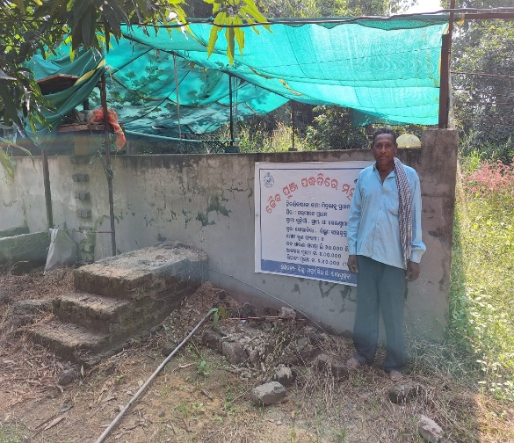 | 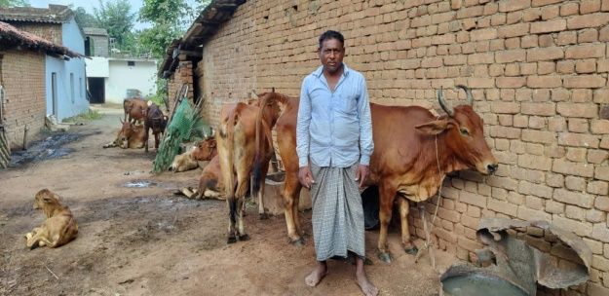
Good quality photographs (2-3) | 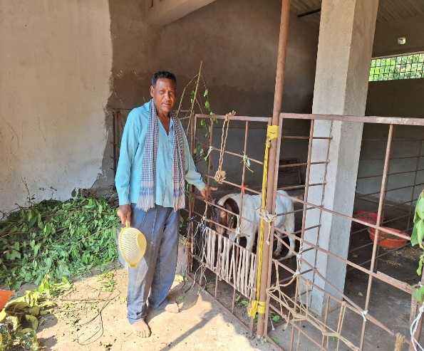 | 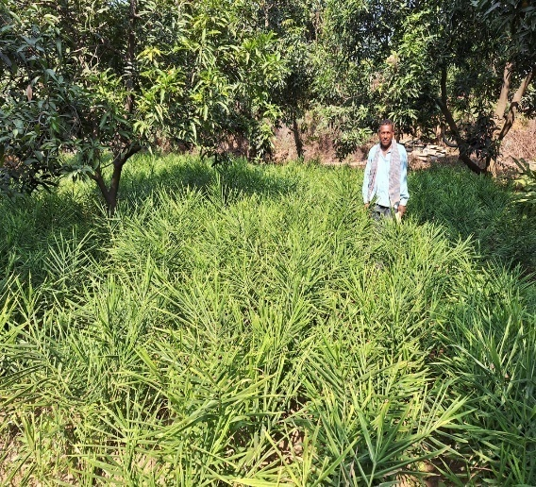

Details of Enterprise/Farming components: He has 16.0 acres of land, in which he developed Integrated farming system in 5 acres having components of Agriculture (Paddy, Sesame, Greengram and Maize), Horticulture (Mango, Ginger,Tomato, Brinjal,Chilli), Livestock (Dairy, Goatery) and Fishery (Bio-floc) and rest land are used for paddy production.
Economic/Production Advantage: From all the component under IFS, his annual income is Rs.7,18,000/- and net income is Rs.4,20,000/-. His income has been enhanced due to adoption of improved technologies demonstrated by KVK and capacity building programmes imparted by KVK scientists. Establishment of different components of the IFS is being made successfully by the help of line departments and technical guidance of KVK scientists.
Employment generation: On developing IFS model he is engaging 2 manpower daily for management of the different enterprises and during crop production he has been engaging a total of 270-280 man-days per annum.
Importance for other Farmers: Farmers of his village & nearby village can enhance their knowledge &skill by visiting his field and spread the technologies to different farmers of 5-6 villages.

3.8. Give details of innovative methodology or innovative technology of Transfer of Technology developed and used during the year

Sl. No. | Name/ Title of the technology | Name/ Details of the Innovator(s) | Brief details of the Innovative Technology
_ | _ | _ | _

3.9. a. Give details of indigenous technology practiced by the farmers in the KVK operational area which can be considered for technology development (in detail with suitable photographs)

Sl. No. | Crop / Enterprise | ITK Practiced | Purpose of ITK
1 | Cattle | Herbal treatment using turmeric Bahada and Camphor paste | Treatment of FMD
2 | Poultry | Use of Neem and Turmeric paste | Treatment of fowl pox

b. Give details of organic farming practiced by the farmer

Sl. No. | Crop / Enterprise | Area (ha)/ No. covered | Production | No. of farmers involved | Market available (Y/N)
 | Vegetable & Fruits | 46 | 6500 q | 140 | Y

3.10. Indicate the specific training need analysis tools/methodology followed by KVKs

Sl. No. | Brief details of the tool/ methodology followed | Purpose for which the tool was followed
- PRA method | Identification of problems, problem analysis, Database formation and primary data collection. | - PRA method
- Farmers interaction and group discussion | Verification of the problem and prioritization of the problem | - Farmers interaction and group discussion
- Training need assessment | Technological gap analysis, need based problem identification | - Training need assessment

3.11. a. Details of equipment available inSoiland Water Testing Laboratory

Sl. No | Name of the Equipment | Qty.
1 | Automatic Nitrogen Analyzer with digestion unit | 1
2 | MridaParikshak soil testing kit | 2
3 | Precision Analytical Balance | 1
4 | pH, EC, TDS meter | 1
5 | Digital soil moisture meter | 1
6 | Digital balance | 1
7 | Flame Photometer | 1
8 | Spectro Photometer | 1
9 | Double distillation unit | 1
10 | DAPS power supply | 1
11 | Rotary Shaker | 1
12 | GPS set | 1

3.11.b. Details of samples analyzed so far :
Number of soil samples analyzed |  |  | No. of Farmers | No. of Villages | Amount realized  (in Rs.)
Through mini soil testing kit/labs | Through soil testing laboratory | Total
- | 60 | 60 | 182 | 5 | -

3.11.c. Details on World Soil Day

Sl.  No. | Activity | No. of Participants | No. of VIPs | Name (s) of VIP(s) | Number of Soil Health Cards distributed | No. of farmers benefitted
1 | Farmers –Scientist Interaction | 95 | 1 | ADM, Jharsguda | 80 | 720

3.12. Activities of rain water harvesting structure and micro irrigation system

No of training programme | No of demonstrations | No of plant material produced | Visit by the farmers | Visit by the officials
2  Awareness and Training Programme | 1 | _ | 50 | 3

3.13. Technology week celebration

Type of activities | No. of activities | Number of participants | Related crop/livestock technology
- | - | -- | -

3.14. RAWE/ FETprogramme - is KVK involved? (N)

No of student trained | No of days stayed

ARS trainees trained | No of days stayed
- | -

3.15. Listof VIP visitors (Minister/ MP/MLA/DM/VC/ZilaSabhadipati/Other Head of Organization/Foreigners)

Date | Name of the person | Purpose of visit
17.01.2023 | Dr. AvijitHalder, Principal Scientist , ICAR-ATARI, Kolkata, Zone V | Visited KVK Jharsuguda
18.10.2023 | Prof. P.K. Roul, Hon’ble VC, OUAT, BBSR | Visited KVK Jharsuguda

- IMPACT

  - Impact of KVK activities (Not to be restricted for reporting period).

Name of specific technology/skill transferred | No. of participants | % of adoption | Change in income (Rs.)
Name of specific technology/skill transferred | No. of participants | % of adoption | Before (Rs./Unit) | After (Rs./Unit)
Improved method of Groundnut cultivation with HYV. | 45 | 70 | 40000 | 50200
Drought tolerant paddy variety Sahabhagidhan | 60 | 62 | 17500 | 24000
Improved method of Greengram cultivation with HYV. | 50 | 64 | 24000 | 32000
Weed management in paddy | 30 | 80 | 19000 | 23000
Sweetcorn cultivation variety –Sugar 75 | 70 | 65 | 25000 | 85000
Backyard Poultry rearing | 80 | 45 | 380/bird | 650/bird
Mushroom production techniques | 90 | 55 | 150/bed | 220/bed
Stress tolerant Poultry rearing –Kadaknath | 70 | 65 | 280/bird | 450/bird
Cultivation of BM-2 Marigold | 60 | 62 | 170000 | 240000
NB: Should be based on actual study, questionnaire/group discussion etc. with ex-participants

4.2. Cases of large scale adoption
(Please furnish detailed information for each case)
Horizontal spread of technologies
Technology | Horizontal spread
Drought tolerant paddy variety Sahabhagidhan | 520 ha
Herbicide application in Rice | 1250 ha
BPH management in Rice | 218 ha
Millet Cultivation variety-Arjun | 60 ha
Sweetcorn cultivation | 82 ha
Cultivation of marigold variety BM-2 | 8 ha
Backyard Poultry rearing –Kadaknath | 25 villages
Nutrient management in Groundnut | 108 ha
YMV resistant greengram cultivation | 250 ha
Mushroom Cultivation | 17 village

Give information in the same format as given below

4.3.Details of impact analysis of KVK activities carried out during the reporting period

Sl. No. | Brief details of technology | Impact of the technology in subjective terms | Impact of the technology in objective terms
1 | Herbicide application in Rice | Adoption percentage- 80%, Horizontal spread-1200 ha | Yield -46 q/ha
2 | BPH tolerant Rice Var. Hasanta | Adoption percentage- 60%, Horizontal spread-200 ha | Yield -52 q/ha

4.4. Details of innovations recorded by the KVK

Thematic area | Agriculture Engineering
Name of the Innovation | Power tiller operated Paddy Thresher
Details of Innovator | Name of farmer: SushantaNaik  Address: Ghantamal, PO-Jhirlapalli, Block- Kolabira,  Dist- Jharsuguda, Contact No.:9777468457  Age-62 Years, Education-Matriculate, Land Holding-5.0 acre.
Back ground of innovation | Threshing of paddy is expensive by using paddy combine harvester and dependent on availability of harvester in time.
Technology details | Power tiller operated Paddy Thresher is made up of wood, which is on an average weight of 3.0 qntl. and drawn by power tiller for threshing of paddy.
Practical utility of innovation | It can be made with local available materials , simple and easy to operate.

4.5. Details of entrepreneurship development

Entrepreneurship development
Name of the enterprise
Name & complete address of the entrepreneur
Role of KVK with quantitative data support:

Timeline of the entrepreneurship development

Technical Components of the Enterprise

Status of entrepreneur before and after the enterprise
Present working condition of enterprise in terms of raw materials availability, labour availability, consumer preference, marketing the product etc. ( Economic viability of the enterprise):
Horizontal spread of enterprise

4.6. Any other initiative taken by the KVK

5. LINKAGES
5.1. Functional linkage with different organizations
Name of organization | Nature of linkage
Regional Research & Technology Transfer Station, Chiplima, Sambalpur | Agro Inputs and Technical assistance
Central Horticultural Experiment station, Bhubaneswar | Resource person, Technology and technical assistance, Agro Input supply
Central Tuber Crop Research Institute, Bhubaneswar | Programme implementation ,convergence mode action , resource person, technical assistance, funding agency, input supply
National Rice Research Institute, Cuttack | Programme implementation, Resource person, technical assistance, funding agency, input supply
Department of Agriculture, Jharsuguda | Programme implementation , convergence mode action ,Resource person, technical assistance, funding agency, input supply
Department of Horticulture, Jharsuguda | Programme implementation , convergence mode action ,Resource person, technical assistance and assistance in infrastructure development
Department of Fishery, Jharsuguda | Programme implementation , convergence mode action , Resource person, technical assistance, Agro input supply
Watershed Development, Jharsuguda | Agro Input supply, seed certification, procurement of seed.
Animal Resource department, Jharsuguda | Supply of farm implements, Agro inputs.
Odisha State seed corporation, Bargarh | Farmers club formation, Resource person,
Odisha Agro Industries corporation, Jharsuguda | Suggestion in formation of technical programmes, Crop insurance.
NABARD, Sundergarh | Agro Input supply, convergence mode action
Lead bank, SBI, Jharsuguda | Resource person, Technical assistance for capacity building
SEWA, Kolabira, (NGOs) | Programme implementation, convergence mode action, Resource person, Technical guidance
AJKA,Lakhanpur, Jharsuguda | Resource person and technical guidance

5.2. List of special programmes undertaken during 2023by the KVK, which have been financed by ATMA/ Central Govt/ State Govt./NABARD/NHM/NFDB/Other Agencies (information of previous years should not be provided)

a) Programmes for infrastructure development

Name of the programme/scheme | Purpose of programme | Date/ Month of initiation | Funding agency | Amount (Rs.)
CBSAE/OMBADC, Govt. of Odisha | - Skill Development  - Establishment of Agri-Enterprise at KVK | December 2022 | CBSAE/OMBADC, Govt. of Odisha | 83.0 lakh
(b) Programme for other activities (training,FLD,OFT, Mela, Exhibition etc.)

Name of the programme/scheme | Purpose of programme | Date/ Month of initiation | Funding agency | Amount (Rs.)
CBSAE/OMBADC, Govt. of Odisha | Capacity Building | December 2022 | CBSAE/OMBADC, Govt. of Odisha

- PERFORMANCE OF INFRASTRUCTURE IN KVK

6.1. Performance of demonstration units (other than instructional farm)
Sl. No. | Name of demo Unit | Year of estt. | Area(Sq.mt) | Details of production |  |  | Amount (Rs.) |  | Remarks
 |  |  |  | Variety/breed | Produce | Qty. | Cost of inputs | Gross income | Remarks
1 | Poly House | 2013 | 120 | HYV & Local | Seedling & saplings | 30000 | 6000 | 80000 | Distributed to farmers
 | Total |  |  |  |  |  | 6000 | 80000

6.2. Performance of Instructional Farm (Crops)
Name  Of the crop | Date of sowing | Date of harvest | Area (ha) | Details of production |  |  | Amount (Rs.) |  | Remarks
 |  | Date of harvest | Area (ha) | Variety | Type of Produce | Qty.(q) | Cost of inputs | Gross income | Remarks

  - Performance of Production Units (bio-agents / bio-pesticides/ bio-fertilizers etc.,)

Sl.  No. | Name of the Product | Qty. (Kg) | Amount (Rs.) |  | Remarks
Sl.  No. | Name of the Product | Qty. (Kg) | Cost of inputs | Gross income | Remarks
1. | Vermicompost | 1000 | 8000 | 15000 | Distributed to farmers

  - Performance of instructional farm (livestock and fisheries production)

Sl.  No | Name  of the animal / bird / aquatics | Details of production |  |  | Amount (Rs.) |  | Remarks
Sl.  No | Name  of the animal / bird / aquatics | Breed | Type of Produce | Qty. | Cost of inputs | Gross income | Remarks
1. | Poultry | Kadaknath | Chicks | 500 | 45500 | 60000 | Distributed to farmers
2.
3.

  - Utilization of hostel facilities

Accommodation available (No. of beds)

Months | No. of trainees stayed | Trainee days  (days stayed) | Reason for short fall (if any)
March, 2023 | 20 | 5
May, 2023 | 20 | 5
June, 2023 | 20 | 5
July, 2023 | 20 | 5
August, 2023 | 20 | 5
September, 2023 | 20 | 4
October, 2023 | 20 | 5
November, 2023 | 20 | 5
November, 2023 | 20 | 4
November,2023 | 25 | 7
December, 2023 | 20 | 5
December, 2023 | 25 | 7
December, 2023 | 20 | 4
Total : | 270 | 66
(For whole of the year)

  - Utilization of staff quarters

Whether staff quarters has been completed:

No. of staffquarters:06
Date of completion: 2012
Occupancy details:
Months | Q I | QII | Q III | QIV | Q V | QVI*
January | √ | √ | √ | √ | √
February | √ | √ | √ | √ | √
March | √ | √ | √ | √ | √
April | √ | √ | √ | √ | √
May | √ | √ | √ | √ | √
June | √ | √ | √ | √ | √
July | √ | √ | √ | √ | √
August | √ | √ | √ | √ | √
September | √ | - | - | √ | √
October | √ | - | - | √ | √
November | √ | - | - | √ | √
December | √ | - | - | √ | √
* Needs major repairing

- FINANCIAL PERFORMANCE

7.1. Details of KVK Bank accounts
Bank account | Name of the bank | Location | Account Number
Contingency | State Bank of India | Main Road, Jharsuguda | 11346748214
Revolving Fund | State Bank of India | Main Road, Jharsuguda | 30938306848

  - Utilization of funds under CFLD on Oilseed (Rs. In Lakhs)

Item | Released by ICAR |  | Expenditure |  | Unspent balance as on -1st April 2023
Item | Kharif | Rabi | Kharif | Rabi | Unspent balance as on -1st April 2023
Groundnut |  | 120000 |  | 120000 | Nil

7.3. Utilization of funds under CFLD on Pulses (Rs. In Lakhs)
Item | Released by ICAR |  | Expenditure |  | Unspent balance as on 1st April 2023
Item | Kharif | Rabi | Kharif | Rabi | Unspent balance as on 1st April 2023
Greengram |  | 88800 |  | 88800 | Nil

  - Utilization of KVK funds during the year 2023-24(Not audited)

Sl.  No. | Particulars | Sanctioned | Released | Expenditure
A. Recurring Contingencies
1 | Pay & Allowances | 8900000 | 7071000 | 7071000
2 | Traveling allowances | 112500 | 112500 | 112500
3 | Contingencies
A | General | 803800 | 803800 | 803800
B | SCSP | 1399000 | 1399000 | 1399000
C | HRD | 30000 | 30000 | 0
D | Swachhta Expenditure | 34000 | 34000 | 34000
TOTAL (A) |  | 11279300 | 9450300 | 9420300
B. Non-Recurring Contingencies
1 | Library | 10000 | 10000 | 10000
TOTAL (B) |  | 10000 | 10000 | 10000
C. REVOLVING FUND |  | - | - | -
GRAND TOTAL (A+B+C) |  | 11289300 | 9460300 | 9430300

7.5. Status of revolving fund (Rs. in lakh) for last five years

Year | Opening balance as on 1st April | Income during the year | Expenditure during the year | Net balance in hand as on 1st April of each year (Kind + cash)
2019-20 | 100000 | 92961 | 124944 | 100000
2020-21 | 100000 | 305408 | 81324 | 73075
2021-22 | 73075 | 601659 | 574334 | 100000
2022-23 | 100000 | 248542 | 198542 | 150000
2023-24 | 100000 | - | - | -

  - (i) Number of SHGs formed by KVKs
(ii) Association of KVKs with SHGs formed by other organizations indicating the area of SHG activities
(iii) Details of marketing channels created for the SHGs

  - Joint activity carried out with line departments and ATMA
Nameof activity | Number of activity | Season | With line department | With ATMA | With both
World Soil day | 1 | Rabi 23-24  (05.12.2023) | Agriculture department, Jharsuguda | -- | Yes
Exposure Visit | 2 | Rabi 2022-23 | Agriculture department, Jharsuguda | -- | Yes
Diagnostic Field Visit for BPH and Stem borer incidence | 7 | Kharif 2023 | Agriculture department, Jharsuguda | -- | --
Millet Conclave | 1 | Rabi 2023 | Agriculture department, Jharsuguda, Odisha Millet Mission | -- | --
Field Days | 4 | Kharif & Rabi | Agriculture and Horticulture Dept., Jharsuiguda
Celebration Of World Fishery Day | 1 | Rabi | Fishery Dept., Jharsuguda

8. Other information

8.1. Prevalent diseases in Crops

Name of the disease | Crop | Date of outbreak | Area affected (in ha) | % Commodity loss | Preventive measures taken for area (in ha)
BPH | Paddy | October and November | 120 | 20 | 90
Rhizome Rot | Ginger | October-December | 20 | 30 | 15
Wilt in Solanaceous crop | Potato, Tomato and Brinjal | November and December | 40 | 28 | 16

8.2. Prevalent diseases in Livestock/Fishery
Name of the disease | Species affected | Date of outbreak | Number of death/ Morbidity rate (%) | Number of animals vaccinated | Preventive measures taken in pond (in ha)

9.1. Nehru YuvaKendra(NYK) Training

Title of the training programme | Period |  | No. of the participant |  | Amount of Fund Received (Rs)
 | From | To | M | F
- | - | - | - | - | -

9.2. PPV & FR Sensitization training Programme
Date of organizing the programme | Resource Person | No. of participants | Registration (crop wise)
 |  |  | Name of crop | No. of registration
- | - | - | - | -

9.3. mKisanPortal (National Farmers’ Portal/ SMSPortal)

Type of message | No. of messages | No. of farmers covered
Crop | 4 | 25000
Livestock | 2
Fishery
Weather | 2
Marketing
Awareness
Training information
Other | 2
Total | 10 | 25000

9.4. KVK Portal and Mobile App

Sl. No. | Particulars | Description
1. | No. of visitors visited the portal | 1200
2. | No. of farmers registered in the portal | -
3. | Mobile Apps developed by KVK | -
4. | Name of the App | -
5. | Language of the App | -
6. | Meant for crop/ livestock/ fishery/ others | -
7. | No. of times downloaded | -

9.5. a. Observation of Swachh Bharat Programme
Date/ Duration of Observation | Activities undertaken
In 1st week of every month | Cleaning of office, campus and farm
Observation of Swachhata Pakhwada | Awareness campaign , meeting and cleaning

b. Details of Swachhta activities with expenditure

Activities | Number | Expenditure (in Rs.)
- Digitization of office records/ e-office | 31
- Basic maintenance | 10 | 3800
- Sanitation and SBM | 8 | 5700
- Cleaning and beautification of surrounding areas | 16
- Vermicomposting/  Composting of biodegradable waste management & other activities on generate of wealth for waste | 22 | 24500
- Used water for agriculture/ horticulture application | -
- Swachhta Awareness at local level | 12
- Swachhta Workshops | --
- Swachhta Pledge | --
- Display and Banner | 6
- Foster healthy competition | --
- Involvement of print and electronic media | --
- Involving the farmers, farm women and village youth in the adopted villages (no of adopted village) | 4
- No of Staff members involved in the activities | 9
- No of VIP/VVIPs involved in the activities | --
16. Any other specific activity (in details) | --
Total | 119 | 34000

9.6. Observation of National Science day

Date of Observation | Activities undertaken

9.7. Programme with SeemaSurakshaBal/ BSF
Title of Programme | Date | No. of participants

9.8. Agriculture Knowledge in rural school

Name and address of school | Date of visit to school | Areas covered | Teaching aids used
Give good quality 1-2 photograph(s)

9.9. Details of ‘Pre-Rabi Campaign’ / ‘Pre-Kharif Campaign’ Programme

Date of programme | No. of Union Ministers attended the programme | No. of Hon’ble MPs (Loksabha/ Rajyasabha) participated | No. of State Govt. Ministers | Participants (No.) |  |  |  |  |  |  | Coverage by Door Darshan (Yes/No) | Coverage by other channels (Number)
 |  |  |  | MLAs Attended the programme | Chairman ZilaPanchayat | Distt. Collector/ DM | Bank Officials | Farmers | Govt. Officials, PRI members etc. | Total | Coverage by Door Darshan (Yes/No) | Coverage by other channels (Number)
Please provide good quality photographs:
9.10. Details of Swachhta Hi Suraksha/ SwachhtaPakhwadaprogramme organized

Sl.  No. | Activity | No. of villages Involved | No. of Participants | No. of VIPs | Name (s) of VIP(s)
1 | Awareness programme | 4 | 100 | -- | --
Please provide good quality photographs:

9.11. Details of MahilaKisan Divas programmeorganized

Sl.  No. | Activity | No. of villages Involved | No. of Participants | No. of VIPs | Name (s) of VIP(s)
1 | Training programme organized | 1 | 25 | -- | --
Please provide good quality photographs:

9.12. No. of Progressive/Innovative/Lead farmer identified (category wise)

Sl.  No. | Name of Farmer | Address of the farmer with contact no. | Innovation/ Leading in enterprise
1. | Naresh Neti | At-H. Kantapali, Block-Jharsuguda  Mob no.9439420491 | IFS model
2. | Sri Ashok Naik | At-Durlaga, Jharsuguda  Mob no.9938564313 | IFS model
3. | Sri SusantaNaik | At-Ghantamal,Block-Kolabira  Jharsuguda  Mob no.9777468457 | Integrated Farming
4. | Sri DuryadhanSahu | At- Kureimal, Block-Lakhanpur  Mob no.8260596362 | Banana cultivation
5 | Sri Narsingha Patel | At-Ghantamal, Block-Kolabira  Jharsuguda, Mob no.9777468457 | Sweet corn and Sunflower cultivation
7. | Smt. Nalini Patel | Village- keldamal,Block-kolabira  Dist- Jharsuguda768202  Mob no. 668172971 | Banana Cultivation
8 | Smt. Sarojini Bhainsal | Village- Saletikra,Block-Jharsuguda  Dist- Jharsuguda-768202  Mob no. 8658678466 | Pond based IFS model
9. | Ms. SunitaNaik | Village- Talpatia,Block-Jharsuguda  Dist- Jharsuguda-768202  Mob no. -9438047109 | Mushroom and Mushroom spawn production
10 | Sri SarojSahu | Village- Tharkaspur,Block-Jharsuguda  Dist- Jharsuguda-768202  Mob no. -7683967227 | Vegetable production
11 | Sri Mitrabhanu Patel | Village- Gudigaon,Block-Jharsuguda  Dist- Jharsuguda-768202  Mob no. - 9556899125 | IFS model

9.13. Revenue generation
Sl.No. | Name of Head | Income(Rs.) | Sponsoring agency
1. | -- | -- | --

9.14. Resource Generation:
Sl.No. | Name of the programme | Purpose of the programme | Sources of fund | Amount  (Rs. lakhs) | Infrastructure created
-- | -- | -- | -- | -- | --

9.15. Performance of Automatic Weather Station in KVK
Date of establishment | Source of funding i.e. IMD/ICAR/Others (pl. specify) | Present status of functioning
2011 | CRIDA, Hyderabad | Not Functioning

9.16. Contingent crop planning

Name of the state | Name of district/KVK | Thematic area | Number of programmes organized | Number of Farmers contacted | A brief about contingent plan executed by the KVK
Odisha | Jharsuguda | Disease and pest management, drought management | 8 | 110 | Diagnostic visit, field visit to the disease and pest affected area of crop .  Advisory crop management,  Rhizome rot management in Ginger

10. Report on Cereal Systems Initiative for South Asia (CSISA)

- Year:
- Introduction / General Information:

 | Title | Objective | Treatment details | Date of sowing | Replication | Result with photographs
Experiment 1
Experiment 2
Experiment 3
…
..
Others (If any)
Please provide good quality photographs:

11. Details ofDAPST/ TSP

- Achievements of physical output under TSP during 2023

Progress of DAPST for the year 2023 (Jan. to Dec., 2023)
Name of KVK
Sl.No. | Item/Activity |  | Units | Targets/Achievements |  | No. of Beneficiaries
Sl.No. |  |  | Units | Annual Targets | Achievements | Annual Targets | Achievements
1 | Trainings (Capacity building/ Skill Development etc.) |  | No.
1 | 1.1 | 1-3 days | No.
1 | 1.2 | 4-10 days | No.
1 | 1.3 | 2-4 weeks | No.
1 | 1.4 | More than 4 weeks | No.
2 | On Farm Trials (OFTs) |  | No.
3 | Front Line Demonstrations (FLDs) and other demonstrations |  | No.
4 | Awareness camps, exposure visits etc. |  | No.
5 | Input Distribution
5 | 5.1 | Seeds (Field Crops) | Tonnes
5 | 5.2 | Seeds (High Value Crops, spices etc.) | kg
5 | 5.3 | Seeds (Root & Tuber Crops) | tonnes
5 | 5.4 | Nursery plants | No.
5 | 5.5 | Cutting , slips, suckers, etc | No.
5 | 5.6 | Mushroom Spawns/ Bio-Fertilizers (in Packets) | Packets
5 | 5.7 | Honey Bee Colonies | No.
5 | 5.8 | Animals-large (Cattle/ Buffalo/ camel/horse/donkey/Mithun/Yak etc.) | No.
5 | 5.9 | Animals-small (pig, sheep, goat etc.) | No.
5 | 5.1 | Poultry chicks / duckling etc | No.
5 | 5.11 | Fish Spawns/ fingerlings | No.
5 | 5.12 | Small equipment's (upto Rs 2000) | No.
5 | 5.13 | Medium Equipment's/ machinery (upto Rs 25000) | No.
5 | 5.14 | Large Equipment's / machinery (> Rs. 25000) | No.
5 | 5.15 | Infrastructure / Civil Works/ Ponds etc | No.
5 | 5.16 | Setting up plant nursery/ seed farm/ hatchery | No.
5 | 5.17 | Land development/ Reclamation / Conservation | hectares
5 | 5.18 | Fertilizers (NPK)/ Secondary fertilizers | tonnes
5 | 5.19 | Micro nutrients | tonnes
5 | 5.2 | FYM/ Vermicompost | tonnes
5 | 5.21 | Soil amendments (Gypsum, lime etc.) | tonnes
5 | 5.22 | Plant protection chemicals | kg
5 | 5.23 | Plant growth Promoter | kg
5 | 5.24 | Animal Feed | tonnes
5 | 5.25 | Animal Fodder | tonnes
5 | 5.26 | Animal medicines | doses
5 | 5.27 | Any other (Liquid PSB etc.) | Litre
6 | Services/Facilitation
6 | 6.1 | Animal Health Camps | No.
6 | 6.2 | Artificial Insemination / Vaccination | No.
6 | 6.3 | Veterinary Services (Hospitalization, on-site treatment, PD, surgery etc) | No.
6 | 6.4 | Testing samples of Soil, plant, water, feed, fodder and livestock | No.
6 | 6.5 | Promotion of agri-entrepreneurship | No.
6 | 6.6 | Promotion of IFS, IOFS, Natural Farming, Nutrigarden, kitchen garden, orchards etc | No.
6 | 6.7 | Creation of market links of farm produces | No.
6 | 6.8 | Use of Institute Facilities (Processing etc.) (in Hours) | Hours
6 | 6.9 | Subsidies/ Assistance (50% of Project cost, Max. Rs 10,000/beneficiary) | No.
7 | Distribution of Literature |  | No.
8 | Employment generation for livelihood |  | (Man-months)
9 | Fellowship, Stipends or Scholarship |  | No.
10 | Area oriented R&D Activity (project addressing the problems of agri. Sector faced by the SC/STs and benefit directly, which is measurable and identifiable |  | No. of projects
11 | Monitoring & Evaluation of DAPSC/ST (upto 3%)
12 | Any other (specify)

- Fund received under TSP in 2023-24 (Rs. In lakh):

12. Details of DAPSC/ SCSP

- Achievements of physical output under SCSP during 2023

Progress of DAPSC for the year 2023 (Jan. to Dec., 2023)
Name of KVK
Sl.No. | Item/Activity |  | Units | Targets/Achievements |  | No. of Beneficiaries
Sl.No. |  |  | Units | Annual Targets | Achievements | Annual Targets | Achievements
1 | Trainings (Capacity building/ Skill Development etc.) |  | No.
1 | 1.1 | 1-3 days | No. | 44 | 44 | 1260 | 1260
1 | 1.2 | 4-10 days | No.
1 | 1.3 | 2-4 weeks | No.
1 | 1.4 | More than 4 weeks | No.
2 | On Farm Trials (OFTs) |  | No. | 5 | 5 | 35 | 35
3 | Front Line Demonstrations (FLDs) and other demonstrations |  | No. | 20 | 20 | 220 | 220
4 | Awareness camps, exposure visits etc. |  | No.
5 | Input Distribution
5 | 5.1 | Seeds (Field Crops) | Tonnes | 0.8 | 0.8 | 32 | 32
5 | 5.2 | Seeds (High Value Crops, spices etc.) | kg
5 | 5.3 | Seeds (Root & Tuber Crops) | tonnes
5 | 5.4 | Nursery plants | No. | 50000 | 45000 | 40 | 40
5 | 5.5 | Cutting , slips, suckers, etc | No.
5 | 5.6 | Mushroom Spawns/ Bio-Fertilizers (in Packets) | Packets | 1000 | 1000 | 20 | 20
5 | 5.7 | Honey Bee Colonies | No. | 5 | 5 | 5 | 5
5 | 5.8 | Animals-large (Cattle/ Buffalo/ camel/horse/donkey/Mithun/Yak etc.) | No.
5 | 5.9 | Animals-small (pig, sheep, goat etc.) | No.
5 | 5.1 | Poultry chicks / duckling etc | No. | 1400 | 1400 | 30 | 30
5 | 5.11 | Fish Spawns/ fingerlings | No.
5 | 5.12 | Small equipment's (upto Rs 2000) | No. | 250 | 250 | 50 | 50
5 | 5.13 | Medium Equipment's/ machinery (upto Rs 25000) | No.
5 | 5.14 | Large Equipment's / machinery (> Rs. 25000) | No.
5 | 5.15 | Infrastructure / Civil Works/ Ponds etc | No.
5 | 5.16 | Setting up plant nursery/ seed farm/ hatchery | No.
5 | 5.17 | Land development/ Reclamation / Conservation | hectares
5 | 5.18 | Fertilizers (NPK)/ Secondary fertilizers | tonnes | 0.65 | 0.65 | 20 | 20
5 | 5.19 | Micro nutrients | tonnes | 0.07 | 0.07 | 20 | 20
5 | 5.2 | FYM/ Vermicompost | tonnes
5 | 5.21 | Soil amendments (Gypsum, lime etc.) | tonnes
5 | 5.22 | Plant protection chemicals | kg | 6 | 6 | 40 | 40
5 | 5.23 | Plant growth Promoter | kg
5 | 5.24 | Animal Feed | tonnes
5 | 5.25 | Animal Fodder | tonnes
5 | 5.26 | Animal medicines | doses
5 | 5.27 | Any other (Liquid PSB etc.) | Litre
6 | Services/Facilitation
6 | 6.1 | Animal Health Camps | No.
6 | 6.2 | Artificial Insemination / Vaccination | No.
6 | 6.3 | Veterinary Services (Hospitalization, on-site treatment, PD, surgery etc) | No.
6 | 6.4 | Testing samples of Soil, plant, water, feed, fodder and livestock | No. | 100 | 100 | 480 | 472
6 | 6.5 | Promotion of agri-entrepreneurship | No.
6 | 6.6 | Promotion of IFS, IOFS, Natural Farming, Nutrigarden, kitchen garden, orchards etc | No.
6 | 6.7 | Creation of market links of farm produces | No.
6 | 6.8 | Use of Institute Facilities (Processing etc.) (in Hours) | Hours
6 | 6.9 | Subsidies/ Assistance (50% of Project cost, Max. Rs 10,000/beneficiary) | No.
7 | Distribution of Literature |  | No. | 2000 | 2000 | 5000 | 5000
8 | Employment generation for livelihood |  | (Man-months)
9 | Fellowship, Stipends or Scholarship |  | No.
10 | Area oriented R&D Activity (project addressing the problems of agri. Sector faced by the SC/STs and benefit directly, which is measurable and identifiable |  | No. of projects
11 | Monitoring & Evaluation of DAPSC/ST (upto 3%)
12 | Any other (specify)

- Fund received under SCSP in 2023-24 (Rs. In lakh):14.0

13.Progress report of NICRA KVK (Technology Demonstration component) during the period
(Applicable for KVKs identified under NICRA)- NA

Natural Resource Management
Name of intervention undertaken | Numbers under taken | No of units | Area (ha) | No of farmers covered / benefitted |  |  |  |  |  |  |  |  |  | Remarks
 |  |  |  | SC |  | ST |  |  | Other |  | Total
 |  |  |  | M | F |  | M | F | M | F | M | F | T

Crop Management

Name of intervention undertaken | Area (ha) | No of farmers covered / benefitted |  |  |  |  |  |  |  |  |  | Remarks
 |  | SC |  | ST |  |  | Other |  | Total
 |  | M | F |  | M | F | M | F | M | F | T

Livestock and fisheries

Name of intervention undertaken | Number of animals covered | No of units | Area (ha) | No of farmers covered / benefitted |  |  |  |  |  |  |  |  |  | Remarks
 |  |  |  | SC |  | ST |  |  | Other |  | Total
 |  |  |  | M | F |  | M | F | M | F | M | F | T

Institutional interventions

Name of intervention undertaken | No of units | Area (ha) | No of farmers covered / benefitted |  |  |  |  |  |  |  |  |  | Remarks
 |  |  | SC |  | ST |  |  | Other |  | Total
 |  |  | M | F |  | M | F | M | F | M | F | T

Capacity building
Thematic area | No of Courses | No of beneficiaries
 |  | SC | ST |  |  | Other |  |  | Total
 |  | M | F | M | F |  | M | F | M | F | T

Extension activities
Thematic area | No of activities | No of beneficiaries
 |  | SC | ST |  |  | Other |  |  | Total
 |  | M | F | M | F |  | M | F | M | F | T

Detailed report should be provided in the circulated Performa

14. Awards/Recognition received by the KVK

Sl. No. | Name of the Award | Year | Conferring Authority | Amount | Purpose

Award received by Farmers from the KVK district
Sl. No. | Name of the Award | Name of the Farmer | Year | Conferring Authority | Amount | Purpose

15. Any significant achievement of the KVK with facts and figures as well as quality photograph

- Number of commodity based organizations/ farmers’ cooperative society/ FPO formed/ associated with during last one year (Details of the group/society may be indicated)

Sl. No. | Name of the organization/ Society | Trust Deed No.& date | Date of Trust Registration  Address | Proposed Activity | Commodity Identified | No. of Members | Financial position  (Rupees in lakh) | Success indicator

- Integrated Farming System (IFS)
Details of KVK Demo. Unit

Sl.  No. | Module details (Component-wise) | Area under IFS (ha) | Production (Commodity-wise) | Cost of production in Rs. (Component-wise) | Value realized in Rs. (Commodity-wise) | No. of farmer adopted practicing IFS | % Change in adoption during the year
1 | Mango Progeny Nursery | 0.6 | Graft | 12000 | -- | -- | --
2 | Mango Orchard | 1.0 | Mango (8q) | 35000 | 16000 | 16 | --
3 | Mixed fruit orchard | 0.2 | Guava (1 q) | 18000 | 2000 | 06 | --
4 | Poultry unit | - | Chicks | 50602 | 93050 | 7 | --
5 | Vermicompost unit | 6 Unit | Vermicompost and vermin | 8290 | 15000 | 15 | --

- Technologies for Doubling Farmers' Income

Sl. No. | Name of the Technology | Brief Details of Technology (3- 5 bullet points) | Net Return to the farmer (Rs.) per ha per year due to adoption of the technology | No. of farmers adopted the technology in the district | One high resolution ‘Photo’ in ‘jpg’ format for each technology
1 | Cultivation of Cow pea, var-KasiKanchan | Cultivation of Cow pea, var-KasiKanchan | 72000 | 32
2 | FLD on Paddy variety Pratikshya | INM in paddy | 42000 | 125
3 | Demonstration on potato var. K. Jyoti | INM in Potato- | 68000 | 70
4 | Rearing of Vanaraja poultry | Vaccination of  Vanaraja Bird  rearing 50  Chicks /6 month | 420/bird | 74
5 | Cultivation of of Greengram var. IPM-02-14 | INM in Greengram IPM-02-14 | 22000 | 108
6 | FLD on Paddy variety Sahabhagidhan | Weed management in paddy by application of Pretilachlor 1250 ml/ha within 48 hr of transplanting orPost emergence application ofBispyribac sodium @ 250ml /ha. | 24000 | 112
7 | FLD on Paddy variety Pratikshya | Weed Management In Paddy, Pre emergence application of Pretilachlor@1250ml/ha or Post emergence Bispyribac sodium @ 250ml /ha | 40000 | 580

- Report on Digital Farming Initiatives in Agriculture/ Digital Ag. Extension Service

 | Database prepared/ covered for |  | KVK level Committee |  | Various activity conducted for farmers
Phase | Total no. of villages | Total no. of farmers | Date of formation | Name of members | Various activity conducted for farmers
I (up-to 15.03.2018) | -- | -- | January 2018 | All line department officials of Jharsuguda with chairmanship of DDA, Jharsuguda | - Farmer interaction  - Group discussion  - Meeting
II (up-to 24.04.218) | 356 | 7820 | January 2018
Total | 356 | 7820 | January 2018

- Information on Visit of Ministers to KVKs, if any (Please provide good quality photographs)

Date of Visit | Name of Hon’ble Minister | Name of Ministry | Salient points in his/ her observation  (2-3 bulleted points)

- a) Information on ASCI Skill Development Training Programme, if undertaken during 2023 (NA)

Name of the Job role | Name of the certified Trainer of KVK for the Job role | Date of start of training | Date of completion of training | No. of participants |  |  |  |  |  | Whether uploaded to SIP Portal (Y/N) | Fund utilized for the training (Rs.)
 |  |  |  | SC |  | ST |  | Other |  | Whether uploaded to SIP Portal (Y/N) | Fund utilized for the training (Rs.)
 |  |  |  | M | F | M | F | M | F | Whether uploaded to SIP Portal (Y/N) | Fund utilized for the training (Rs.)
- | - | - | - | - |  |  |  |  |  | - | -
(Please provide good quality photographs)

b) Information on Skill Development Training Programme (Other than ASCI or less than 200 hrs., if any) if undertaken during 2023

Thematic area of training | Title of the training | Duration (in hrs.) | No. of participants |  |  |  |  |  |  |  |  | Fund utilized for the training (Rs.)
 |  |  | SC |  | ST |  | Other |  | Total
 |  |  | M | F | M | F | M | F | M | F | T
IGA | Commercial Mushroom cultivation (3 nos.) | 98 | 6 | 10 | 5 | 12 | 13 | 14 | 24 | 36 | 60 | 2,30,000
IGA | Mushroom spawn production | 35 | 1 | 2 | 2 | 4 | 3 | 8 | 6 | 14 | 20 | 75,000
IGA | Vermicomposting (2 nos.) | 70 | 3 | 6 | 2 | 4 | 8 | 17 | 13 | 27 | 40 | 1,50,000
IGA | Scientific Bee Keeping(2 nos.) | 63 | 4 | 5 | 5 | 3 | 12 | 11 | 21 | 19 | 40 | 1,55,000
IGA | Nursery raising of vegetables | 35 | 2 | 1 | 2 | 2 | 7 | 6 | 11 | 9 | 20 | 75,000
- Information on NARI Project(if applicable)

Name of Nodal Officer | No. of OFT on specified aspects | Title(s) of OFT | No. of FLD on specified aspects | No. of capacity development programme on specified aspects | Total no. of farm women/ girls involved in the project | Details of Issues related to gender mainstreaming addressed through the project
- | - | - | - | - | - | -

- Any other programme organized by KVK, not covered above

Sl.  No. | Name of the programme | Date of the programme | Venue | Purpose | No. of participants

- Good quality action photographs of overall achievements of KVK during the year
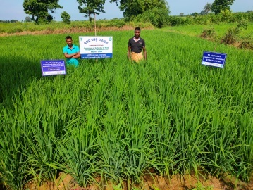 | 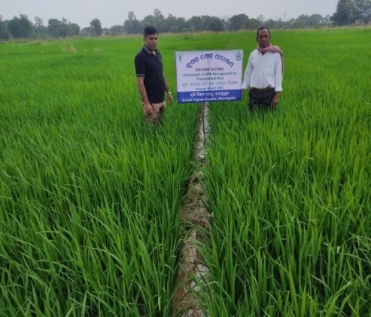 | 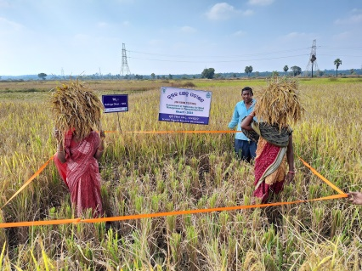
Assessment of herbicides for weed management in transplanted rice | Assessment of BPH management in transplanted rice | Assessment of Rice varieties for rain fed medium land
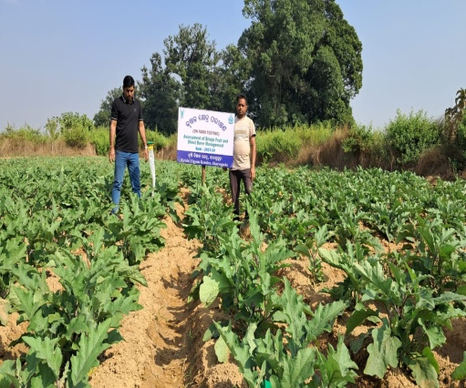 | 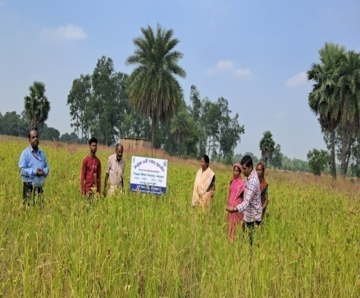 | 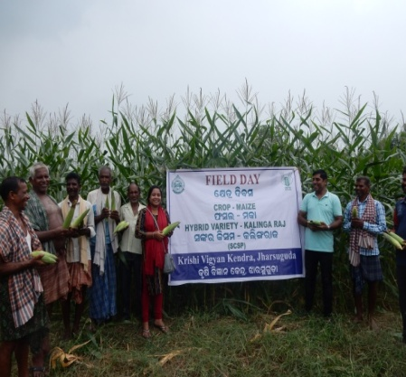
Assessment of Brinjal shoot and fruit borer management | Demonstration of HYV of Finger millet variety-Arjun | Demonstration of hybrid maize variety Kalinga raj
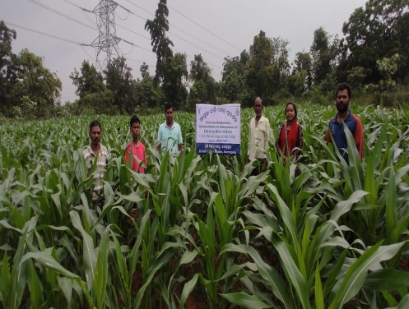 | 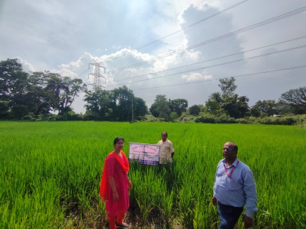 | 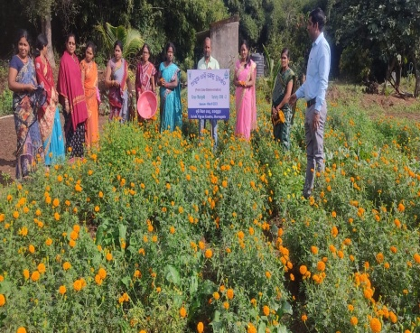
Demonstration on management of Fall Army Worm in Maize | Demonstration of herbicide for weed management in upland rice | Demonstration of Marigold variety –Bidhan Marigold 2
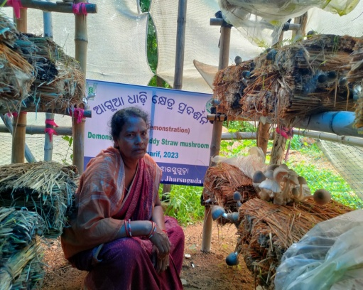 | 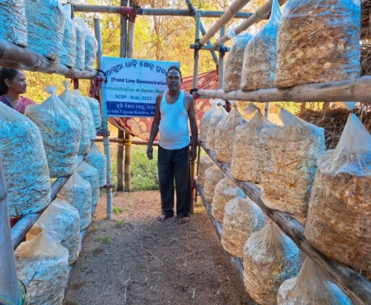 | 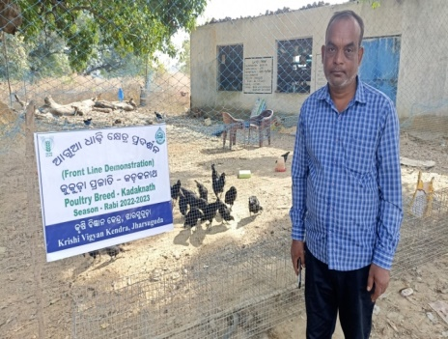
Demonstration of paddy straw mushroom cultivation | Demonstration on Cultivation of Oyster mushroom by using crumbled straw | Demonstration of stress tolerant poultry breed Kadaknath
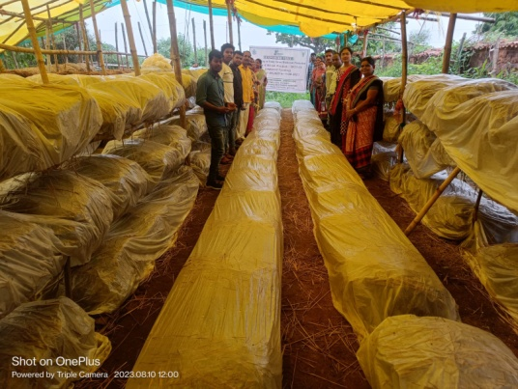 | 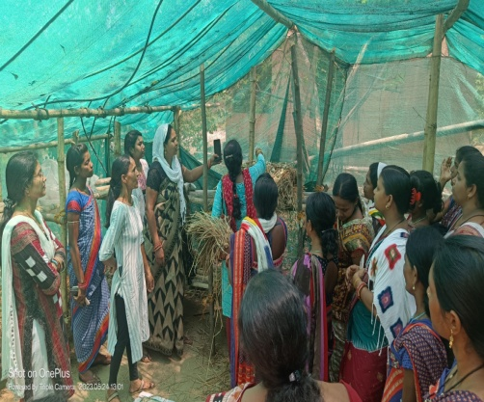 | 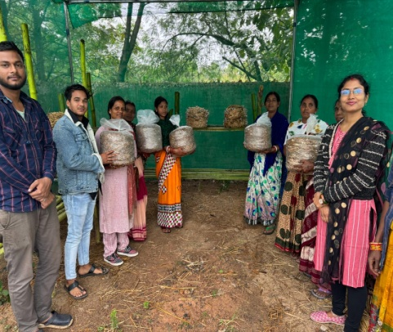
Skill Training on Mushroom Cultivation
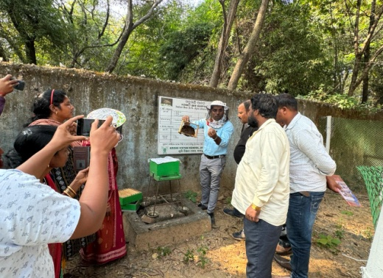 | 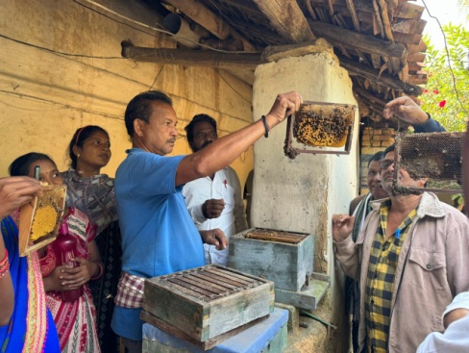 | 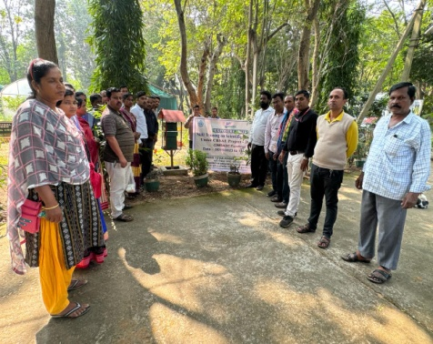
Skill Training on Scientific Bee Keeping
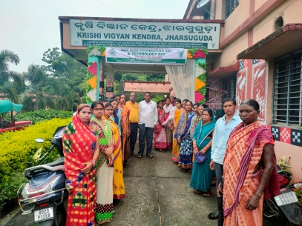 | 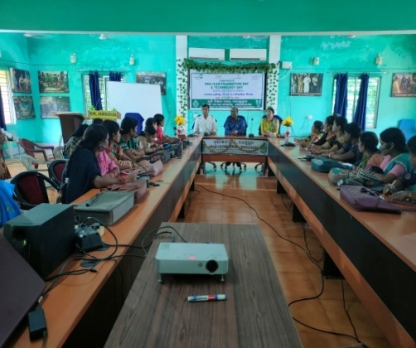 | 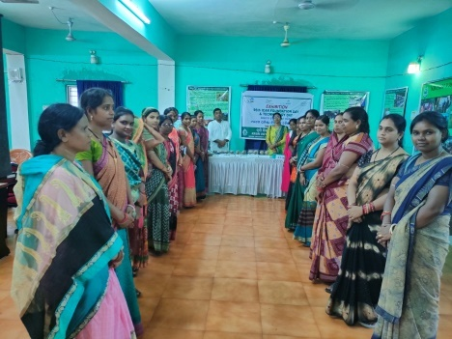
Celebration of ICAR Foundation Day
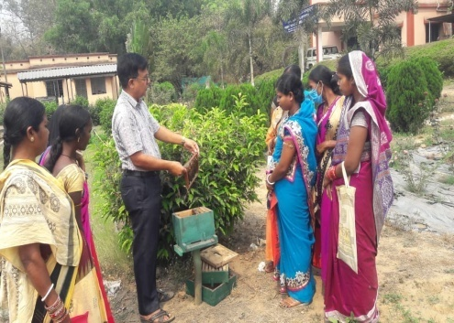 | 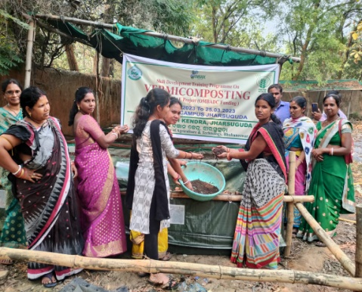 | 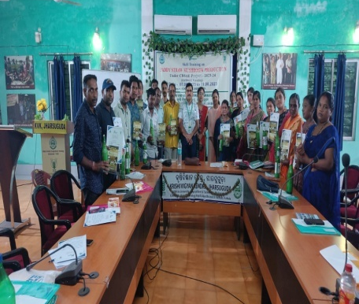
Skill Development Training Programmes

***

